Schema PIDXLibDS.xsd

schema location: | \\fsprod01\users\bryan.mcpadden\MyDocs\PIDX5\5.02.01\5.02.01 8-31-2016\XSD Definitions and Diagrams\PIDXLibDS.xsd
attribute form default: | unqualified
element form default: | qualified
targetNamespace: | http://www.pidx.org/schema/ds/v5.02

Attributes | Elements | Complex types | Simple types | Attr. groups
FixVersion | ActionCode | AgentData | ActionCodeEnum | PIDXVersion
MajorVersion | Activity | AuthorizationData | ActivityTypeEnum
MinorVersion | ActivityDate | AuthRequestData | AgentTypeEnum
 | ActivityType | AuthResponseData | BlockValues
 | AddressLine | DensityType | BOLTypeEnum
 | Agency | DocumentBaseClass | CustomsRoleEnum
 | Agent | DocumentData | DensityUnits
 | AgentDocument | EquipmentData | DocumentTypes
 | AgentDocuments | GeoLocation | DriverEnteredData
 | AgentType | GravityType | EMCSDestinationEnum
 | AllocationReserve | LoadDocumentType | EMCSGuarantorEnum
 | annotation | LoadPlanInfo | EMCSSubmissionMessageEnum
 | Authorization | MaxFillLevels | EMCSTransportArrangerEnum
 | AuthorizationNo | MeasurementBaseClass | EMCSTransportEnum
 | AuthorizationSetting | MeasurementComplexType | EnergyContentUnits
 | AuthorizedLoad | MixPercentageType | ErrorClaseEnum
 | AuthorizingSystem | MOTBaseClass | FenceUnits
 | AuthParties | NoQuantityType | GravityUnits
 | AuthRequests | OnBoardDefinition | IncoTermEnums
 | AuthResponses | PartnerInformation | LengthUnits
 | AuthSequence | PartnerRoleInformation | LineItemResponseEnum
 | AuthTransport | PIDXPlannedMovementReq | LocationSecondaryTypes
 | BeginPeriod | PMMOT | MeasurementQualifierEnum
 | BlendAlteration | PMQuantity | MeasurementQualifierEnumDeprecated
 | BlockIndicator | PMResponseBaseClass | MeasurementTypeEnum
 | Body | PMResponseBody | MeasurementUnitQualf
 | BOLRespErrorCode | PMResponseComplex | MOTTypeEnum
 | BOLRespErrorDescription | PMResponseFailedData | MovementTypes
 | BOLResponse | PMResponseSucessData | PartnerRoleCodes
 | BOLStoredSucessfully | PostingData | PartnerSecondaryCodes
 | BOLType | PressureType | PostingTypeEnum
 | CarrierIdentifier | ProductData | PressureUnits
 | CityName | ProductDataV1 | ProductIdentifierTypes
 | Company | ProductWeightType | RailPartnerRoles
 | Compartment | QuantityScheduleType | RatioUnits
 | CompartmentNumber | RailDefinition | ReferenceTypes
 | CompartmentQuantity | RailReferenceDefinition | RightToLIftEnum
 | Compartments | RevisionData | ScheduleTypeEnum
 | CompartmentSpecification | SecondaryLoadReferenceCT | StatusCodes
 | ComplementaryInfLanguage | TankDeliveryData | TemperatureUnits
 | ComplementaryInformation | TemperatureType | TransportSecondaryTypes
 | Component | TruckDefinition | VolumeUnits
 | ComponentContract | VechicleSpecificationData | WeightUnits
 | ComponentId | VolumeType | YesNo
 | ComponentText
 | ComponentType
 | ConfiguredVehicle
 | ConfiguredVehicleParts
 | ConfiguredVehicles
 | ConnectingTrack
 | Consignee
 | ConsigneeCountry
 | ConsigneeLanguage
 | ConsigneeReleaseNumber
 | ContactEmail
 | ContactName
 | ContactNumber
 | ContainerSize
 | Content
 | County
 | Currency
 | DateTime
 | Density
 | DenyCode
 | DenyDescription
 | DenySellerMsg
 | DestinationIdentifier
 | DestinationLanguage
 | DestinationTypeCode
 | DetailAuthorization
 | DetailDates
 | DetailPartners
 | DetailPostingReference
 | DetailReferences
 | DisplayList
 | DistributionChannel
 | Document
 | DocumentDate
 | DocumentDates
 | DocumentHeader
 | DocumentIdentifier
 | DocumentLineItem
 | DocumentLineItems
 | DocumentName
 | DocumentOriginator
 | DocumentReference
 | DocumentReferenceType
 | Documents
 | DocumentSequence
 | DocumentStatus
 | DocumentType
 | DriverCardNo
 | DriverDocumentIdentifier
 | DriverIdentifier
 | DriverLicense
 | DriverName
 | EMCS
 | EndPeriod
 | Engine
 | EngineIdentifier
 | EngineIdentifierType
 | EngineSecondaryIdentifier
 | EoriNumber
 | EquipmentSpecification
 | ErrorClass
 | ErrorIdentifier
 | ExpireDate
 | Export
 | Exporter
 | ExportInfo
 | ExportPartners
 | Failed
 | FinalShipper
 | FinalShipperDocumentSequence
 | ForeignTariffRegulation
 | From
 | FromSeller
 | GeoFence
 | GeoFenceUnit
 | Gravity
 | Guarantor
 | Guarantors
 | GuarantorTypeCode
 | Header
 | Incoterms
 | IncotermsText
 | IssueDate
 | IssuedDate
 | IssuingAgency
 | JourneyTime
 | LastDateTime
 | LastModified
 | Latitude
 | LeftOnBoard
 | LineItemError
 | LineItemErrors
 | LineItemNumber
 | LineItemResponse
 | LineItemResponses
 | LineItemResponseType
 | LineItemStatus
 | LoadCompartment
 | LoadCompartments
 | LoadingPart
 | LoadingPartIdentifier
 | LoadingPartIdentifierType
 | LoadingParts
 | LoadingPartSecondaryIdentifier
 | LoadingPlanPart
 | LoadingPlanParts
 | LoadingRef
 | LoadingType
 | LoadPartIdentification
 | LoadPartSpecification
 | LoadPlan
 | Location
 | LocationIdentifier
 | LocationIdentifierType
 | LocationSecondaryIdentifier
 | Longitude
 | MaxAmounts
 | MaxVolume
 | MaxWeight
 | Measurement
 | MeasurementInformation
 | MeasurementQualifier
 | MeasurementReference
 | Measurements
 | MeasurementType
 | Message
 | Metered
 | MeterIdentifier
 | MixPercentage
 | ModeOfTransport
 | MOTinfo
 | MotItem
 | MotSubType
 | MotType
 | MovementType
 | NextDocumentSequence
 | NoQuantity
 | NumberOfCompartments
 | NumberOfRailCars
 | OrderInfo
 | OrderNumber
 | OriginalDocumentIdentifier
 | PartnerExciseNumber
 | PartnerIdentifier
 | PartnerLocation
 | PartnerName
 | PartnerRoleIndicator
 | Partners
 | PartnerVATNumber
 | Party
 | PartyIdentifier
 | PartyIdentifierType
 | PartyOwner
 | PartySecondaryIdentifier
 | PeriodQuantity
 | PIDXProductID
 | PIDXTerminalIdentifier
 | PIDXTerminalOwner
 | PlannedLifting
 | PlannedModeOfTransport
 | PlannedMovementRequest
 | PlannedProduct
 | PlannedQuantity
 | PMReceivedDateTime
 | PostalCode
 | PostalCountry
 | Posting
 | PostingReference
 | PostingReferenceDetail
 | PostingSegment
 | PostingType
 | Pressure
 | PriorToLoad
 | ProcessingCompleteDateTime
 | Product
 | ProductIdentifer
 | ProductIdentifers
 | ProductIdentifier
 | ProductIdentifiers
 | ProductIdentifierType
 | ProductList
 | ProductText
 | ProductWeight
 | Quantity
 | QuantitySchedule
 | QuantitySchedules
 | QuantityUnit
 | Rail
 | RailCarIdentifier
 | RailCarType
 | RailCarTypeText
 | RailPartners
 | RailParty
 | RailReference
 | RailReferences
 | RailTextKey
 | RailTextKeySequence
 | RailTextValue
 | Rate
 | ReasonCode
 | Recipe
 | Recipes
 | RecipientDocumentIdentifier
 | Reference
 | ReferenceIdentifier
 | ReferenceItem
 | ReferenceOwner
 | ReferenceQualifier
 | References
 | ReferenceType
 | RegionCode
 | RenewalDate
 | Required
 | Response
 | ResponseInfo
 | ResponseResult
 | ResponseType
 | Revision
 | RevisionNumber
 | RightToLiftCheck
 | RightToLiftSystem
 | RoutingCodes
 | SalesDivision
 | SalesOrganization
 | ScheduleType
 | Seal
 | SealNo
 | Seals
 | SealString
 | SealType
 | SecondaryLoadReference
 | SellerDocumentSequence
 | SellerNum
 | ServiceAgreementNumber
 | ServiceAgreementType
 | Shift
 | ShiftSeq
 | ShipperData
 | ShipperInfo
 | SoldToIdentifier
 | Source
 | SourceDocument
 | SplitLoading
 | StateOrProvince
 | StockOwner
 | StockStatus
 | StorageLocation
 | StorageTankIdentifier
 | SubmissionMessageType
 | Success
 | TankCapacity
 | TankDelivery
 | TankDeliveryDetail
 | TankDeliveryQuantity
 | TankIdentifier
 | TankUnit
 | Tariff
 | Tax
 | TaxCode
 | TaxDetail
 | TaxDutyIdentifier
 | TaxLevel
 | TaxLicenseIdentifier
 | TaxMovemtCode
 | TaxMovemtDesc
 | TaxType
 | Temperature
 | Terms
 | ThirdParty
 | ThirdPartyConsignee
 | To
 | TpuIdentifierCard
 | TpuLicense
 | TpuType
 | TrackClass
 | Transport
 | TransportArrangerCode
 | TransportData
 | TransportIdentifier
 | TransportIdentifierType
 | TransportModeCode
 | TransportSecondaryIdentifier
 | Truck
 | Unit
 | UnitQualifier
 | UnladenWeight
 | URL
 | UserName
 | Validated
 | VehicleIdentifier
 | VersionConversion
 | Volume
 | VolumeUnit
 | WeightUnit

attribute FixVersion
namespace | http://www.pidx.org/schema/ds/v5.02
type | string
properties | fixed 01
used by | attributeGroup PIDXVersion
annotation | documentation  Fix Version - Incremented when Enumeration Values are added
source | <attribute name="FixVersion" type="string" fixed="01">  <annotation>  <documentation>Fix Version - Incremented when Enumeration Values are added</documentation>  </annotation>  </attribute>

attribute MajorVersion
namespace | http://www.pidx.org/schema/ds/v5.02
type | string
properties | fixed 05
used by | attributeGroup PIDXVersion
annotation | documentation  Major Version - Incremented when New Required Elements are added
source | <attribute name="MajorVersion" type="string" fixed="05">  <annotation>  <documentation>Major Version - Incremented when New Required Elements are added </documentation>  </annotation>  </attribute>

attribute MinorVersion
namespace | http://www.pidx.org/schema/ds/v5.02
type | string
properties | fixed 02
used by | attributeGroup PIDXVersion
annotation | documentation  Minor Version - Incremented when New non-required elements are added
source | <attribute name="MinorVersion" type="string" fixed="02">  <annotation>  <documentation>Minor Version - Incremented when New non-required elements are added </documentation>  </annotation>  </attribute>

element ActionCode
diagram | 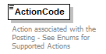
namespace | http://www.pidx.org/schema/ds/v5.02
type | pidx:ActionCodeEnum
properties | content simple
used by | complexType PostingData
facets | enumeration Loading  enumeration BatchLoading  enumeration Delivery  enumeration Unload  enumeration Stockresult  enumeration Inventory  enumeration Transfers  enumeration Orders  enumeration ShipmentOrder  enumeration Contract  enumeration LoadID  enumeration Nomination  enumeration SalesOrder
annotation | documentation  Action associated with the Posting - See Enums for Supported Actions
source | <element name="ActionCode" type="pidx:ActionCodeEnum">  <annotation>  <documentation>Action associated with the Posting - See Enums for Supported Actions</documentation>  </annotation>  </element>

element Activity
diagram | 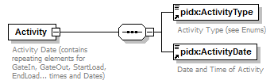
namespace | http://www.pidx.org/schema/ds/v5.02
properties | content complex
children | pidx:ActivityType pidx:ActivityDate
used by | elements DetailDates DocumentDates  complexType PostingData
annotation | documentation  Activity Date (contains repeating elements for GateIn, GateOut, StartLoad, EndLoad... times and Dates)
source | <element name="Activity">  <annotation>  <documentation>Activity Date (contains repeating elements for GateIn, GateOut, StartLoad, EndLoad... times and Dates)</documentation>  </annotation>  <complexType>  <sequence>  <element ref="pidx:ActivityType"/>  <element ref="pidx:ActivityDate">  <annotation>  <documentation>Date and Time of Activity</documentation>  </annotation>  </element>  </sequence>  </complexType>  </element>

element ActivityDate
diagram | 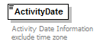
namespace | http://www.pidx.org/schema/ds/v5.02
type | dateTime
properties | content simple
used by | element Activity
annotation | documentation  Activity Date Information exclude time zone
source | <element name="ActivityDate" type="dateTime">  <annotation>  <documentation>Activity Date Information exclude time zone</documentation>  </annotation>  </element>

element ActivityType
diagram | 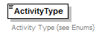
namespace | http://www.pidx.org/schema/ds/v5.02
type | pidx:ActivityTypeEnum
properties | content simple
used by | element Activity
facets | enumeration ArchiveDate  enumeration BookStart  enumeration BookEnd  enumeration BayIn  enumeration BayOut  enumeration DocPrint  enumeration EndLoad  enumeration EstDeliveryStart  enumeration EstDeliveryEnd  enumeration EstPickupDate  enumeration EstStartLoad  enumeration ExpireDate  enumeration GateIn  enumeration GateOut  enumeration Staging  enumeration StartLoad  enumeration ValidDate  enumeration WeighIn  enumeration WeightOut
annotation | documentation  Activity Type (see Enums)
source | <element name="ActivityType" type="pidx:ActivityTypeEnum">  <annotation>  <documentation>Activity Type (see Enums)</documentation>  </annotation>  </element>

element AddressLine
diagram | 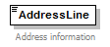
namespace | http://www.pidx.org/schema/ds/v5.02
type | string
properties | content simple
used by | element Location  complexType PartnerInformation
annotation | documentation  Address information
source | <element name="AddressLine" type="string">  <annotation>  <documentation>Address information</documentation>  </annotation>  </element>

element Agency
diagram | 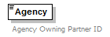
namespace | http://www.pidx.org/schema/ds/v5.02
type | string
properties | content simple
used by | element Location  complexType PartnerInformation
annotation | documentation  Agency Owning Partner ID
source | <element name="Agency" type="string">  <annotation>  <documentation>Agency Owning Partner ID</documentation>  </annotation>  </element>

element Agent
diagram | 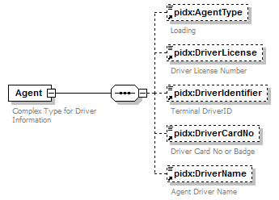
namespace | http://www.pidx.org/schema/ds/v5.02
properties | content complex
children | pidx:AgentType pidx:DriverLicense pidx:DriverIdentifier pidx:DriverCardNo pidx:DriverName
used by | elements AuthTransport TruckDefinition/Agents Transport  complexType LoadPlanInfo
annotation | documentation  Complex Type for Driver Information
source | <element name="Agent">  <annotation>  <documentation>Complex Type for Driver Information</documentation>  </annotation>  <complexType>  <sequence>  <element ref="pidx:AgentType" minOccurs="0"/>  <element ref="pidx:DriverLicense" minOccurs="0"/>  <element ref="pidx:DriverIdentifier" minOccurs="0">  <annotation>  <documentation>Terminal DriverID</documentation>  </annotation>  </element>  <element ref="pidx:DriverCardNo" minOccurs="0">  <annotation>  <documentation>Driver Card No or Badge</documentation>  </annotation>  </element>  <element ref="pidx:DriverName" minOccurs="0"/>  </sequence>  </complexType>  </element>

element AgentDocument
diagram | 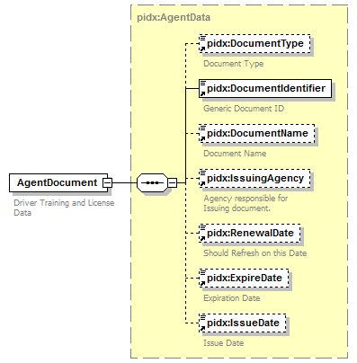
namespace | http://www.pidx.org/schema/ds/v5.02
type | pidx:AgentData
properties | content complex
children | pidx:DocumentType pidx:DocumentIdentifier pidx:DocumentName pidx:IssuingAgency pidx:RenewalDate pidx:ExpireDate pidx:IssueDate
used by | element AgentDocuments
annotation | documentation  Driver Training and License Data
source | <element name="AgentDocument" type="pidx:AgentData">  <annotation>  <documentation>Driver Training and License Data </documentation>  </annotation>  </element>

element AgentDocuments
diagram | 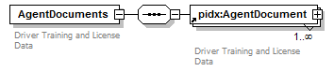
namespace | http://www.pidx.org/schema/ds/v5.02
properties | content complex
children | pidx:AgentDocument
annotation | documentation  Driver Training and License Data
source | <element name="AgentDocuments">  <annotation>  <documentation>Driver Training and License Data</documentation>  </annotation>  <complexType>  <sequence>  <element ref="pidx:AgentDocument" maxOccurs="unbounded"/>  </sequence>  </complexType>  </element>

element AgentType
diagram | 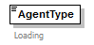
namespace | http://www.pidx.org/schema/ds/v5.02
type | pidx:AgentTypeEnum
properties | content simple  default LoadingAgent
used by | element Agent
facets | enumeration DeliveryAgent  enumeration LoadingAgent
annotation | documentation  Loading
source | <element name="AgentType" type="pidx:AgentTypeEnum" default="LoadingAgent">  <annotation>  <documentation>Loading</documentation>  </annotation>  </element>

element AllocationReserve
diagram | 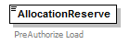
namespace | http://www.pidx.org/schema/ds/v5.02
type | pidx:YesNo
properties | content simple  default No
used by | element AuthorizationSetting
facets | enumeration Yes  enumeration No
annotation | documentation  PreAuthorize Load
source | <element name="AllocationReserve" type="pidx:YesNo" default="No">  <annotation>  <documentation>PreAuthorize Load</documentation>  </annotation>  </element>

element annotation
diagram | 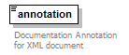
namespace | http://www.pidx.org/schema/ds/v5.02
type | string
properties | content simple
annotation | documentation  Documentation Annotation for XML document
source | <element name="annotation" type="string">  <annotation>  <documentation>Documentation Annotation for XML document</documentation>  </annotation>  </element>

element Authorization
diagram | 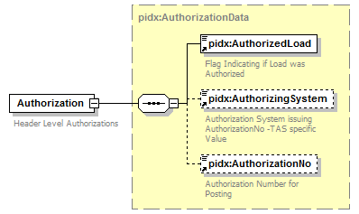
namespace | http://www.pidx.org/schema/ds/v5.02
type | pidx:AuthorizationData
properties | content complex
children | pidx:AuthorizedLoad pidx:AuthorizingSystem pidx:AuthorizationNo
used by | elements AuthorizationSetting DocumentLineItem  complexTypes PMResponseSucessData PostingData
annotation | documentation  Header Level Authorizations
source | <element name="Authorization" type="pidx:AuthorizationData">  <annotation>  <documentation>Header Level Authorizations</documentation>  </annotation>  </element>

element AuthorizationNo
diagram | 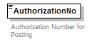
namespace | http://www.pidx.org/schema/ds/v5.02
type | string
properties | content simple
used by | element ResponseInfo  complexType AuthorizationData
annotation | documentation  Authorization Number for Posting
source | <element name="AuthorizationNo" type="string">  <annotation>  <documentation>Authorization Number for Posting</documentation>  </annotation>  </element>

element AuthorizationSetting
diagram | 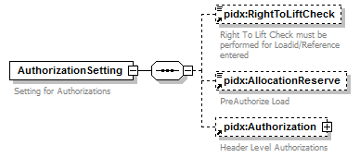
namespace | http://www.pidx.org/schema/ds/v5.02
properties | content complex
children | pidx:RightToLiftCheck pidx:AllocationReserve pidx:Authorization
used by | element DocumentHeader
annotation | documentation  Setting for Authorizations
source | <element name="AuthorizationSetting">  <annotation>  <documentation>Setting for Authorizations</documentation>  </annotation>  <complexType>  <sequence>  <element ref="pidx:RightToLiftCheck" minOccurs="0"/>  <element ref="pidx:AllocationReserve" minOccurs="0"/>  <element ref="pidx:Authorization" minOccurs="0"/>  </sequence>  </complexType>  </element>

element AuthorizedLoad
diagram | 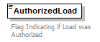
namespace | http://www.pidx.org/schema/ds/v5.02
type | restriction of string
properties | content simple  default Authorized
used by | complexType AuthorizationData
facets | enumeration Authorized  enumeration UnAuthorized  enumeration NoLoad
annotation | documentation  Flag Indicating if Load was Authorized
source | <element name="AuthorizedLoad" default="Authorized">  <annotation>  <documentation>Flag Indicating if Load was Authorized</documentation>  </annotation>  <simpleType>  <restriction base="string">  <enumeration value="Authorized"/>  <enumeration value="UnAuthorized"/>  <enumeration value="NoLoad">  <annotation>  <documentation>NoLoad indicates a cancellation of an authorized load. The NoLoad flag will cause all hold amounts to be removed.</documentation>  </annotation>  </enumeration>  </restriction>  </simpleType>  </element>

element AuthorizingSystem
diagram | 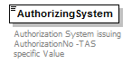
namespace | http://www.pidx.org/schema/ds/v5.02
type | string
properties | content simple
used by | element ResponseInfo  complexType AuthorizationData
annotation | documentation  Authorization System issuing AuthorizationNo -TAS specific Value
source | <element name="AuthorizingSystem" type="string">  <annotation>  <documentation>Authorization System issuing AuthorizationNo -TAS specific Value</documentation>  </annotation>  </element>

element AuthParties
diagram | 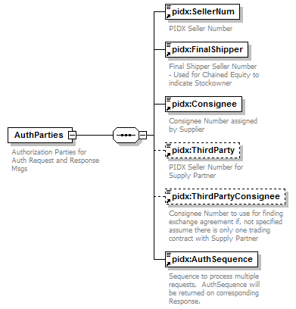
namespace | http://www.pidx.org/schema/ds/v5.02
properties | content complex
children | pidx:SellerNum pidx:FinalShipper pidx:Consignee pidx:ThirdParty pidx:ThirdPartyConsignee pidx:AuthSequence
used by | complexTypes AuthRequestData AuthResponseData
annotation | documentation  Authorization Parties for Auth Request and Response Msgs
source | <element name="AuthParties">  <annotation>  <documentation>Authorization Parties for Auth Request and Response Msgs</documentation>  </annotation>  <complexType>  <sequence>  <element ref="pidx:SellerNum"/>  <element ref="pidx:FinalShipper"/>  <element ref="pidx:Consignee"/>  <element ref="pidx:ThirdParty" minOccurs="0"/>  <element ref="pidx:ThirdPartyConsignee" minOccurs="0"/>  <element ref="pidx:AuthSequence"/>  </sequence>  </complexType>  </element>

element AuthRequests
diagram | 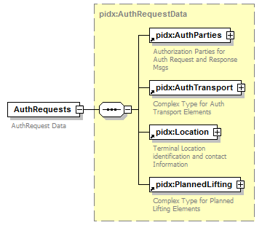
namespace | http://www.pidx.org/schema/ds/v5.02
type | pidx:AuthRequestData
properties | content complex
children | pidx:AuthParties pidx:AuthTransport pidx:Location pidx:PlannedLifting
annotation | documentation  AuthRequest Data
source | <element name="AuthRequests" type="pidx:AuthRequestData">  <annotation>  <documentation>AuthRequest Data</documentation>  </annotation>  </element>

element AuthResponses
diagram | 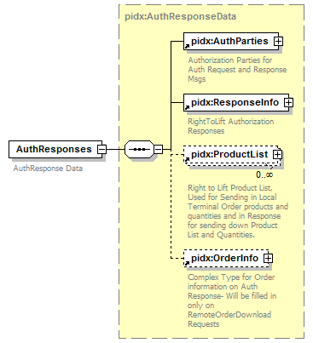
namespace | http://www.pidx.org/schema/ds/v5.02
type | pidx:AuthResponseData
properties | content complex
children | pidx:AuthParties pidx:ResponseInfo pidx:ProductList pidx:OrderInfo
annotation | documentation  AuthResponse Data
source | <element name="AuthResponses" type="pidx:AuthResponseData">  <annotation>  <documentation>AuthResponse Data</documentation>  </annotation>  </element>

element AuthSequence
diagram | 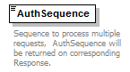
namespace | http://www.pidx.org/schema/ds/v5.02
type | integer
properties | content simple  default 1
used by | element AuthParties
annotation | documentation  Sequence to process multiple requests, AuthSequence will be returned on corresponding Response.
source | <element name="AuthSequence" type="integer" default="1">  <annotation>  <documentation>Sequence to process multiple requests, AuthSequence will be returned on corresponding Response.</documentation>  </annotation>  </element>

element AuthTransport
diagram | 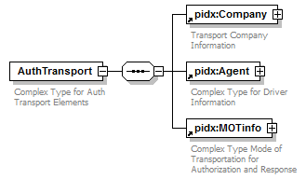
namespace | http://www.pidx.org/schema/ds/v5.02
properties | content complex
children | pidx:Company pidx:Agent pidx:MOTinfo
used by | complexType AuthRequestData
annotation | documentation  Complex Type for Auth Transport Elements
source | <element name="AuthTransport">  <annotation>  <documentation>Complex Type for Auth Transport Elements</documentation>  </annotation>  <complexType>  <sequence>  <element ref="pidx:Company"/>  <element ref="pidx:Agent"/>  <element ref="pidx:MOTinfo"/>  </sequence>  </complexType>  </element>

element BeginPeriod
diagram | 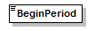
namespace | http://www.pidx.org/schema/ds/v5.02
type | date
properties | content simple
used by | complexType QuantityScheduleType
source | <element name="BeginPeriod" type="date"/>

element BlendAlteration
diagram | 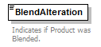
namespace | http://www.pidx.org/schema/ds/v5.02
type | restriction of string
properties | content simple  default 00
used by | element Product
facets | enumeration 00  enumeration 01  enumeration 02  enumeration 03  enumeration 04  enumeration 05
annotation | documentation  Indicates if Product was Blended.
source | <element name="BlendAlteration" default="00">  <annotation>  <documentation>Indicates if Product was Blended.</documentation>  </annotation>  <simpleType>  <restriction base="string">  <enumeration value="00">  <annotation>  <documentation>Unused - Additives specified in Recipes Section</documentation>  </annotation>  </enumeration>  <enumeration value="01">  <annotation>  <documentation>Product was Truck Blended with another product </documentation>  </annotation>  </enumeration>  <enumeration value="02">  <annotation>  <documentation>Product contains Additive </documentation>  </annotation>  </enumeration>  <enumeration value="03">  <annotation>  <documentation>Product was Blended and contain Additive </documentation>  </annotation>  </enumeration>  <enumeration value="04">  <annotation>  <documentation>Product contains Detergent Additive</documentation>  </annotation>  </enumeration>  <enumeration value="05">  <annotation>  <documentation>Product was Blended and contains Detergent Additive</documentation>  </annotation>  </enumeration>  </restriction>  </simpleType>  </element>

element BlockIndicator
diagram | 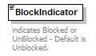
namespace | http://www.pidx.org/schema/ds/v5.02
type | pidx:BlockValues
properties | content simple  default Unblocked
used by | elements DocumentHeader DocumentLineItem
facets | enumeration Blocked  enumeration Unblocked
annotation | documentation  indicates Blocked or UnBlocked - Default is Unblocked.
source | <element name="BlockIndicator" type="pidx:BlockValues" default="Unblocked">  <annotation>  <documentation>indicates Blocked or UnBlocked - Default is Unblocked.</documentation>  </annotation>  </element>

element Body
diagram | 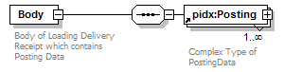
namespace | http://www.pidx.org/schema/ds/v5.02
properties | content complex
children | pidx:Posting
annotation | documentation  Body of Loading Delivery Receipt which contains Posting Data
source | <element name="Body">  <annotation>  <documentation>Body of Loading Delivery Receipt which contains Posting Data</documentation>  </annotation>  <complexType>  <sequence>  <element ref="pidx:Posting" maxOccurs="unbounded"/>  </sequence>  </complexType>  </element>

element BOLRespErrorCode
diagram | 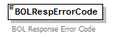
namespace | http://www.pidx.org/schema/ds/v5.02
type | string
properties | content simple
used by | element BOLResponse
annotation | documentation  BOL Response Error Code
source | <element name="BOLRespErrorCode" type="string">  <annotation>  <documentation>BOL Response Error Code</documentation>  </annotation>  </element>

element BOLRespErrorDescription
diagram | 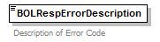
namespace | http://www.pidx.org/schema/ds/v5.02
type | string
properties | content simple
used by | element BOLResponse
annotation | documentation  Description of Error Code
source | <element name="BOLRespErrorDescription" type="string">  <annotation>  <documentation>Description of Error Code</documentation>  </annotation>  </element>

element BOLResponse
diagram | 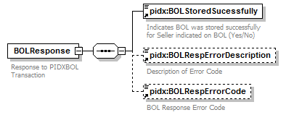
namespace | http://www.pidx.org/schema/ds/v5.02
properties | content complex
children | pidx:BOLStoredSucessfully pidx:BOLRespErrorDescription pidx:BOLRespErrorCode
annotation | documentation  Response to PIDXBOL Transaction
source | <element name="BOLResponse">  <annotation>  <documentation>Response to PIDXBOL Transaction</documentation>  </annotation>  <complexType>  <sequence>  <element ref="pidx:BOLStoredSucessfully"/>  <element ref="pidx:BOLRespErrorDescription" minOccurs="0"/>  <element ref="pidx:BOLRespErrorCode" minOccurs="0"/>  </sequence>  </complexType>  </element>

element BOLStoredSucessfully
diagram | 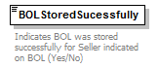
namespace | http://www.pidx.org/schema/ds/v5.02
type | restriction of string
properties | content simple
used by | element BOLResponse
facets | enumeration Yes  enumeration No
annotation | documentation  Indicates BOL was stored successfully for Seller indicated on BOL (Yes/No)
source | <element name="BOLStoredSucessfully">  <annotation>  <documentation>Indicates BOL was stored successfully for Seller indicated on BOL (Yes/No)</documentation>  </annotation>  <simpleType>  <restriction base="string">  <enumeration value="Yes"/>  <enumeration value="No"/>  </restriction>  </simpleType>  </element>

element BOLType
diagram | 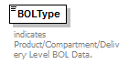
namespace | http://www.pidx.org/schema/ds/v5.02
type | pidx:BOLTypeEnum
properties | content simple
used by | complexType DocumentData
facets | enumeration Product  enumeration Compartment  enumeration Delivery
annotation | documentation  indicates Product/Compartment/Delivery Level BOL Data.
source | <element name="BOLType" type="pidx:BOLTypeEnum">  <annotation>  <documentation>indicates Product/Compartment/Delivery Level BOL Data.</documentation>  </annotation>  </element>

element CarrierIdentifier
diagram | 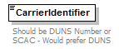
namespace | http://www.pidx.org/schema/ds/v5.02
type | string
properties | content simple
annotation | documentation  Should be DUNS Number or SCAC - Would prefer DUNS
source | <element name="CarrierIdentifier" type="string">  <annotation>  <documentation>Should be DUNS Number or SCAC - Would prefer DUNS</documentation>  </annotation>  </element>

element CityName
diagram | 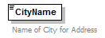
namespace | http://www.pidx.org/schema/ds/v5.02
type | string
properties | content simple
used by | element Location  complexType PartnerInformation
annotation | documentation  Name of City for Address
source | <element name="CityName" type="string">  <annotation>  <documentation>Name of City for Address</documentation>  </annotation>  </element>

element Company
diagram | 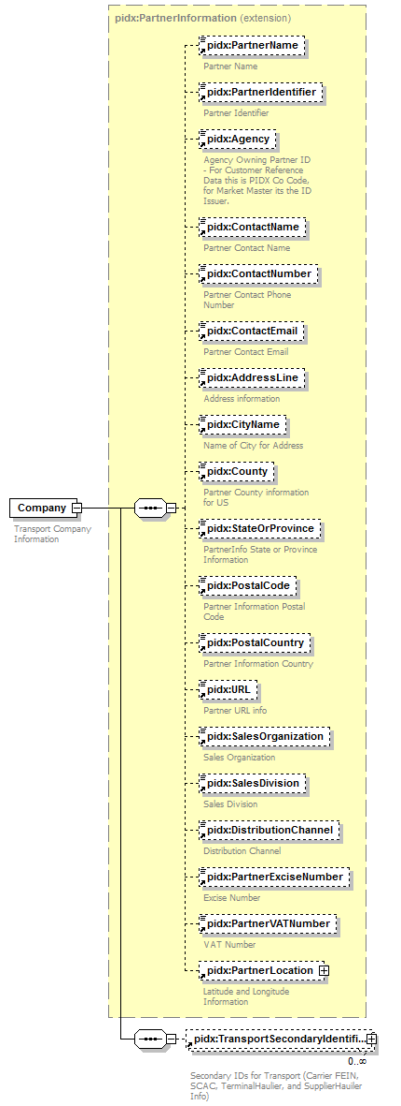
namespace | http://www.pidx.org/schema/ds/v5.02
type | extension of pidx:PartnerInformation
properties | content complex
children | pidx:PartnerName pidx:PartnerIdentifier pidx:Agency pidx:ContactName pidx:ContactNumber pidx:ContactEmail pidx:AddressLine pidx:CityName pidx:County pidx:StateOrProvince pidx:PostalCode pidx:PostalCountry pidx:URL pidx:SalesOrganization pidx:SalesDivision pidx:DistributionChannel pidx:PartnerExciseNumber pidx:PartnerVATNumber pidx:PartnerLocation pidx:TransportSecondaryIdentifier
used by | elements AuthTransport Transport  complexType LoadPlanInfo
annotation | documentation  Transport Company Information
source | <element name="Company">  <annotation>  <documentation>Transport Company Information</documentation>  </annotation>  <complexType>  <complexContent>  <extension base="pidx:PartnerInformation">  <sequence>  <element ref="pidx:TransportSecondaryIdentifier" minOccurs="0" maxOccurs="unbounded"/>  </sequence>  </extension>  </complexContent>  </complexType>  </element>

element Compartment
diagram | 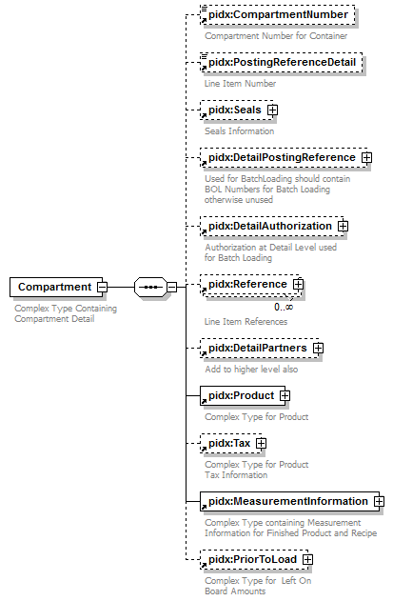
namespace | http://www.pidx.org/schema/ds/v5.02
properties | content complex
children | pidx:CompartmentNumber pidx:PostingReferenceDetail pidx:Seals pidx:DetailPostingReference pidx:DetailAuthorization pidx:Reference pidx:DetailPartners pidx:Product pidx:Tax pidx:MeasurementInformation pidx:PriorToLoad
used by | elements Compartments Content
annotation | documentation  Complex Type Containing Compartment Detail
source | <element name="Compartment">  <annotation>  <documentation>Complex Type Containing Compartment Detail</documentation>  </annotation>  <complexType>  <sequence>  <element ref="pidx:CompartmentNumber" minOccurs="0"/>  <element ref="pidx:PostingReferenceDetail" minOccurs="0">  <annotation>  <documentation>Line Item Number</documentation>  </annotation>  </element>  <element ref="pidx:Seals" minOccurs="0"/>  <element ref="pidx:DetailPostingReference" minOccurs="0"/>  <element ref="pidx:DetailAuthorization" minOccurs="0"/>  <element ref="pidx:Reference" minOccurs="0" maxOccurs="unbounded"/>  <element ref="pidx:DetailPartners" minOccurs="0">  <annotation>  <documentation>Add to higher level also</documentation>  </annotation>  </element>  <element ref="pidx:Product"/>  <element ref="pidx:Tax" minOccurs="0"/>  <element ref="pidx:MeasurementInformation"/>  <element ref="pidx:PriorToLoad" minOccurs="0"/>  </sequence>  </complexType>  </element>

element CompartmentNumber
diagram | 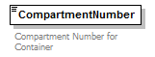
namespace | http://www.pidx.org/schema/ds/v5.02
type | string
properties | content simple
used by | elements Compartment LoadCompartment ProductList  complexType TankDeliveryData
annotation | documentation  Compartment Number for Container
source | <element name="CompartmentNumber" type="string">  <annotation>  <documentation>Compartment Number for Container</documentation>  </annotation>  </element>

element CompartmentQuantity
diagram | 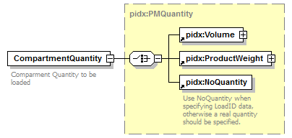
namespace | http://www.pidx.org/schema/ds/v5.02
type | pidx:PMQuantity
properties | content complex
children | pidx:Volume pidx:ProductWeight pidx:NoQuantity
used by | element LoadCompartment
annotation | documentation  Comparment Quantity to be loaded
source | <element name="CompartmentQuantity" type="pidx:PMQuantity">  <annotation>  <documentation>Comparment Quantity to be loaded</documentation>  </annotation>  </element>

element Compartments
diagram | 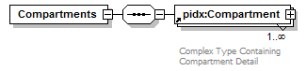
namespace | http://www.pidx.org/schema/ds/v5.02
properties | content complex
children | pidx:Compartment
used by | element LoadingPart
source | <element name="Compartments">  <complexType>  <sequence>  <element ref="pidx:Compartment" maxOccurs="unbounded"/>  </sequence>  </complexType>  </element>

element CompartmentSpecification
diagram | 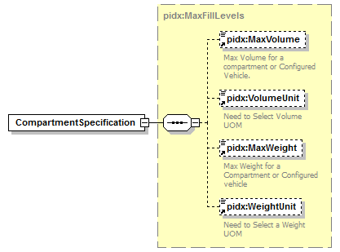
namespace | http://www.pidx.org/schema/ds/v5.02
type | pidx:MaxFillLevels
properties | content complex
children | pidx:MaxVolume pidx:VolumeUnit pidx:MaxWeight pidx:WeightUnit
used by | element LoadCompartment
source | <element name="CompartmentSpecification" type="pidx:MaxFillLevels"/>

element ComplementaryInfLanguage
diagram | 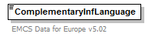
namespace | http://www.pidx.org/schema/ds/v5.02
type | string
properties | content simple
used by | element EMCS
annotation | documentation  EMCS Data for Europe v5.02
source | <element name="ComplementaryInfLanguage" type="string">  <annotation>  <documentation>EMCS Data for Europe v5.02</documentation>  </annotation>  </element>

element ComplementaryInformation
diagram | 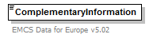
namespace | http://www.pidx.org/schema/ds/v5.02
type | string
properties | content simple
used by | element EMCS
annotation | documentation  EMCS Data for Europe v5.02
source | <element name="ComplementaryInformation" type="string">  <annotation>  <documentation>EMCS Data for Europe v5.02</documentation>  </annotation>  </element>

element Component
diagram | 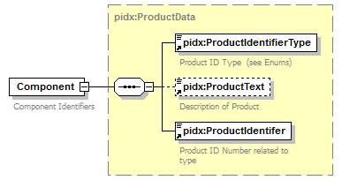
namespace | http://www.pidx.org/schema/ds/v5.02
type | pidx:ProductData
properties | content complex
children | pidx:ProductIdentifierType pidx:ProductText pidx:ProductIdentifer
used by | element Recipe
annotation | documentation  Component Identifiers
source | <element name="Component" type="pidx:ProductData">  <annotation>  <documentation>Component Identifiers</documentation>  </annotation>  </element>

element ComponentContract
diagram | 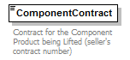
namespace | http://www.pidx.org/schema/ds/v5.02
type | string
properties | content simple
used by | element Recipe
annotation | documentation  Contract for the Component Product being Lifted (seller's contract number)
source | <element name="ComponentContract" type="string">  <annotation>  <documentation>Contract for the Component Product being Lifted (seller's contract number)</documentation>  </annotation>  </element>

element ComponentId
diagram | 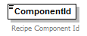
namespace | http://www.pidx.org/schema/ds/v5.02
type | string
properties | content simple
annotation | documentation  Recipe Component Id
source | <element name="ComponentId" type="string">  <annotation>  <documentation>Recipe Component Id</documentation>  </annotation>  </element>

element ComponentText
diagram | 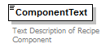
namespace | http://www.pidx.org/schema/ds/v5.02
type | string
properties | content simple
annotation | documentation  Text Description of Recipe Component
source | <element name="ComponentText" type="string">  <annotation>  <documentation>Text Description of Recipe Component</documentation>  </annotation>  </element>

element ComponentType
diagram | 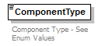
namespace | http://www.pidx.org/schema/ds/v5.02
type | restriction of string
properties | content simple
used by | element Recipe
facets | enumeration BaseProduct  enumeration BioComponent  enumeration Additive  enumeration Dye  enumeration Other
annotation | documentation  Component Type - See Enum Values
source | <element name="ComponentType">  <annotation>  <documentation>Component Type - See Enum Values</documentation>  </annotation>  <simpleType>  <restriction base="string">  <enumeration value="BaseProduct">  <annotation>  <documentation>Recipe Base Product</documentation>  </annotation>  </enumeration>  <enumeration value="BioComponent"/>  <enumeration value="Additive">  <annotation>  <documentation>Recipe Additive</documentation>  </annotation>  </enumeration>  <enumeration value="Dye">  <annotation>  <documentation>Recipe Dye</documentation>  </annotation>  </enumeration>  <enumeration value="Other">  <annotation>  <documentation>Recipe Other - Partner Agreed upon definition</documentation>  </annotation>  </enumeration>  </restriction>  </simpleType>  </element>

element ConfiguredVehicle
diagram | 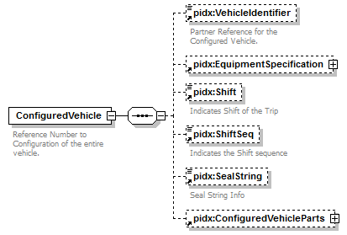
namespace | http://www.pidx.org/schema/ds/v5.02
properties | content complex
children | pidx:VehicleIdentifier pidx:EquipmentSpecification pidx:Shift pidx:ShiftSeq pidx:SealString pidx:ConfiguredVehicleParts
used by | elements ConfiguredVehicles ModeOfTransport  complexType LoadPlanInfo
annotation | documentation  Reference Number to Configuration of the entire vehicle.
source | <element name="ConfiguredVehicle">  <annotation>  <documentation>Reference Number to Configuration of the entire vehicle.</documentation>  </annotation>  <complexType>  <sequence>  <element ref="pidx:VehicleIdentifier" minOccurs="0"/>  <element ref="pidx:EquipmentSpecification" minOccurs="0"/>  <element ref="pidx:Shift" minOccurs="0"/>  <element ref="pidx:ShiftSeq" minOccurs="0"/>  <element ref="pidx:SealString" minOccurs="0"/>  <element ref="pidx:ConfiguredVehicleParts" minOccurs="0"/>  </sequence>  </complexType>  </element>

element ConfiguredVehicleParts
diagram | 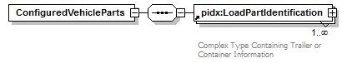
namespace | http://www.pidx.org/schema/ds/v5.02
properties | content complex
children | pidx:LoadPartIdentification
used by | element ConfiguredVehicle
source | <element name="ConfiguredVehicleParts">  <complexType>  <sequence>  <element ref="pidx:LoadPartIdentification" maxOccurs="unbounded"/>  </sequence>  </complexType>  </element>

element ConfiguredVehicles
diagram | 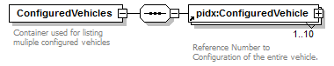
namespace | http://www.pidx.org/schema/ds/v5.02
properties | content complex
children | pidx:ConfiguredVehicle
used by | complexType TruckDefinition
annotation | documentation  Container used for listing muliple configured vehicles
source | <element name="ConfiguredVehicles">  <annotation>  <documentation>Container used for listing muliple configured vehicles</documentation>  </annotation>  <complexType>  <sequence>  <element ref="pidx:ConfiguredVehicle" maxOccurs="10"/>  </sequence>  </complexType>  </element>

element ConnectingTrack
diagram | 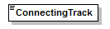
namespace | http://www.pidx.org/schema/ds/v5.02
type | string
properties | content simple
used by | complexType RailDefinition
source | <element name="ConnectingTrack" type="string"/>

element Consignee
diagram | 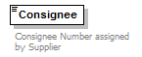
namespace | http://www.pidx.org/schema/ds/v5.02
type | string
properties | content simple
used by | element AuthParties
annotation | documentation  Consignee Number assigned by Supplier
source | <element name="Consignee" type="string">  <annotation>  <documentation>Consignee Number assigned by Supplier</documentation>  </annotation>  </element>

element ConsigneeCountry
diagram | 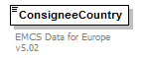
namespace | http://www.pidx.org/schema/ds/v5.02
type | string
properties | content simple
used by | element EMCS
annotation | documentation  EMCS Data for Europe v5.02
source | <element name="ConsigneeCountry" type="string">  <annotation>  <documentation>EMCS Data for Europe v5.02</documentation>  </annotation>  </element>

element ConsigneeLanguage
diagram | 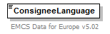
namespace | http://www.pidx.org/schema/ds/v5.02
type | string
properties | content simple
used by | element EMCS
annotation | documentation  EMCS Data for Europe v5.02
source | <element name="ConsigneeLanguage" type="string">  <annotation>  <documentation>EMCS Data for Europe v5.02</documentation>  </annotation>  </element>

element ConsigneeReleaseNumber
diagram | 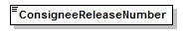
namespace | http://www.pidx.org/schema/ds/v5.02
type | string
properties | content simple
used by | element EMCS
source | <element name="ConsigneeReleaseNumber" type="string"/>

element ContactEmail
diagram | 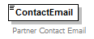
namespace | http://www.pidx.org/schema/ds/v5.02
type | string
properties | content simple
used by | element Location  complexType PartnerInformation
annotation | documentation  Partner Contact Email
source | <element name="ContactEmail" type="string">  <annotation>  <documentation>Partner Contact Email</documentation>  </annotation>  </element>

element ContactName
diagram | 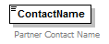
namespace | http://www.pidx.org/schema/ds/v5.02
type | string
properties | content simple
used by | element Location  complexType PartnerInformation
annotation | documentation  Partner Contact Name
source | <element name="ContactName" type="string">  <annotation>  <documentation>Partner Contact Name</documentation>  </annotation>  </element>

element ContactNumber
diagram | 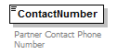
namespace | http://www.pidx.org/schema/ds/v5.02
type | string
properties | content simple
used by | element Location  complexType PartnerInformation
annotation | documentation  Partner Contact Phone Number
source | <element name="ContactNumber" type="string">  <annotation>  <documentation>Partner Contact Phone Number</documentation>  </annotation>  </element>

element ContainerSize
diagram | 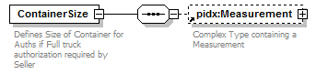
namespace | http://www.pidx.org/schema/ds/v5.02
properties | content complex
children | pidx:Measurement
used by | element MOTinfo
annotation | documentation  Defines Size of Container for Auths if Full truck authorization required by Seller
source | <element name="ContainerSize">  <annotation>  <documentation>Defines Size of Container for Auths if Full truck authorization required by Seller</documentation>  </annotation>  <complexType>  <sequence>  <element ref="pidx:Measurement" minOccurs="0"/>  </sequence>  </complexType>  </element>

element Content
diagram | 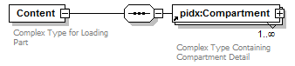
namespace | http://www.pidx.org/schema/ds/v5.02
properties | content complex
children | pidx:Compartment
annotation | documentation  Complex Type for Loading Part
source | <element name="Content">  <annotation>  <documentation>Complex Type for Loading Part</documentation>  </annotation>  <complexType>  <sequence>  <element ref="pidx:Compartment" maxOccurs="unbounded"/>  </sequence>  </complexType>  </element>

element County
diagram | 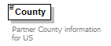
namespace | http://www.pidx.org/schema/ds/v5.02
type | string
properties | content simple
used by | element Location  complexType PartnerInformation
annotation | documentation  Partner County information for US
source | <element name="County" type="string">  <annotation>  <documentation>Partner County information for US</documentation>  </annotation>  </element>

element Currency
diagram | 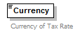
namespace | http://www.pidx.org/schema/ds/v5.02
type | string
properties | content simple
used by | element TaxDetail
annotation | documentation  Currency of Tax Rate
source | <element name="Currency" type="string">  <annotation>  <documentation>Currency of Tax Rate  </documentation>  </annotation>  </element>

element DateTime
diagram | 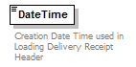
namespace | http://www.pidx.org/schema/ds/v5.02
type | dateTime
properties | content simple
used by | element Header
annotation | documentation  Creation Date Time used in Loading Delivery Receipt Header
source | <element name="DateTime" type="dateTime">  <annotation>  <documentation>Creation Date Time used in Loading Delivery Receipt Header</documentation>  </annotation>  </element>

element Density
diagram | 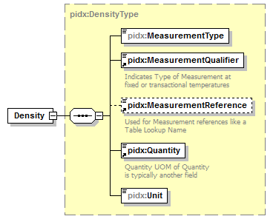
namespace | http://www.pidx.org/schema/ds/v5.02
type | pidx:DensityType
properties | content complex
children | pidx:MeasurementType pidx:MeasurementQualifier pidx:MeasurementReference pidx:Quantity pidx:Unit
source | <element name="Density" type="pidx:DensityType"/>

element DenyCode
diagram | 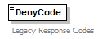
namespace | http://www.pidx.org/schema/ds/v5.02
type | restriction of string
properties | content simple
used by | element ResponseInfo
annotation | documentation  Legacy Response Codes
source | <element name="DenyCode">  <annotation>  <documentation>Legacy Response Codes</documentation>  </annotation>  <simpleType>  <restriction base="string"/>  </simpleType>  </element>

element DenyDescription
diagram | 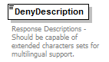
namespace | http://www.pidx.org/schema/ds/v5.02
type | string
properties | content simple
used by | element ResponseInfo
annotation | documentation  Response Descriptions - Should be capable of extended characters sets for multilingual support.
source | <element name="DenyDescription" type="string">  <annotation>  <documentation>Response Descriptions - Should be capable of extended characters sets for multilingual support. </documentation>  </annotation>  </element>

element DenySellerMsg
diagram | 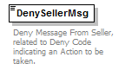
namespace | http://www.pidx.org/schema/ds/v5.02
type | string
properties | content simple
used by | element ResponseInfo
annotation | documentation  Deny Message From Seller, related to Deny Code indicating an Action to be taken.
source | <element name="DenySellerMsg" type="string">  <annotation>  <documentation>Deny Message From Seller, related to Deny Code indicating an Action to be taken.</documentation>  </annotation>  </element>

element DestinationIdentifier
diagram | 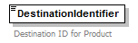
namespace | http://www.pidx.org/schema/ds/v5.02
type | string
properties | content simple
used by | element ProductList
annotation | documentation  Destination ID for Product
source | <element name="DestinationIdentifier" type="string">  <annotation>  <documentation>Destination ID for Product</documentation>  </annotation>  </element>

element DestinationLanguage
diagram | 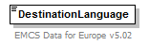
namespace | http://www.pidx.org/schema/ds/v5.02
type | string
properties | content simple
used by | element EMCS
annotation | documentation  EMCS Data for Europe v5.02
source | <element name="DestinationLanguage" type="string">  <annotation>  <documentation>EMCS Data for Europe v5.02</documentation>  </annotation>  </element>

element DestinationTypeCode
diagram | 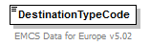
namespace | http://www.pidx.org/schema/ds/v5.02
type | pidx:EMCSDestinationEnum
properties | content simple
used by | element EMCS
facets | enumeration 1  enumeration 2  enumeration 3  enumeration 4  enumeration 5  enumeration 6  enumeration 8
annotation | documentation  EMCS Data for Europe v5.02
source | <element name="DestinationTypeCode" type="pidx:EMCSDestinationEnum">  <annotation>  <documentation>EMCS Data for Europe v5.02</documentation>  </annotation>  </element>

element DetailAuthorization
diagram | 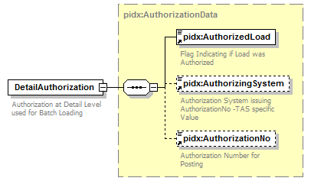
namespace | http://www.pidx.org/schema/ds/v5.02
type | pidx:AuthorizationData
properties | content complex
children | pidx:AuthorizedLoad pidx:AuthorizingSystem pidx:AuthorizationNo
used by | element Compartment
annotation | documentation  Authorization at Detail Level used for Batch Loading
source | <element name="DetailAuthorization" type="pidx:AuthorizationData">  <annotation>  <documentation>Authorization at Detail Level used for Batch Loading</documentation>  </annotation>  </element>

element DetailDates
diagram | 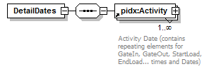
namespace | http://www.pidx.org/schema/ds/v5.02
properties | content complex
children | pidx:Activity
used by | element DocumentLineItem
source | <element name="DetailDates">  <complexType>  <sequence>  <element ref="pidx:Activity" maxOccurs="unbounded"/>  </sequence>  </complexType>  </element>

element DetailPartners
diagram | 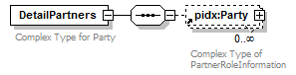
namespace | http://www.pidx.org/schema/ds/v5.02
properties | content complex
children | pidx:Party
used by | elements Compartment DocumentLineItem
annotation | documentation  Complex Type for Party
source | <element name="DetailPartners">  <annotation>  <documentation>Complex Type for Party</documentation>  </annotation>  <complexType>  <sequence>  <element ref="pidx:Party" minOccurs="0" maxOccurs="unbounded"/>  </sequence>  </complexType>  </element>

element DetailPostingReference
diagram | 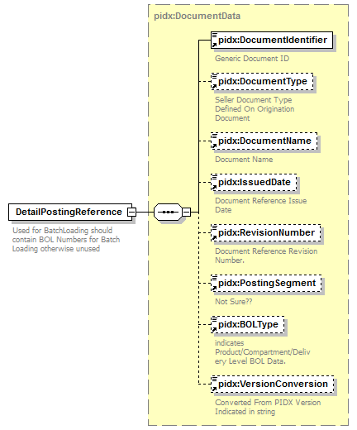
namespace | http://www.pidx.org/schema/ds/v5.02
type | pidx:DocumentData
properties | content complex
children | pidx:DocumentIdentifier pidx:DocumentType pidx:DocumentName pidx:IssuedDate pidx:RevisionNumber pidx:PostingSegment pidx:BOLType pidx:VersionConversion
used by | element Compartment
annotation | documentation  Used for BatchLoading should contain BOL Numbers for Batch Loading otherwise unused
source | <element name="DetailPostingReference" type="pidx:DocumentData">  <annotation>  <documentation>Used for BatchLoading should contain BOL Numbers for Batch Loading otherwise unused</documentation>  </annotation>  </element>

element DetailReferences
diagram | 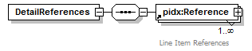
namespace | http://www.pidx.org/schema/ds/v5.02
properties | content complex
children | pidx:Reference
used by | elements DocumentLineItem LoadCompartment
source | <element name="DetailReferences">  <complexType>  <sequence>  <element ref="pidx:Reference" maxOccurs="unbounded"/>  </sequence>  </complexType>  </element>

element DisplayList
diagram | 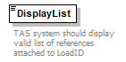
namespace | http://www.pidx.org/schema/ds/v5.02
type | pidx:YesNo
properties | content simple  default No
used by | complexType SecondaryLoadReferenceCT
facets | enumeration Yes  enumeration No
annotation | documentation  TAS system should display valid list of references attached to LoadID
source | <element name="DisplayList" type="pidx:YesNo" default="No">  <annotation>  <documentation>TAS system should display valid list of references attached to LoadID</documentation>  </annotation>  </element>

element DistributionChannel
diagram | 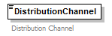
namespace | http://www.pidx.org/schema/ds/v5.02
type | string
properties | content simple
used by | complexType PartnerInformation
annotation | documentation  Distribution Channel
source | <element name="DistributionChannel" type="string">  <annotation>  <documentation>Distribution Channel</documentation>  </annotation>  </element>

element Document
diagram | 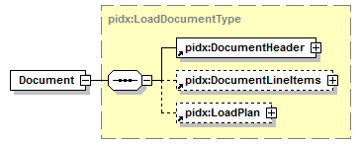
namespace | http://www.pidx.org/schema/ds/v5.02
type | pidx:LoadDocumentType
properties | content complex
children | pidx:DocumentHeader pidx:DocumentLineItems pidx:LoadPlan
used by | elements Documents OrderInfo
source | <element name="Document" type="pidx:LoadDocumentType"/>

element DocumentDate
diagram | 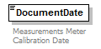
namespace | http://www.pidx.org/schema/ds/v5.02
type | dateTime
properties | content simple
used by | element MeasurementInformation
annotation | documentation  Measurements Meter Calibration Date
source | <element name="DocumentDate" type="dateTime">  <annotation>  <documentation>Measurements Meter Calibration Date</documentation>  </annotation>  </element>

element DocumentDates
diagram | 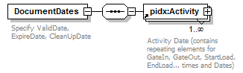
namespace | http://www.pidx.org/schema/ds/v5.02
properties | content complex
children | pidx:Activity
used by | element DocumentHeader
annotation | documentation  Specify ValidDate, ExpireDate, CleanUpDate
source | <element name="DocumentDates">  <annotation>  <documentation>Specify ValidDate, ExpireDate, CleanUpDate</documentation>  </annotation>  <complexType>  <sequence>  <element ref="pidx:Activity" maxOccurs="unbounded"/>  </sequence>  </complexType>  </element>

element DocumentHeader
diagram | 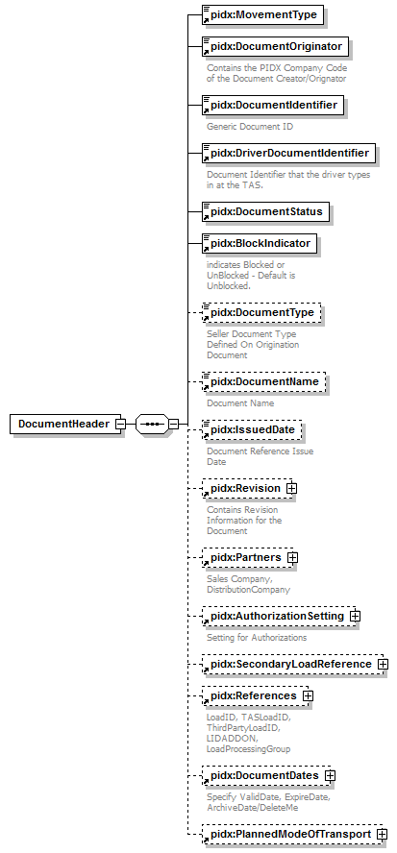
namespace | http://www.pidx.org/schema/ds/v5.02
properties | content complex
children | pidx:MovementType pidx:DocumentOriginator pidx:DocumentIdentifier pidx:DriverDocumentIdentifier pidx:DocumentStatus pidx:BlockIndicator pidx:DocumentType pidx:DocumentName pidx:IssuedDate pidx:Revision pidx:Partners pidx:AuthorizationSetting pidx:SecondaryLoadReference pidx:References pidx:DocumentDates pidx:PlannedModeOfTransport
used by | complexType LoadDocumentType
source | <element name="DocumentHeader">  <complexType>  <sequence>  <element ref="pidx:MovementType"/>  <element ref="pidx:DocumentOriginator"/>  <element ref="pidx:DocumentIdentifier"/>  <element ref="pidx:DriverDocumentIdentifier"/>  <element ref="pidx:DocumentStatus"/>  <element ref="pidx:BlockIndicator"/>  <element ref="pidx:DocumentType" minOccurs="0"/>  <element ref="pidx:DocumentName" minOccurs="0"/>  <element ref="pidx:IssuedDate" minOccurs="0"/>  <element ref="pidx:Revision" minOccurs="0"/>  <element ref="pidx:Partners" minOccurs="0">  <annotation>  <documentation>Sales Company, DistributionCompany</documentation>  </annotation>  </element>  <element ref="pidx:AuthorizationSetting" minOccurs="0"/>  <element ref="pidx:SecondaryLoadReference" minOccurs="0"/>  <element ref="pidx:References" minOccurs="0">  <annotation>  <documentation>LoadID, TASLoadID, ThirdPartyLoadID, LIDADDON, LoadProcessingGroup</documentation>  </annotation>  </element>  <element ref="pidx:DocumentDates" minOccurs="0">  <annotation>  <documentation>Specify ValidDate, ExpireDate, ArchiveDate/DeleteMe</documentation>  </annotation>  </element>  <element ref="pidx:PlannedModeOfTransport" minOccurs="0"/>  </sequence>  </complexType>  </element>

element DocumentIdentifier
diagram | 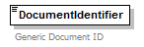
namespace | http://www.pidx.org/schema/ds/v5.02
type | string
properties | content simple
used by | elements DocumentHeader DocumentReference Header PlannedLifting ResponseInfo  complexTypes AgentData DocumentData PMResponseBody
annotation | documentation  Generic Document ID
source | <element name="DocumentIdentifier" type="string">  <annotation>  <documentation>Generic Document ID</documentation>  </annotation>  </element>

element DocumentLineItem
diagram | 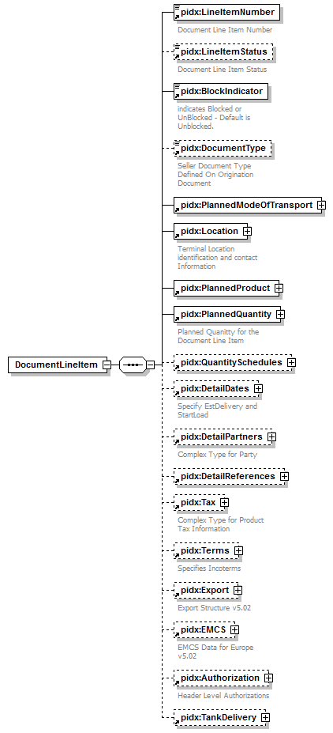
namespace | http://www.pidx.org/schema/ds/v5.02
properties | content complex
children | pidx:LineItemNumber pidx:LineItemStatus pidx:BlockIndicator pidx:DocumentType pidx:PlannedModeOfTransport pidx:Location pidx:PlannedProduct pidx:PlannedQuantity pidx:QuantitySchedules pidx:DetailDates pidx:DetailPartners pidx:DetailReferences pidx:Tax pidx:Terms pidx:Export pidx:EMCS pidx:Authorization pidx:TankDelivery
used by | element DocumentLineItems
source | <element name="DocumentLineItem">  <complexType>  <sequence>  <element ref="pidx:LineItemNumber"/>  <element ref="pidx:LineItemStatus" minOccurs="0"/>  <element ref="pidx:BlockIndicator"/>  <element ref="pidx:DocumentType" minOccurs="0"/>  <element ref="pidx:PlannedModeOfTransport"/>  <element ref="pidx:Location"/>  <element ref="pidx:PlannedProduct"/>  <element ref="pidx:PlannedQuantity"/>  <element ref="pidx:QuantitySchedules" minOccurs="0"/>  <element ref="pidx:DetailDates" minOccurs="0">  <annotation>  <documentation>Specify EstDelivery and StartLoad</documentation>  </annotation>  </element>  <element ref="pidx:DetailPartners" minOccurs="0"/>  <element ref="pidx:DetailReferences" minOccurs="0"/>  <element ref="pidx:Tax" minOccurs="0"/>  <element ref="pidx:Terms" minOccurs="0"/>  <element ref="pidx:Export" minOccurs="0"/>  <element ref="pidx:EMCS" minOccurs="0"/>  <element ref="pidx:Authorization" minOccurs="0"/>  <element ref="pidx:TankDelivery" minOccurs="0"/>  </sequence>  </complexType>  </element>

element DocumentLineItems
diagram | 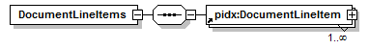
namespace | http://www.pidx.org/schema/ds/v5.02
properties | content complex
children | pidx:DocumentLineItem
used by | complexType LoadDocumentType
source | <element name="DocumentLineItems">  <complexType>  <sequence>  <element ref="pidx:DocumentLineItem" maxOccurs="unbounded"/>  </sequence>  </complexType>  </element>

element DocumentName
diagram | 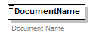
namespace | http://www.pidx.org/schema/ds/v5.02
type | string
properties | content simple
used by | elements DocumentHeader DocumentReference  complexTypes AgentData DocumentData
annotation | documentation  Document Name
source | <element name="DocumentName" type="string">  <annotation>  <documentation>Document Name </documentation>  </annotation>  </element>

element DocumentOriginator
diagram | 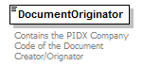
namespace | http://www.pidx.org/schema/ds/v5.02
type | string
properties | content simple
used by | elements DocumentHeader DocumentReference PlannedLifting ResponseInfo  complexType PMResponseBody
annotation | documentation  Contains the PIDX Company Code of the Document Creator/Orignator
source | <element name="DocumentOriginator" type="string">  <annotation>  <documentation>Contains the PIDX Company Code of the Document Creator/Orignator</documentation>  </annotation>  </element>

element DocumentReference
diagram | 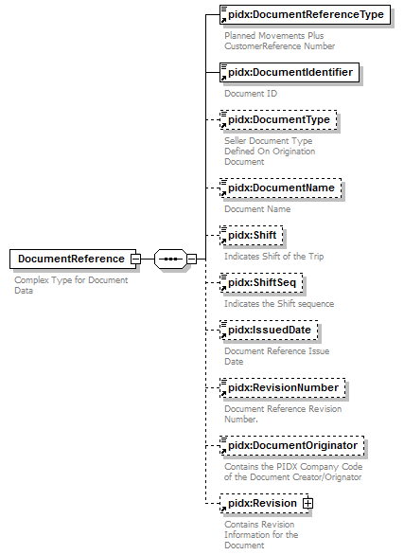
namespace | http://www.pidx.org/schema/ds/v5.02
properties | content complex
children | pidx:DocumentReferenceType pidx:DocumentIdentifier pidx:DocumentType pidx:DocumentName pidx:Shift pidx:ShiftSeq pidx:IssuedDate pidx:RevisionNumber pidx:DocumentOriginator pidx:Revision
used by | complexType PostingData
annotation | documentation  Complex Type for Document Data
source | <element name="DocumentReference">  <annotation>  <documentation>Complex Type for Document Data</documentation>  </annotation>  <complexType>  <sequence>  <element ref="pidx:DocumentReferenceType"/>  <element ref="pidx:DocumentIdentifier">  <annotation>  <documentation>Document ID</documentation>  </annotation>  </element>  <element ref="pidx:DocumentType" minOccurs="0"/>  <element ref="pidx:DocumentName" minOccurs="0"/>  <element ref="pidx:Shift" minOccurs="0"/>  <element ref="pidx:ShiftSeq" minOccurs="0"/>  <element ref="pidx:IssuedDate" minOccurs="0"/>  <element ref="pidx:RevisionNumber" minOccurs="0"/>  <element ref="pidx:DocumentOriginator" minOccurs="0"/>  <element ref="pidx:Revision" minOccurs="0"/>  </sequence>  </complexType>  </element>

element DocumentReferenceType
diagram | 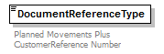
namespace | http://www.pidx.org/schema/ds/v5.02
type | union of (pidx:DocumentTypes, pidx:DriverEnteredData)
properties | content simple
used by | element DocumentReference
annotation | documentation  Planned Movements Plus CustomerReference Number
source | <element name="DocumentReferenceType">  <annotation>  <documentation>Planned Movements Plus CustomerReference Number</documentation>  </annotation>  <simpleType>  <union memberTypes="pidx:DocumentTypes pidx:DriverEnteredData"/>  </simpleType>  </element>

element Documents
diagram | 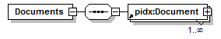
namespace | http://www.pidx.org/schema/ds/v5.02
properties | content complex
children | pidx:Document
source | <element name="Documents">  <complexType>  <sequence>  <element ref="pidx:Document" maxOccurs="unbounded"/>  </sequence>  </complexType>  </element>

element DocumentSequence
diagram | 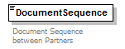
namespace | http://www.pidx.org/schema/ds/v5.02
type | integer
properties | content simple
used by | element Header
annotation | documentation  Document Sequence between Partners
source | <element name="DocumentSequence" type="integer">  <annotation>  <documentation>Document Sequence between Partners</documentation>  </annotation>  </element>

element DocumentStatus
diagram | 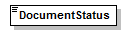
namespace | http://www.pidx.org/schema/ds/v5.02
type | pidx:StatusCodes
properties | content simple
used by | element DocumentHeader
facets | enumeration New  enumeration Changed  enumeration Deleted
source | <element name="DocumentStatus" type="pidx:StatusCodes"/>

element DocumentType
diagram | 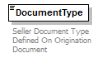
namespace | http://www.pidx.org/schema/ds/v5.02
type | string
properties | content simple
used by | elements DocumentHeader DocumentLineItem DocumentReference  complexTypes AgentData DocumentData
annotation | documentation  Seller Document Type Defined On Origination Document
source | <element name="DocumentType" type="string">  <annotation>  <documentation>Seller Document Type Defined On Origination Document</documentation>  </annotation>  </element>

element DriverCardNo
diagram | 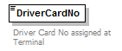
namespace | http://www.pidx.org/schema/ds/v5.02
type | string
properties | content simple
used by | element Agent
annotation | documentation  Driver Card No assigned at Terminal
source | <element name="DriverCardNo" type="string">  <annotation>  <documentation>Driver Card No assigned at Terminal</documentation>  </annotation>  </element>

element DriverDocumentIdentifier
diagram | 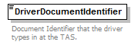
namespace | http://www.pidx.org/schema/ds/v5.02
type | string
properties | content simple
used by | elements DocumentHeader PlannedLifting ResponseInfo
annotation | documentation  Document Identifier that the driver types in at the TAS.
source | <element name="DriverDocumentIdentifier" type="string">  <annotation>  <documentation>Document Identifier that the driver types in at the TAS.</documentation>  </annotation>  </element>

element DriverIdentifier
diagram | 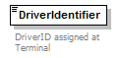
namespace | http://www.pidx.org/schema/ds/v5.02
type | string
properties | content simple
used by | element Agent
annotation | documentation  DriverID assigned at Terminal
source | <element name="DriverIdentifier" type="string">  <annotation>  <documentation>DriverID assigned at Terminal</documentation>  </annotation>  </element>

element DriverLicense
diagram | 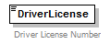
namespace | http://www.pidx.org/schema/ds/v5.02
type | string
properties | content simple
used by | element Agent
annotation | documentation  Driver License Number
source | <element name="DriverLicense" type="string">  <annotation>  <documentation>Driver License Number</documentation>  </annotation>  </element>

element DriverName
diagram | 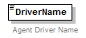
namespace | http://www.pidx.org/schema/ds/v5.02
type | string
properties | content simple
used by | element Agent
annotation | documentation  Agent Driver Name
source | <element name="DriverName" type="string">  <annotation>  <documentation>Agent Driver Name</documentation>  </annotation>  </element>

element EMCS
diagram | 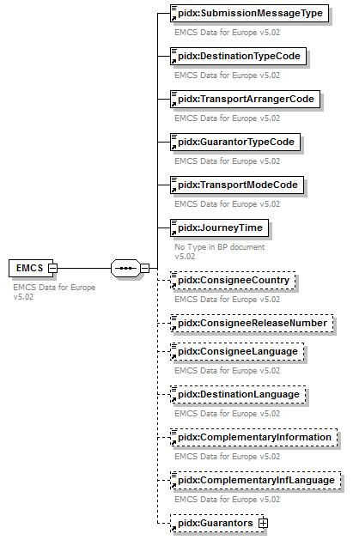
namespace | http://www.pidx.org/schema/ds/v5.02
properties | content complex
children | pidx:SubmissionMessageType pidx:DestinationTypeCode pidx:TransportArrangerCode pidx:GuarantorTypeCode pidx:TransportModeCode pidx:JourneyTime pidx:ConsigneeCountry pidx:ConsigneeReleaseNumber pidx:ConsigneeLanguage pidx:DestinationLanguage pidx:ComplementaryInformation pidx:ComplementaryInfLanguage pidx:Guarantors
used by | element DocumentLineItem
annotation | documentation  EMCS Data for Europe v5.02
source | <element name="EMCS">  <annotation>  <documentation>EMCS Data for Europe v5.02</documentation>  </annotation>  <complexType>  <sequence>  <element ref="pidx:SubmissionMessageType"/>  <element ref="pidx:DestinationTypeCode"/>  <element ref="pidx:TransportArrangerCode"/>  <element ref="pidx:GuarantorTypeCode"/>  <element ref="pidx:TransportModeCode"/>  <element ref="pidx:JourneyTime"/>  <element ref="pidx:ConsigneeCountry" minOccurs="0"/>  <element ref="pidx:ConsigneeReleaseNumber" minOccurs="0"/>  <element ref="pidx:ConsigneeLanguage" minOccurs="0"/>  <element ref="pidx:DestinationLanguage" minOccurs="0"/>  <element ref="pidx:ComplementaryInformation" minOccurs="0"/>  <element ref="pidx:ComplementaryInfLanguage" minOccurs="0"/>  <element ref="pidx:Guarantors" minOccurs="0"/>  </sequence>  </complexType>  </element>

element EndPeriod
diagram | 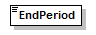
namespace | http://www.pidx.org/schema/ds/v5.02
type | date
properties | content simple
used by | complexType QuantityScheduleType
source | <element name="EndPeriod" type="date"/>

element Engine
diagram | 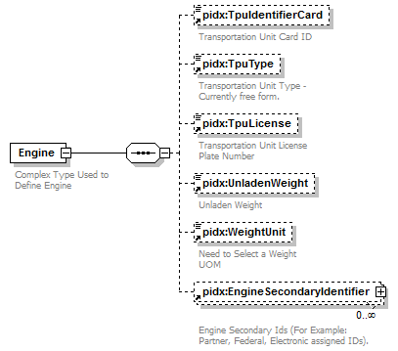
namespace | http://www.pidx.org/schema/ds/v5.02
properties | content complex
children | pidx:TpuIdentifierCard pidx:TpuType pidx:TpuLicense pidx:UnladenWeight pidx:WeightUnit pidx:EngineSecondaryIdentifier
used by | element ModeOfTransport  complexType LoadPlanInfo
annotation | documentation  Complex Type Used to Define Engine
source | <element name="Engine">  <annotation>  <documentation>Complex Type Used to Define Engine</documentation>  </annotation>  <complexType>  <sequence>  <element ref="pidx:TpuIdentifierCard" minOccurs="0">  <annotation>  <documentation>Transportation Unit Card ID </documentation>  </annotation>  </element>  <element ref="pidx:TpuType" minOccurs="0"/>  <element ref="pidx:TpuLicense" minOccurs="0"/>  <element ref="pidx:UnladenWeight" minOccurs="0"/>  <element ref="pidx:WeightUnit" minOccurs="0"/>  <element ref="pidx:EngineSecondaryIdentifier" minOccurs="0" maxOccurs="unbounded"/>  </sequence>  </complexType>  </element>

element EngineIdentifier
diagram | 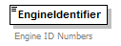
namespace | http://www.pidx.org/schema/ds/v5.02
type | string
properties | content simple
used by | element EngineSecondaryIdentifier
annotation | documentation  Engine ID Numbers
source | <element name="EngineIdentifier" type="string">  <annotation>  <documentation>Engine ID Numbers</documentation>  </annotation>  </element>

element EngineIdentifierType
diagram | 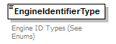
namespace | http://www.pidx.org/schema/ds/v5.02
type | restriction of string
properties | content simple
used by | element EngineSecondaryIdentifier
facets | enumeration PartnerEngineID  enumeration FederalAssignedID  enumeration ElectronicID
annotation | documentation  Engine ID Types (See Enums)
source | <element name="EngineIdentifierType">  <annotation>  <documentation>Engine ID Types (See Enums)</documentation>  </annotation>  <simpleType>  <restriction base="string">  <enumeration value="PartnerEngineID"/>  <enumeration value="FederalAssignedID"/>  <enumeration value="ElectronicID"/>  </restriction>  </simpleType>  </element>

element EngineSecondaryIdentifier
diagram | 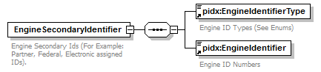
namespace | http://www.pidx.org/schema/ds/v5.02
properties | content complex
children | pidx:EngineIdentifierType pidx:EngineIdentifier
used by | element Engine
annotation | documentation  Engine Secondary Ids (For Example: Partner, Federal, Electronic assigned IDs).
source | <element name="EngineSecondaryIdentifier">  <annotation>  <documentation>Engine Secondary Ids (For Example: Partner, Federal, Electronic assigned IDs).</documentation>  </annotation>  <complexType>  <sequence>  <element ref="pidx:EngineIdentifierType"/>  <element ref="pidx:EngineIdentifier"/>  </sequence>  </complexType>  </element>

element EoriNumber
diagram | 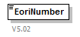
namespace | http://www.pidx.org/schema/ds/v5.02
type | string
properties | content simple
used by | element Export
annotation | documentation  V5.02
source | <element name="EoriNumber" type="string">  <annotation>  <documentation>V5.02</documentation>  </annotation>  </element>

element EquipmentSpecification
diagram | 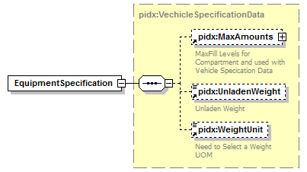
namespace | http://www.pidx.org/schema/ds/v5.02
type | pidx:VechicleSpecificationData
properties | content complex
children | pidx:MaxAmounts pidx:UnladenWeight pidx:WeightUnit
used by | elements ConfiguredVehicle LoadPartSpecification
source | <element name="EquipmentSpecification" type="pidx:VechicleSpecificationData"/>

element ErrorClass
diagram | 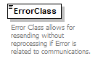
namespace | http://www.pidx.org/schema/ds/v5.02
type | pidx:ErrorClaseEnum
properties | content simple
used by | complexType PMResponseFailedData
facets | enumeration Communications  enumeration MasterData  enumeration AuthorizationFailed  enumeration DocumentRestriction
annotation | documentation  Error Class allows for resending without reprocessing if Error is related to communications.
source | <element name="ErrorClass" type="pidx:ErrorClaseEnum">  <annotation>  <documentation>Error Class allows for resending without reprocessing if Error is related to communications.</documentation>  </annotation>  </element>

element ErrorIdentifier
diagram | 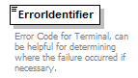
namespace | http://www.pidx.org/schema/ds/v5.02
type | string
properties | content simple
used by | element LineItemErrors/pidxLineItemError  complexType PMResponseFailedData
annotation | documentation  Error Code for Terminal, can be helpful for determining where the failure occurred if necessary.
source | <element name="ErrorIdentifier" type="string">  <annotation>  <documentation>Error Code for Terminal, can be helpful for determining where the failure occurred if necessary.</documentation>  </annotation>  </element>

element ExpireDate
diagram | 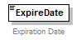
namespace | http://www.pidx.org/schema/ds/v5.02
type | date
properties | content simple
used by | complexType AgentData
annotation | documentation  Expiration Date
source | <element name="ExpireDate" type="date">  <annotation>  <documentation>Expiration Date</documentation>  </annotation>  </element>

element Export
diagram | 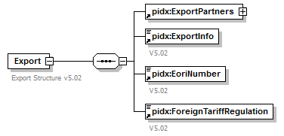
namespace | http://www.pidx.org/schema/ds/v5.02
properties | content complex
children | pidx:ExportPartners pidx:ExportInfo pidx:EoriNumber pidx:ForeignTariffRegulation
used by | element DocumentLineItem
annotation | documentation  Export Structure v5.02
source | <element name="Export">  <annotation>  <documentation>Export Structure v5.02</documentation>  </annotation>  <complexType>  <sequence>  <element ref="pidx:ExportPartners"/>  <element ref="pidx:ExportInfo"/>  <element ref="pidx:EoriNumber"/>  <element ref="pidx:ForeignTariffRegulation"/>  </sequence>  </complexType>  </element>

element Exporter
diagram | 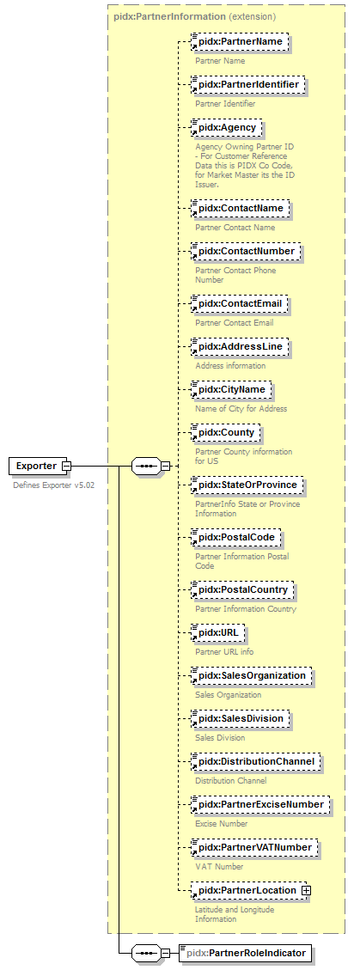
namespace | http://www.pidx.org/schema/ds/v5.02
type | extension of pidx:PartnerInformation
properties | content complex
children | pidx:PartnerName pidx:PartnerIdentifier pidx:Agency pidx:ContactName pidx:ContactNumber pidx:ContactEmail pidx:AddressLine pidx:CityName pidx:County pidx:StateOrProvince pidx:PostalCode pidx:PostalCountry pidx:URL pidx:SalesOrganization pidx:SalesDivision pidx:DistributionChannel pidx:PartnerExciseNumber pidx:PartnerVATNumber pidx:PartnerLocation pidx:PartnerRoleIndicator
used by | element ExportPartners
annotation | documentation  Defines Exporter v5.02
source | <element name="Exporter">  <annotation>  <documentation>Defines Exporter v5.02</documentation>  </annotation>  <complexType>  <complexContent>  <extension base="pidx:PartnerInformation">  <sequence>  <element name="PartnerRoleIndicator" type="pidx:CustomsRoleEnum"/>  </sequence>  </extension>  </complexContent>  </complexType>  </element>

element Exporter/PartnerRoleIndicator
diagram | 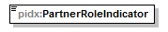
namespace | http://www.pidx.org/schema/ds/v5.02
type | pidx:CustomsRoleEnum
properties | isRef 0  content simple
used by | complexType PartnerRoleInformation
facets | enumeration BorderCrossingPoint  enumeration CustomsOffice  enumeration Exporter
source | <element name="PartnerRoleIndicator" type="pidx:CustomsRoleEnum"/>

element ExportInfo
diagram | 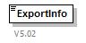
namespace | http://www.pidx.org/schema/ds/v5.02
type | string
properties | content simple
used by | element Export
annotation | documentation  V5.02
source | <element name="ExportInfo" type="string">  <annotation>  <documentation>V5.02</documentation>  </annotation>  </element>

element ExportPartners
diagram | 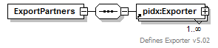
namespace | http://www.pidx.org/schema/ds/v5.02
properties | content complex
children | pidx:Exporter
used by | element Export
source | <element name="ExportPartners">  <complexType>  <sequence>  <element ref="pidx:Exporter" maxOccurs="unbounded"/>  </sequence>  </complexType>  </element>

element Failed
diagram | 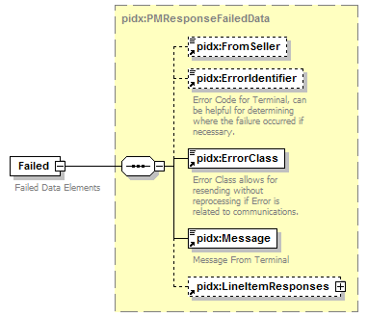
namespace | http://www.pidx.org/schema/ds/v5.02
type | pidx:PMResponseFailedData
properties | content complex
children | pidx:FromSeller pidx:ErrorIdentifier pidx:ErrorClass pidx:Message pidx:LineItemResponses
used by | element ResponseResult
annotation | documentation  Failed Data Elements
source | <element name="Failed" type="pidx:PMResponseFailedData">  <annotation>  <documentation>Failed Data Elements</documentation>  </annotation>  </element>

element FinalShipper
diagram | 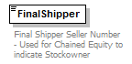
namespace | http://www.pidx.org/schema/ds/v5.02
type | string
properties | content simple
used by | element AuthParties
annotation | documentation  Final Shipper Seller Number - Used for Chained Equity to indicate Stockowner
source | <element name="FinalShipper" type="string">  <annotation>  <documentation>Final Shipper Seller Number - Used for Chained Equity to indicate Stockowner</documentation>  </annotation>  </element>

element FinalShipperDocumentSequence
diagram | 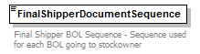
namespace | http://www.pidx.org/schema/ds/v5.02
type | integer
properties | content simple
used by | element ShipperData
annotation | documentation  Final Shipper BOL Sequence - Sequence used for each BOL going to stockowner
source | <element name="FinalShipperDocumentSequence" type="integer">  <annotation>  <documentation>Final Shipper BOL Sequence - Sequence used for each BOL going to stockowner</documentation>  </annotation>  </element>

element ForeignTariffRegulation
diagram | 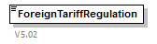
namespace | http://www.pidx.org/schema/ds/v5.02
type | string
properties | content simple
used by | element Export
annotation | documentation  V5.02
source | <element name="ForeignTariffRegulation" type="string">  <annotation>  <documentation>V5.02</documentation>  </annotation>  </element>

element From
diagram | 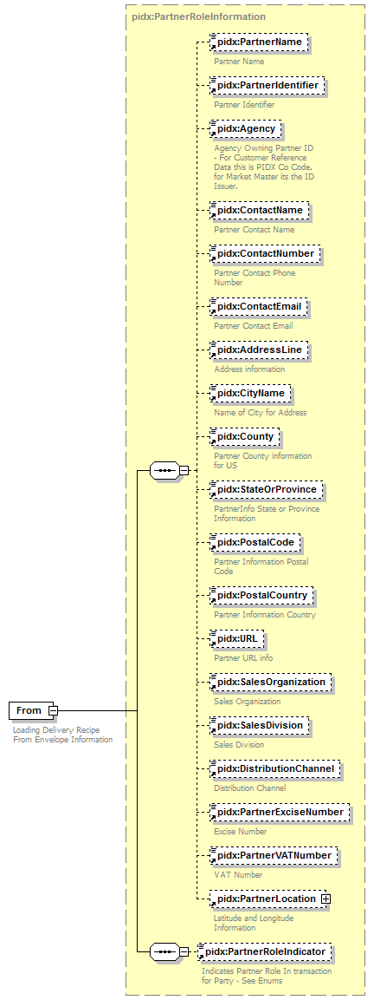
namespace | http://www.pidx.org/schema/ds/v5.02
type | pidx:PartnerRoleInformation
properties | content complex  mixed false
children | pidx:PartnerName pidx:PartnerIdentifier pidx:Agency pidx:ContactName pidx:ContactNumber pidx:ContactEmail pidx:AddressLine pidx:CityName pidx:County pidx:StateOrProvince pidx:PostalCode pidx:PostalCountry pidx:URL pidx:SalesOrganization pidx:SalesDivision pidx:DistributionChannel pidx:PartnerExciseNumber pidx:PartnerVATNumber pidx:PartnerLocation pidx:PartnerRoleIndicator
used by | element Header
annotation | documentation  Loading Delivery Recipe From Envelope Information
source | <element name="From" type="pidx:PartnerRoleInformation">  <annotation>  <documentation>Loading Delivery Recipe From Envelope Information</documentation>  </annotation>  </element>

element FromSeller
diagram | 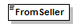
namespace | http://www.pidx.org/schema/ds/v5.02
type | string
properties | content simple
used by | element LineItemResponse  complexTypes PIDXPlannedMovementReq PMResponseFailedData PMResponseSucessData
source | <element name="FromSeller" type="string"/>

element GeoFence
diagram | 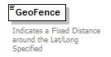
namespace | http://www.pidx.org/schema/ds/v5.02
type | decimal
properties | content simple
used by | complexType GeoLocation
annotation | documentation  Indicates a Fixed Distance around the Lat/Long Specified
source | <element name="GeoFence" type="decimal">  <annotation>  <documentation>Indicates a Fixed Distance around the Lat/Long Specified</documentation>  </annotation>  </element>

element GeoFenceUnit
diagram | 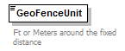
namespace | http://www.pidx.org/schema/ds/v5.02
type | pidx:FenceUnits
properties | content simple
used by | complexType GeoLocation
facets | enumeration FT  enumeration YD  enumeration M  enumeration KM
annotation | documentation  Ft or Meters around the fixed distance
source | <element name="GeoFenceUnit" type="pidx:FenceUnits">  <annotation>  <documentation>Ft or Meters around the fixed distance</documentation>  </annotation>  </element>

element Gravity
diagram | 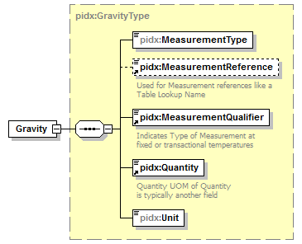
namespace | http://www.pidx.org/schema/ds/v5.02
type | pidx:GravityType
properties | content complex
children | pidx:MeasurementType pidx:MeasurementReference pidx:MeasurementQualifier pidx:Quantity pidx:Unit
source | <element name="Gravity" type="pidx:GravityType"/>

element Guarantor
diagram | 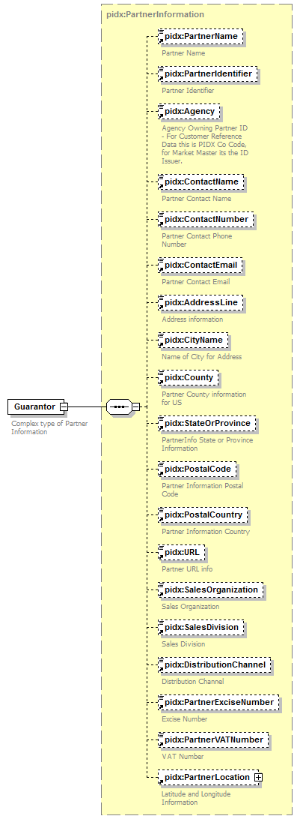
namespace | http://www.pidx.org/schema/ds/v5.02
type | pidx:PartnerInformation
properties | content complex
children | pidx:PartnerName pidx:PartnerIdentifier pidx:Agency pidx:ContactName pidx:ContactNumber pidx:ContactEmail pidx:AddressLine pidx:CityName pidx:County pidx:StateOrProvince pidx:PostalCode pidx:PostalCountry pidx:URL pidx:SalesOrganization pidx:SalesDivision pidx:DistributionChannel pidx:PartnerExciseNumber pidx:PartnerVATNumber pidx:PartnerLocation
used by | element Guarantors
annotation | documentation  Complex type of Partner Information
source | <element name="Guarantor" type="pidx:PartnerInformation">  <annotation>  <documentation>Complex type of Partner Information</documentation>  </annotation>  </element>

element Guarantors
diagram | 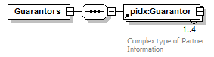
namespace | http://www.pidx.org/schema/ds/v5.02
properties | content complex
children | pidx:Guarantor
used by | element EMCS
source | <element name="Guarantors">  <complexType>  <sequence>  <element ref="pidx:Guarantor" maxOccurs="4"/>  </sequence>  </complexType>  </element>

element GuarantorTypeCode
diagram | 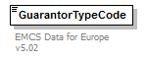
namespace | http://www.pidx.org/schema/ds/v5.02
type | pidx:EMCSGuarantorEnum
properties | content simple
used by | element EMCS
facets | enumeration 0  enumeration 1  enumeration 2  enumeration 3  enumeration 4  enumeration 12  enumeration 13  enumeration 14  enumeration 23  enumeration 24  enumeration 34  enumeration 123  enumeration 124  enumeration 134  enumeration 234  enumeration 1234
annotation | documentation  EMCS Data for Europe v5.02
source | <element name="GuarantorTypeCode" type="pidx:EMCSGuarantorEnum">  <annotation>  <documentation>EMCS Data for Europe v5.02</documentation>  </annotation>  </element>

element Header
diagram | 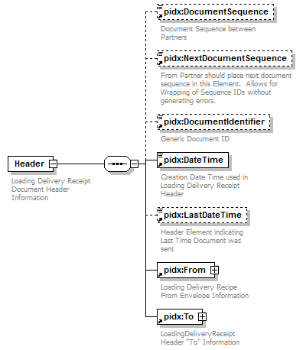
namespace | http://www.pidx.org/schema/ds/v5.02
properties | content complex
children | pidx:DocumentSequence pidx:NextDocumentSequence pidx:DocumentIdentifier pidx:DateTime pidx:LastDateTime pidx:From pidx:To
used by | complexType PMResponseComplex
annotation | documentation  Loading Delivery Receipt Document Header Information
source | <element name="Header">  <annotation>  <documentation>Loading Delivery Receipt Document Header Information</documentation>  </annotation>  <complexType>  <sequence>  <element ref="pidx:DocumentSequence" minOccurs="0"/>  <element ref="pidx:NextDocumentSequence" minOccurs="0"/>  <element ref="pidx:DocumentIdentifier" minOccurs="0"/>  <element ref="pidx:DateTime"/>  <element ref="pidx:LastDateTime" minOccurs="0"/>  <element ref="pidx:From"/>  <element ref="pidx:To"/>  </sequence>  </complexType>  </element>

element Incoterms
diagram | 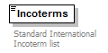
namespace | http://www.pidx.org/schema/ds/v5.02
type | pidx:IncoTermEnums
properties | content simple
used by | element Terms
facets | enumeration EXW  enumeration FCA  enumeration CPT  enumeration CIP  enumeration DAT  enumeration DAP  enumeration DDP  enumeration FAS  enumeration FOB  enumeration CFR  enumeration CIF  enumeration DAF  enumeration DES  enumeration DEQ  enumeration DDU
annotation | documentation  Standard International Incoterm list
source | <element name="Incoterms" type="pidx:IncoTermEnums">  <annotation>  <documentation>Standard International Incoterm list</documentation>  </annotation>  </element>

element IncotermsText
diagram | 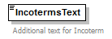
namespace | http://www.pidx.org/schema/ds/v5.02
type | string
properties | content simple
used by | element Terms
annotation | documentation  Additional text for Incoterm
source | <element name="IncotermsText" type="string">  <annotation>  <documentation>Additional text for Incoterm</documentation>  </annotation>  </element>

element IssueDate
diagram | 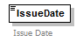
namespace | http://www.pidx.org/schema/ds/v5.02
type | date
properties | content simple
used by | complexType AgentData
annotation | documentation  Issue Date
source | <element name="IssueDate" type="date">  <annotation>  <documentation>Issue Date</documentation>  </annotation>  </element>

element IssuedDate
diagram | 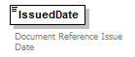
namespace | http://www.pidx.org/schema/ds/v5.02
type | dateTime
properties | content simple
used by | elements DocumentHeader DocumentReference  complexType DocumentData
annotation | documentation  Document Reference Issue Date
source | <element name="IssuedDate" type="dateTime">  <annotation>  <documentation>Document Reference Issue Date</documentation>  </annotation>  </element>

element IssuingAgency
diagram | 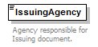
namespace | http://www.pidx.org/schema/ds/v5.02
type | string
properties | content simple
used by | complexType AgentData
annotation | documentation  Agency responsible for Issuing document.
source | <element name="IssuingAgency" type="string">  <annotation>  <documentation>Agency responsible for Issuing document.</documentation>  </annotation>  </element>

element JourneyTime
diagram | 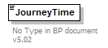
namespace | http://www.pidx.org/schema/ds/v5.02
type | string
properties | content simple
used by | element EMCS
annotation | documentation  No Type in BP document v5.02
source | <element name="JourneyTime" type="string">  <annotation>  <documentation>No Type in BP document v5.02</documentation>  </annotation>  </element>

element LastDateTime
diagram | 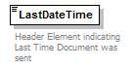
namespace | http://www.pidx.org/schema/ds/v5.02
type | dateTime
properties | content simple
used by | element Header
annotation | documentation  Header Element indicating Last Time Document was sent
source | <element name="LastDateTime" type="dateTime">  <annotation>  <documentation>Header Element indicating Last Time Document was sent</documentation>  </annotation>  </element>

element LastModified
diagram | 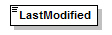
namespace | http://www.pidx.org/schema/ds/v5.02
type | dateTime
properties | content simple
used by | complexType RevisionData
source | <element name="LastModified" type="dateTime"/>

element Latitude
diagram | 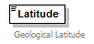
namespace | http://www.pidx.org/schema/ds/v5.02
type | decimal
properties | content simple
used by | complexType GeoLocation
annotation | documentation  Geological Latitude
source | <element name="Latitude" type="decimal">  <annotation>  <documentation>Geological Latitude</documentation>  </annotation>  </element>

element LeftOnBoard
diagram | 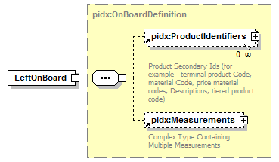
namespace | http://www.pidx.org/schema/ds/v5.02
type | pidx:OnBoardDefinition
properties | content complex
children | pidx:ProductIdentifiers pidx:Measurements
used by | element LoadCompartment
source | <element name="LeftOnBoard" type="pidx:OnBoardDefinition"/>

element LineItemError
diagram | 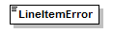
namespace | http://www.pidx.org/schema/ds/v5.02
source | <element name="LineItemError"/>

element LineItemErrors
diagram | 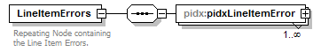
namespace | http://www.pidx.org/schema/ds/v5.02
properties | content complex
children | pidx:pidxLineItemError
annotation | documentation  Repeating Node containing the Line Item Errors.
source | <element name="LineItemErrors">  <annotation>  <documentation>Repeating Node containing the Line Item Errors.</documentation>  </annotation>  <complexType>  <sequence>  <element name="pidxLineItemError" maxOccurs="unbounded">  <complexType>  <sequence>  <element ref="pidx:LineItemNumber"/>  <element ref="pidx:ErrorIdentifier" minOccurs="0"/>  <element ref="pidx:Message" minOccurs="0"/>  </sequence>  </complexType>  </element>  </sequence>  </complexType>  </element>

element LineItemErrors/pidxLineItemError
diagram | 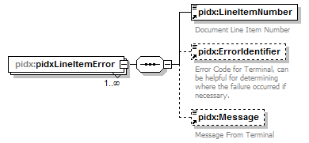
namespace | http://www.pidx.org/schema/ds/v5.02
properties | isRef 0  minOcc 1  maxOcc unbounded  content complex
children | pidx:LineItemNumber pidx:ErrorIdentifier pidx:Message
source | <element name="pidxLineItemError" maxOccurs="unbounded">  <complexType>  <sequence>  <element ref="pidx:LineItemNumber"/>  <element ref="pidx:ErrorIdentifier" minOccurs="0"/>  <element ref="pidx:Message" minOccurs="0"/>  </sequence>  </complexType>  </element>

element LineItemNumber
diagram | 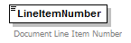
namespace | http://www.pidx.org/schema/ds/v5.02
type | string
properties | content simple
used by | elements DocumentLineItem LineItemResponse LineItemErrors/pidxLineItemError
annotation | documentation  Document Line Item Number
source | <element name="LineItemNumber" type="string">  <annotation>  <documentation>Document Line Item Number</documentation>  </annotation>  </element>

element LineItemResponse
diagram | 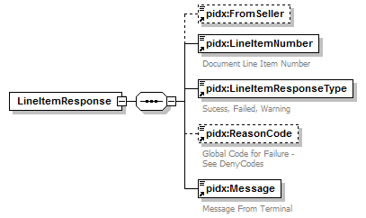
namespace | http://www.pidx.org/schema/ds/v5.02
properties | content complex
children | pidx:FromSeller pidx:LineItemNumber pidx:LineItemResponseType pidx:ReasonCode pidx:Message
used by | element LineItemResponses
source | <element name="LineItemResponse">  <complexType>  <sequence>  <element ref="pidx:FromSeller" minOccurs="0"/>  <element ref="pidx:LineItemNumber"/>  <element ref="pidx:LineItemResponseType"/>  <element ref="pidx:ReasonCode" minOccurs="0">  <annotation>  <documentation>Global Code for Failure - See DenyCodes</documentation>  </annotation>  </element>  <element ref="pidx:Message"/>  </sequence>  </complexType>  </element>

element LineItemResponses
diagram | 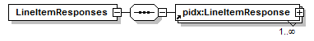
namespace | http://www.pidx.org/schema/ds/v5.02
properties | content complex
children | pidx:LineItemResponse
used by | complexTypes PMResponseFailedData PMResponseSucessData
source | <element name="LineItemResponses">  <complexType>  <sequence>  <element ref="pidx:LineItemResponse" maxOccurs="unbounded"/>  </sequence>  </complexType>  </element>

element LineItemResponseType
diagram | 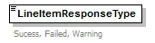
namespace | http://www.pidx.org/schema/ds/v5.02
type | pidx:LineItemResponseEnum
properties | content simple
used by | element LineItemResponse
facets | enumeration Failed  enumeration Success  enumeration Warning
annotation | documentation  Sucess, Failed, Warning
source | <element name="LineItemResponseType" type="pidx:LineItemResponseEnum">  <annotation>  <documentation>Sucess, Failed, Warning</documentation>  </annotation>  </element>

element LineItemStatus
diagram | 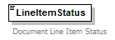
namespace | http://www.pidx.org/schema/ds/v5.02
type | pidx:StatusCodes
properties | content simple
used by | element DocumentLineItem
facets | enumeration New  enumeration Changed  enumeration Deleted
annotation | documentation  Document Line Item Status
source | <element name="LineItemStatus" type="pidx:StatusCodes">  <annotation>  <documentation>Document Line Item Status</documentation>  </annotation>  </element>

element LoadCompartment
diagram | 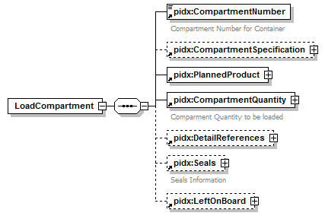
namespace | http://www.pidx.org/schema/ds/v5.02
properties | content complex
children | pidx:CompartmentNumber pidx:CompartmentSpecification pidx:PlannedProduct pidx:CompartmentQuantity pidx:DetailReferences pidx:Seals pidx:LeftOnBoard
used by | element LoadCompartments
source | <element name="LoadCompartment">  <complexType>  <sequence>  <element ref="pidx:CompartmentNumber"/>  <element ref="pidx:CompartmentSpecification" minOccurs="0"/>  <element ref="pidx:PlannedProduct"/>  <element ref="pidx:CompartmentQuantity"/>  <element ref="pidx:DetailReferences" minOccurs="0"/>  <element ref="pidx:Seals" minOccurs="0"/>  <element ref="pidx:LeftOnBoard" minOccurs="0"/>  </sequence>  </complexType>  </element>

element LoadCompartments
diagram | 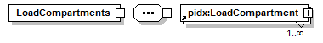
namespace | http://www.pidx.org/schema/ds/v5.02
properties | content complex
children | pidx:LoadCompartment
used by | element LoadingPlanPart
source | <element name="LoadCompartments">  <complexType>  <sequence>  <element ref="pidx:LoadCompartment" maxOccurs="unbounded"/>  </sequence>  </complexType>  </element>

element LoadingPart
diagram | 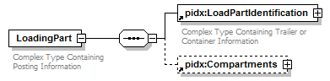
namespace | http://www.pidx.org/schema/ds/v5.02
properties | content complex
children | pidx:LoadPartIdentification pidx:Compartments
used by | element LoadingParts
annotation | documentation  Complex Type Containing Posting Information
source | <element name="LoadingPart">  <annotation>  <documentation>Complex Type Containing Posting Information</documentation>  </annotation>  <complexType>  <sequence>  <element ref="pidx:LoadPartIdentification"/>  <element ref="pidx:Compartments" minOccurs="0"/>  </sequence>  </complexType>  </element>

element LoadingPartIdentifier
diagram | 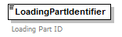
namespace | http://www.pidx.org/schema/ds/v5.02
type | string
properties | content simple
used by | element LoadingPartSecondaryIdentifier
annotation | documentation  Loading Part ID
source | <element name="LoadingPartIdentifier" type="string">  <annotation>  <documentation>Loading Part ID</documentation>  </annotation>  </element>

element LoadingPartIdentifierType
diagram | 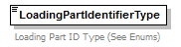
namespace | http://www.pidx.org/schema/ds/v5.02
type | restriction of string
properties | content simple
used by | element LoadingPartSecondaryIdentifier
facets | enumeration PartnerEngineID  enumeration FederalAssignedID  enumeration ElectronicID
annotation | documentation  Loading Part ID Type (See Enums)
source | <element name="LoadingPartIdentifierType">  <annotation>  <documentation>Loading Part ID Type (See Enums)</documentation>  </annotation>  <simpleType>  <restriction base="string">  <enumeration value="PartnerEngineID"/>  <enumeration value="FederalAssignedID"/>  <enumeration value="ElectronicID"/>  </restriction>  </simpleType>  </element>

element LoadingParts
diagram | 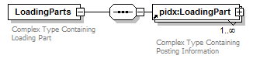
namespace | http://www.pidx.org/schema/ds/v5.02
properties | content complex
children | pidx:LoadingPart
used by | element Transport
annotation | documentation  Complex Type Containing Loading Part
source | <element name="LoadingParts">  <annotation>  <documentation>Complex Type Containing Loading Part</documentation>  </annotation>  <complexType>  <sequence>  <element ref="pidx:LoadingPart" maxOccurs="unbounded"/>  </sequence>  </complexType>  </element>

element LoadingPartSecondaryIdentifier
diagram | 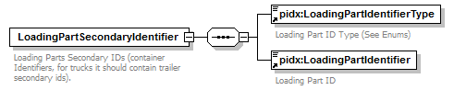
namespace | http://www.pidx.org/schema/ds/v5.02
properties | content complex
children | pidx:LoadingPartIdentifierType pidx:LoadingPartIdentifier
used by | element LoadPartIdentification
annotation | documentation  Loading Parts Secondary IDs (container Identifiers, for trucks it should contain trailer secondary ids).
source | <element name="LoadingPartSecondaryIdentifier">  <annotation>  <documentation>Loading Parts Secondary IDs (container Identifiers, for trucks it should contain trailer secondary ids).</documentation>  </annotation>  <complexType>  <sequence>  <element ref="pidx:LoadingPartIdentifierType"/>  <element ref="pidx:LoadingPartIdentifier"/>  </sequence>  </complexType>  </element>

element LoadingPlanPart
diagram | 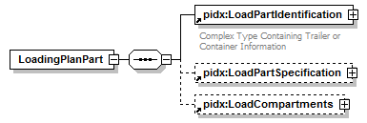
namespace | http://www.pidx.org/schema/ds/v5.02
properties | content complex
children | pidx:LoadPartIdentification pidx:LoadPartSpecification pidx:LoadCompartments
used by | element LoadingPlanParts
source | <element name="LoadingPlanPart">  <complexType>  <sequence>  <element ref="pidx:LoadPartIdentification"/>  <element ref="pidx:LoadPartSpecification" minOccurs="0"/>  <element ref="pidx:LoadCompartments" minOccurs="0"/>  </sequence>  </complexType>  </element>

element LoadingPlanParts
diagram | 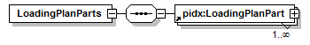
namespace | http://www.pidx.org/schema/ds/v5.02
properties | content complex
children | pidx:LoadingPlanPart
used by | complexType LoadPlanInfo
source | <element name="LoadingPlanParts">  <complexType>  <sequence>  <element ref="pidx:LoadingPlanPart" maxOccurs="unbounded"/>  </sequence>  </complexType>  </element>

element LoadingRef
diagram | 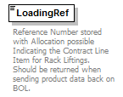
namespace | http://www.pidx.org/schema/ds/v5.02
type | string
properties | content simple
used by | element ProductList
annotation | documentation  Reference Number stored with Allocation possible Indicating the Contract Line Item for Rack Liftings. Should be returned when sending product data back on BOL.
source | <element name="LoadingRef" type="string">  <annotation>  <documentation>Reference Number stored with Allocation possible Indicating the Contract Line Item for Rack Liftings. Should be returned when sending product data back on BOL.</documentation>  </annotation>  </element>

element LoadingType
diagram | 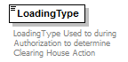
namespace | http://www.pidx.org/schema/ds/v5.02
type | restriction of string
properties | content simple
used by | elements PlannedLifting ResponseInfo
facets | enumeration RackPickup  enumeration RealTimeRemoteOrderDownload  enumeration LocalTerminalOrder
annotation | documentation  LoadingType Used to during Authorization to determine Clearing House Action
source | <element name="LoadingType">  <annotation>  <documentation>LoadingType Used to during Authorization to determine Clearing House Action</documentation>  </annotation>  <simpleType>  <restriction base="string">  <enumeration value="RackPickup">  <annotation>  <documentation>Used to indicate an unplanned pickup for Authorization. No Product Information is contained at Clearing House for this Authorization. TAS should determine if Order Download is required from Clearing House (configurable option on Consignee) or if user picked a local terminal order.</documentation>  </annotation>  </enumeration>  <enumeration value="RealTimeRemoteOrderDownload">  <annotation>  <documentation>TAS has configured Consignee to execute loading through Remote Orders</documentation>  </annotation>  </enumeration>  <enumeration value="LocalTerminalOrder">  <annotation>  <documentation>Loading Agent Picked an Order at the terminal, Product Amounts and Product ID should be sent in with authorization. Authorization will be run against the product and amounts to determine if the Consignee has available credit and product allocations necessary to Auth the load.</documentation>  </annotation>  </enumeration>  </restriction>  </simpleType>  </element>

element LoadPartIdentification
diagram | 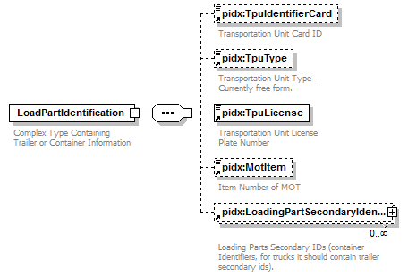
namespace | http://www.pidx.org/schema/ds/v5.02
properties | content complex
children | pidx:TpuIdentifierCard pidx:TpuType pidx:TpuLicense pidx:MotItem pidx:LoadingPartSecondaryIdentifier
used by | elements ConfiguredVehicleParts LoadingPart LoadingPlanPart
annotation | documentation  Complex Type Containing Trailer or Container Information
source | <element name="LoadPartIdentification">  <annotation>  <documentation>Complex Type Containing Trailer or Container Information</documentation>  </annotation>  <complexType>  <sequence>  <element ref="pidx:TpuIdentifierCard" minOccurs="0">  <annotation>  <documentation>Transportation Unit Card ID </documentation>  </annotation>  </element>  <element ref="pidx:TpuType" minOccurs="0"/>  <element ref="pidx:TpuLicense"/>  <element ref="pidx:MotItem" minOccurs="0"/>  <element ref="pidx:LoadingPartSecondaryIdentifier" minOccurs="0" maxOccurs="unbounded"/>  </sequence>  </complexType>  </element>

element LoadPartSpecification
diagram | 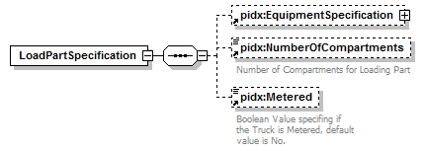
namespace | http://www.pidx.org/schema/ds/v5.02
properties | content complex
children | pidx:EquipmentSpecification pidx:NumberOfCompartments pidx:Metered
used by | element LoadingPlanPart
source | <element name="LoadPartSpecification">  <complexType>  <sequence>  <element ref="pidx:EquipmentSpecification" minOccurs="0"/>  <element ref="pidx:NumberOfCompartments" minOccurs="0"/>  <element ref="pidx:Metered" minOccurs="0"/>  </sequence>  </complexType>  </element>

element LoadPlan
diagram | 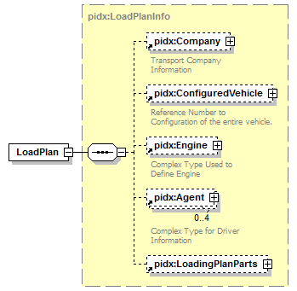
namespace | http://www.pidx.org/schema/ds/v5.02
type | pidx:LoadPlanInfo
properties | content complex
children | pidx:Company pidx:ConfiguredVehicle pidx:Engine pidx:Agent pidx:LoadingPlanParts
used by | complexType LoadDocumentType
source | <element name="LoadPlan" type="pidx:LoadPlanInfo"/>

element Location
diagram | 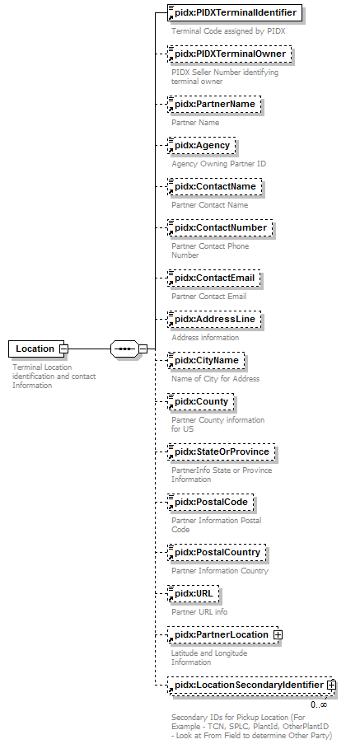
namespace | http://www.pidx.org/schema/ds/v5.02
properties | content complex
children | pidx:PIDXTerminalIdentifier pidx:PIDXTerminalOwner pidx:PartnerName pidx:Agency pidx:ContactName pidx:ContactNumber pidx:ContactEmail pidx:AddressLine pidx:CityName pidx:County pidx:StateOrProvince pidx:PostalCode pidx:PostalCountry pidx:URL pidx:PartnerLocation pidx:LocationSecondaryIdentifier
used by | element DocumentLineItem  complexTypes AuthRequestData PostingData
annotation | documentation  Terminal Location identification and contact Information
source | <element name="Location">  <annotation>  <documentation>Terminal Location identification and contact Information</documentation>  </annotation>  <complexType>  <sequence>  <element ref="pidx:PIDXTerminalIdentifier"/>  <element ref="pidx:PIDXTerminalOwner" minOccurs="0"/>  <element ref="pidx:PartnerName" minOccurs="0"/>  <element ref="pidx:Agency" minOccurs="0"/>  <element ref="pidx:ContactName" minOccurs="0"/>  <element ref="pidx:ContactNumber" minOccurs="0"/>  <element ref="pidx:ContactEmail" minOccurs="0"/>  <element ref="pidx:AddressLine" minOccurs="0"/>  <element ref="pidx:CityName" minOccurs="0"/>  <element ref="pidx:County" minOccurs="0"/>  <element ref="pidx:StateOrProvince" minOccurs="0"/>  <element ref="pidx:PostalCode" minOccurs="0"/>  <element ref="pidx:PostalCountry" minOccurs="0"/>  <element ref="pidx:URL" minOccurs="0"/>  <element ref="pidx:PartnerLocation" minOccurs="0"/>  <element ref="pidx:LocationSecondaryIdentifier" minOccurs="0" maxOccurs="unbounded"/>  </sequence>  </complexType>  </element>

element LocationIdentifier
diagram | 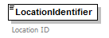
namespace | http://www.pidx.org/schema/ds/v5.02
type | string
properties | content simple
used by | element LocationSecondaryIdentifier
annotation | documentation  Location ID
source | <element name="LocationIdentifier" type="string">  <annotation>  <documentation>Location ID </documentation>  </annotation>  </element>

element LocationIdentifierType
diagram | 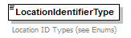
namespace | http://www.pidx.org/schema/ds/v5.02
type | pidx:LocationSecondaryTypes
properties | content simple
used by | element LocationSecondaryIdentifier
facets | enumeration SPLC  enumeration PartnerPlantID  enumeration OtherPlantID
annotation | documentation  Location ID Types (see Enums)
source | <element name="LocationIdentifierType" type="pidx:LocationSecondaryTypes">  <annotation>  <documentation>Location ID Types (see Enums)</documentation>  </annotation>  </element>

element LocationSecondaryIdentifier
diagram | 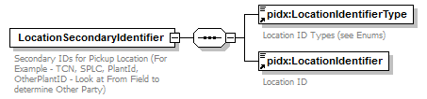
namespace | http://www.pidx.org/schema/ds/v5.02
properties | content complex
children | pidx:LocationIdentifierType pidx:LocationIdentifier
used by | element Location
annotation | documentation  Secondary IDs for Pickup Location (For Example - TCN, SPLC, PlantId, OtherPlantID - Look at From Field to determine Other Party)
source | <element name="LocationSecondaryIdentifier">  <annotation>  <documentation>Secondary IDs for Pickup Location (For Example - TCN, SPLC, PlantId, OtherPlantID - Look at From Field to determine Other Party)</documentation>  </annotation>  <complexType>  <sequence>  <element ref="pidx:LocationIdentifierType"/>  <element ref="pidx:LocationIdentifier"/>  </sequence>  </complexType>  </element>

element Longitude
diagram | 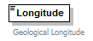
namespace | http://www.pidx.org/schema/ds/v5.02
type | decimal
properties | content simple
used by | complexType GeoLocation
annotation | documentation  Geological Longitude
source | <element name="Longitude" type="decimal">  <annotation>  <documentation>Geological Longitude</documentation>  </annotation>  </element>

element MaxAmounts
diagram | 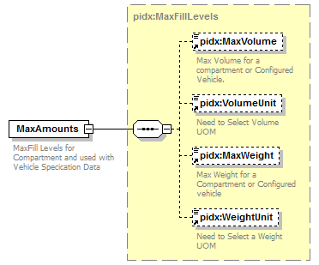
namespace | http://www.pidx.org/schema/ds/v5.02
type | pidx:MaxFillLevels
properties | content complex
children | pidx:MaxVolume pidx:VolumeUnit pidx:MaxWeight pidx:WeightUnit
used by | complexType VechicleSpecificationData
annotation | documentation  MaxFill Levels for Compartment and used with Vehicle Specication Data
source | <element name="MaxAmounts" type="pidx:MaxFillLevels">  <annotation>  <documentation>MaxFill Levels for Compartment and used with Vehicle Specication Data</documentation>  </annotation>  </element>

element MaxVolume
diagram | 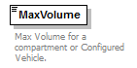
namespace | http://www.pidx.org/schema/ds/v5.02
type | double
properties | content simple
used by | complexType MaxFillLevels
annotation | documentation  Max Volume for a compartment or Configured Vehicle.
source | <element name="MaxVolume" type="double">  <annotation>  <documentation>Max Volume for a compartment or Configured Vehicle.</documentation>  </annotation>  </element>

element MaxWeight
diagram | 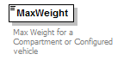
namespace | http://www.pidx.org/schema/ds/v5.02
type | double
properties | content simple
used by | complexType MaxFillLevels
annotation | documentation  Max Weight for a Compartment or Configured vehicle
source | <element name="MaxWeight" type="double">  <annotation>  <documentation>Max Weight for a Compartment or Configured vehicle</documentation>  </annotation>  </element>

element Measurement
diagram | 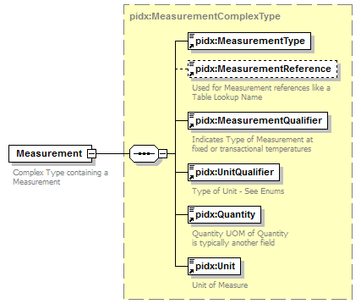
namespace | http://www.pidx.org/schema/ds/v5.02
type | pidx:MeasurementComplexType
properties | content complex
children | pidx:MeasurementType pidx:MeasurementReference pidx:MeasurementQualifier pidx:UnitQualifier pidx:Quantity pidx:Unit
used by | elements ContainerSize Measurements ProductList
annotation | documentation  Complex Type containing a Measurement
source | <element name="Measurement" type="pidx:MeasurementComplexType">  <annotation>  <documentation>Complex Type containing a Measurement</documentation>  </annotation>  </element>

element MeasurementInformation
diagram | 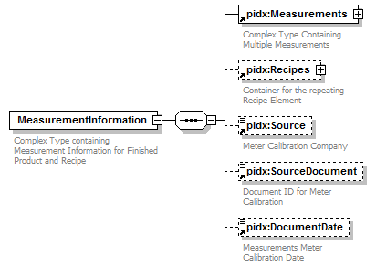
namespace | http://www.pidx.org/schema/ds/v5.02
properties | content complex
children | pidx:Measurements pidx:Recipes pidx:Source pidx:SourceDocument pidx:DocumentDate
used by | element Compartment
annotation | documentation  Complex Type containing Measurement Information for Finished Product and Recipe
source | <element name="MeasurementInformation">  <annotation>  <documentation>Complex Type containing Measurement Information for Finished Product and Recipe</documentation>  </annotation>  <complexType>  <sequence>  <element ref="pidx:Measurements"/>  <element ref="pidx:Recipes" minOccurs="0"/>  <element ref="pidx:Source" minOccurs="0">  <annotation>  <documentation>Meter Calibration Company</documentation>  </annotation>  </element>  <element ref="pidx:SourceDocument" minOccurs="0"/>  <element ref="pidx:DocumentDate" minOccurs="0"/>  </sequence>  </complexType>  </element>

element MeasurementQualifier
diagram | 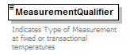
namespace | http://www.pidx.org/schema/ds/v5.02
type | union of (pidx:MeasurementQualifierEnum, pidx:MeasurementQualifierEnumDeprecated)
properties | content simple
used by | complexTypes DensityType GravityType MeasurementComplexType PressureType TemperatureType
annotation | documentation  Indicates Type of Measurement at fixed or transactional temperatures
source | <element name="MeasurementQualifier">  <annotation>  <documentation>Indicates Type of Measurement at fixed or transactional temperatures</documentation>  </annotation>  <simpleType>  <union memberTypes="pidx:MeasurementQualifierEnum pidx:MeasurementQualifierEnumDeprecated"/>  </simpleType>  </element>

element MeasurementReference
diagram | 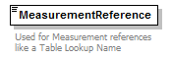
namespace | http://www.pidx.org/schema/ds/v5.02
type | string
properties | content simple
used by | complexTypes DensityType GravityType MeasurementComplexType
annotation | documentation  Used for Measurement references like a Table Lookup Name
source | <element name="MeasurementReference" type="string">  <annotation>  <documentation>Used for Measurement references like a Table Lookup Name</documentation>  </annotation>  </element>

element Measurements
diagram | 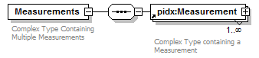
namespace | http://www.pidx.org/schema/ds/v5.02
properties | content complex
children | pidx:Measurement
used by | elements MeasurementInformation Recipe  complexType OnBoardDefinition
annotation | documentation  Complex Type Containing Multiple Measurements
source | <element name="Measurements">  <annotation>  <documentation>Complex Type Containing Multiple Measurements</documentation>  </annotation>  <complexType>  <sequence>  <element ref="pidx:Measurement" maxOccurs="unbounded"/>  </sequence>  </complexType>  </element>

element MeasurementType
diagram | 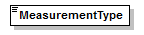
namespace | http://www.pidx.org/schema/ds/v5.02
type | union of (pidx:MeasurementTypeEnum)
properties | content simple
used by | complexType MeasurementComplexType
source | <element name="MeasurementType">  <simpleType>  <union memberTypes="pidx:MeasurementTypeEnum"/>  </simpleType>  </element>

element Message
diagram | 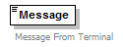
namespace | http://www.pidx.org/schema/ds/v5.02
type | string
properties | content simple
used by | elements LineItemResponse LineItemErrors/pidxLineItemError  complexTypes PMResponseFailedData PMResponseSucessData
annotation | documentation  Message From Terminal
source | <element name="Message" type="string">  <annotation>  <documentation>Message From Terminal</documentation>  </annotation>  </element>

element Metered
diagram | 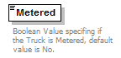
namespace | http://www.pidx.org/schema/ds/v5.02
type | pidx:YesNo
properties | content simple  default No
used by | element LoadPartSpecification
facets | enumeration Yes  enumeration No
annotation | documentation  Boolean Value specifing if the Truck is Metered, default value is No.
source | <element name="Metered" type="pidx:YesNo" default="No">  <annotation>  <documentation>Boolean Value specifing if the Truck is Metered, default value is No.</documentation>  </annotation>  </element>

element MeterIdentifier
diagram | 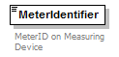
namespace | http://www.pidx.org/schema/ds/v5.02
type | string
properties | content simple
used by | elements Product Recipe
annotation | documentation  MeterID on Measuring Device
source | <element name="MeterIdentifier" type="string">  <annotation>  <documentation>MeterID on Measuring Device</documentation>  </annotation>  </element>

element MixPercentage
diagram | 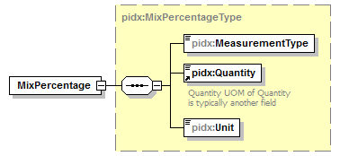
namespace | http://www.pidx.org/schema/ds/v5.02
type | pidx:MixPercentageType
properties | content complex
children | pidx:MeasurementType pidx:Quantity pidx:Unit
source | <element name="MixPercentage" type="pidx:MixPercentageType"/>

element ModeOfTransport
diagram | 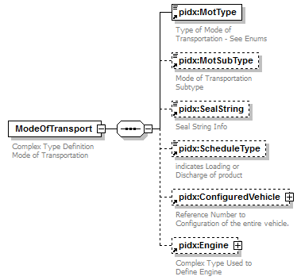
namespace | http://www.pidx.org/schema/ds/v5.02
properties | content complex
children | pidx:MotType pidx:MotSubType pidx:SealString pidx:ScheduleType pidx:ConfiguredVehicle pidx:Engine
used by | elements MOTinfo Transport
annotation | documentation  Complex Type Definition Mode of Transportation
source | <element name="ModeOfTransport">  <annotation>  <documentation>Complex Type Definition Mode of Transportation</documentation>  </annotation>  <complexType>  <sequence>  <element ref="pidx:MotType"/>  <element ref="pidx:MotSubType" minOccurs="0"/>  <element ref="pidx:SealString" minOccurs="0"/>  <element ref="pidx:ScheduleType" minOccurs="0"/>  <element ref="pidx:ConfiguredVehicle" minOccurs="0"/>  <element ref="pidx:Engine" minOccurs="0"/>  </sequence>  </complexType>  </element>

element MOTinfo
diagram | 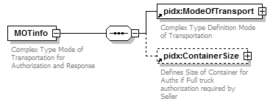
namespace | http://www.pidx.org/schema/ds/v5.02
properties | content complex
children | pidx:ModeOfTransport pidx:ContainerSize
used by | element AuthTransport
annotation | documentation  Complex Type Mode of Transportation for Authorization and Response
source | <element name="MOTinfo">  <annotation>  <documentation>Complex Type Mode of Transportation for Authorization and Response</documentation>  </annotation>  <complexType>  <sequence>  <element ref="pidx:ModeOfTransport"/>  <element ref="pidx:ContainerSize" minOccurs="0"/>  </sequence>  </complexType>  </element>

element MotItem
diagram | 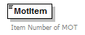
namespace | http://www.pidx.org/schema/ds/v5.02
type | integer
properties | content simple
used by | elements LoadPartIdentification ProductList
annotation | documentation  Item Number of MOT
source | <element name="MotItem" type="integer">  <annotation>  <documentation>Item Number of MOT</documentation>  </annotation>  </element>

element MotSubType
diagram | 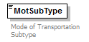
namespace | http://www.pidx.org/schema/ds/v5.02
type | string
properties | content simple
used by | element ModeOfTransport  complexType PMMOT
annotation | documentation  Mode of Transportation Subtype
source | <element name="MotSubType" type="string">  <annotation>  <documentation>Mode of Transportation Subtype</documentation>  </annotation>  </element>

element MotType
diagram | 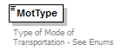
namespace | http://www.pidx.org/schema/ds/v5.02
type | pidx:MOTTypeEnum
properties | content simple  default Truck
used by | element ModeOfTransport  complexType PMMOT
facets | enumeration Truck  enumeration Rail  enumeration Barge  enumeration Pipeline  enumeration StorageTank  enumeration Vessel  enumeration BookTransfer  enumeration Container
annotation | documentation  Type of Mode of Transportation - See Enums
source | <element name="MotType" type="pidx:MOTTypeEnum" default="Truck">  <annotation>  <documentation>Type of Mode of Transportation - See Enums</documentation>  </annotation>  </element>

element MovementType
diagram | 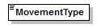
namespace | http://www.pidx.org/schema/ds/v5.02
type | pidx:MovementTypes
properties | content simple
used by | elements DocumentHeader PlannedLifting ResponseInfo  complexTypes PIDXPlannedMovementReq PMResponseBody
facets | enumeration LoadID  enumeration Nomination  enumeration Contract  enumeration Order  enumeration Shipment
source | <element name="MovementType" type="pidx:MovementTypes"/>

element NextDocumentSequence
diagram | 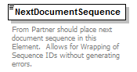
namespace | http://www.pidx.org/schema/ds/v5.02
type | integer
properties | content simple
used by | element Header
annotation | documentation  From Partner should place next document sequence in this Element. Allows for Wrapping of Sequence IDs without generating errors.
source | <element name="NextDocumentSequence" type="integer">  <annotation>  <documentation>From Partner should place next document sequence in this Element. Allows for Wrapping of Sequence IDs without generating errors.</documentation>  </annotation>  </element>

element NoQuantity
diagram | 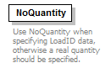
namespace | http://www.pidx.org/schema/ds/v5.02
type | pidx:NoQuantityType
properties | content complex
used by | complexType PMQuantity
annotation | documentation  Use NoQuantity when specifying LoadID data, otherwise a real quantity should be specified.
source | <element name="NoQuantity" type="pidx:NoQuantityType">  <annotation>  <documentation>Use NoQuantity when specifying LoadID data, otherwise a real quantity should be specified.</documentation>  </annotation>  </element>

element NumberOfCompartments
diagram | 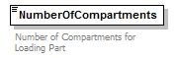
namespace | http://www.pidx.org/schema/ds/v5.02
type | integer
properties | content simple
used by | element LoadPartSpecification
annotation | documentation  Number of Compartments for Loading Part
source | <element name="NumberOfCompartments" type="integer">  <annotation>  <documentation>Number of Compartments for Loading Part</documentation>  </annotation>  </element>

element NumberOfRailCars
diagram | 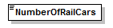
namespace | http://www.pidx.org/schema/ds/v5.02
type | integer
properties | content simple
used by | complexType RailDefinition
source | <element name="NumberOfRailCars" type="integer"/>

element OrderInfo
diagram | 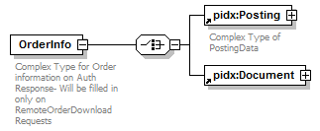
namespace | http://www.pidx.org/schema/ds/v5.02
type | extension of pidx:DocumentBaseClass
properties | content complex
children | pidx:Posting pidx:Document
used by | complexType AuthResponseData
annotation | documentation  Complex Type for Order information on Auth Response- Will be filled in only on RemoteOrderDownload Requests
source | <element name="OrderInfo">  <annotation>  <documentation>Complex Type for Order information on Auth Response- Will be filled in only on RemoteOrderDownload Requests</documentation>  </annotation>  <complexType>  <complexContent>  <extension base="pidx:DocumentBaseClass">  <choice>  <element ref="pidx:Posting"/>  <element ref="pidx:Document"/>  </choice>  </extension>  </complexContent>  </complexType>  </element>

element OrderNumber
diagram | 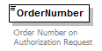
namespace | http://www.pidx.org/schema/ds/v5.02
type | string
properties | content simple
used by | element PlannedLifting
annotation | documentation  Order Number on Authorization Request
source | <element name="OrderNumber" type="string">  <annotation>  <documentation>Order Number on Authorization Request</documentation>  </annotation>  </element>

element OriginalDocumentIdentifier
diagram | 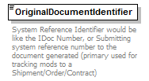
namespace | http://www.pidx.org/schema/ds/v5.02
type | string
properties | content simple
used by | complexTypes PMResponseBody RevisionData
annotation | documentation  System Reference Identifier would be like the IDoc Number, or Submitting system reference number to the document generated (primary used for tracking mods to a Shipment/Order/Contract)
source | <element name="OriginalDocumentIdentifier" type="string">  <annotation>  <documentation>System Reference Identifier would be like the IDoc Number, or Submitting system reference number to the document generated (primary used for tracking mods to a Shipment/Order/Contract)</documentation>  </annotation>  </element>

element PartnerExciseNumber
diagram | 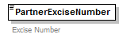
namespace | http://www.pidx.org/schema/ds/v5.02
type | string
properties | content simple
used by | complexType PartnerInformation
annotation | documentation  Excise Number
source | <element name="PartnerExciseNumber" type="string">  <annotation>  <documentation>Excise Number</documentation>  </annotation>  </element>

element PartnerIdentifier
diagram | 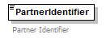
namespace | http://www.pidx.org/schema/ds/v5.02
type | string
properties | content simple
used by | complexType PartnerInformation
annotation | documentation  Partner Identifier
source | <element name="PartnerIdentifier" type="string">  <annotation>  <documentation>Partner Identifier </documentation>  </annotation>  </element>

element PartnerLocation
diagram | 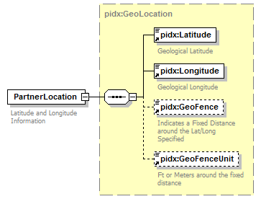
namespace | http://www.pidx.org/schema/ds/v5.02
type | pidx:GeoLocation
properties | content complex
children | pidx:Latitude pidx:Longitude pidx:GeoFence pidx:GeoFenceUnit
used by | element Location  complexType PartnerInformation
annotation | documentation  Latitude and Longitude Information
source | <element name="PartnerLocation" type="pidx:GeoLocation">  <annotation>  <documentation>Latitude and Longitude Information</documentation>  </annotation>  </element>

element PartnerName
diagram | 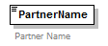
namespace | http://www.pidx.org/schema/ds/v5.02
type | string
properties | content simple
used by | element Location  complexType PartnerInformation
annotation | documentation  Partner Name
source | <element name="PartnerName" type="string">  <annotation>  <documentation>Partner Name</documentation>  </annotation>  </element>

element PartnerRoleIndicator
diagram | 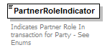
namespace | http://www.pidx.org/schema/ds/v5.02
type | union of (pidx:CustomsRoleEnum, pidx:PartnerRoleCodes, pidx:RailPartnerRoles)
properties | content simple
used by | complexType PartnerRoleInformation
annotation | documentation  Indicates Partner Role In transaction for Party - See Enums
source | <element name="PartnerRoleIndicator">  <annotation>  <documentation>Indicates Partner Role In transaction for Party - See Enums</documentation>  </annotation>  <simpleType>  <union memberTypes="pidx:CustomsRoleEnum pidx:PartnerRoleCodes pidx:RailPartnerRoles"/>  </simpleType>  </element>

element Partners
diagram | 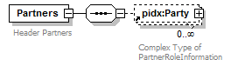
namespace | http://www.pidx.org/schema/ds/v5.02
properties | content complex
children | pidx:Party
used by | element DocumentHeader  complexType PostingData
annotation | documentation  Header Partners
source | <element name="Partners">  <annotation>  <documentation>Header Partners</documentation>  </annotation>  <complexType>  <sequence>  <element ref="pidx:Party" minOccurs="0" maxOccurs="unbounded"/>  </sequence>  </complexType>  </element>

element PartnerVATNumber
diagram | 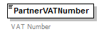
namespace | http://www.pidx.org/schema/ds/v5.02
type | string
properties | content simple
used by | complexType PartnerInformation
annotation | documentation  VAT Number
source | <element name="PartnerVATNumber" type="string">  <annotation>  <documentation>VAT Number</documentation>  </annotation>  </element>

element Party
diagram | 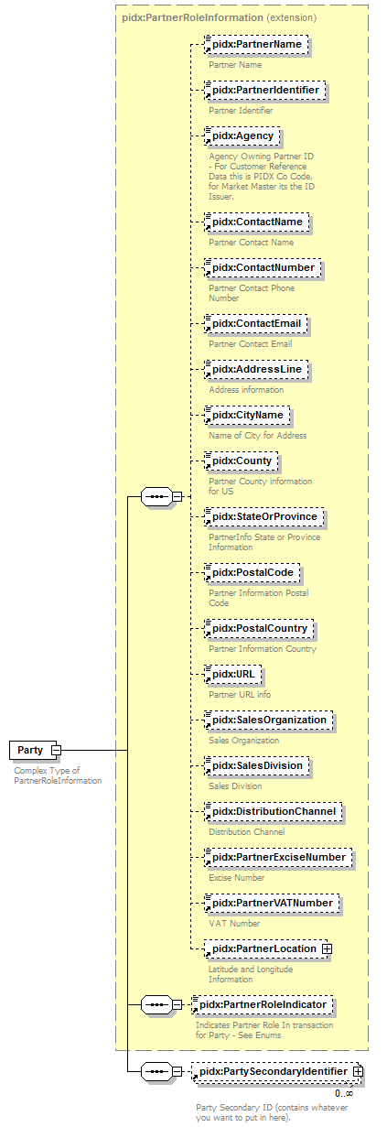
namespace | http://www.pidx.org/schema/ds/v5.02
type | extension of pidx:PartnerRoleInformation
properties | content complex
children | pidx:PartnerName pidx:PartnerIdentifier pidx:Agency pidx:ContactName pidx:ContactNumber pidx:ContactEmail pidx:AddressLine pidx:CityName pidx:County pidx:StateOrProvince pidx:PostalCode pidx:PostalCountry pidx:URL pidx:SalesOrganization pidx:SalesDivision pidx:DistributionChannel pidx:PartnerExciseNumber pidx:PartnerVATNumber pidx:PartnerLocation pidx:PartnerRoleIndicator pidx:PartySecondaryIdentifier
used by | elements DetailPartners Partners
annotation | documentation  Complex Type of PartnerRoleInformation
source | <element name="Party">  <annotation>  <documentation>Complex Type of PartnerRoleInformation</documentation>  </annotation>  <complexType>  <complexContent>  <extension base="pidx:PartnerRoleInformation">  <sequence>  <element ref="pidx:PartySecondaryIdentifier" minOccurs="0" maxOccurs="unbounded"/>  </sequence>  </extension>  </complexContent>  </complexType>  </element>

element PartyIdentifier
diagram | 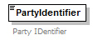
namespace | http://www.pidx.org/schema/ds/v5.02
type | string
properties | content simple
used by | element PartySecondaryIdentifier
annotation | documentation  Party IDentifier
source | <element name="PartyIdentifier" type="string">  <annotation>  <documentation>Party IDentifier</documentation>  </annotation>  </element>

element PartyIdentifierType
diagram | 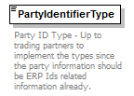
namespace | http://www.pidx.org/schema/ds/v5.02
type | string
properties | content simple
used by | element PartySecondaryIdentifier
annotation | documentation  Party ID Type - Up to trading partners to implement the types since the party information should be ERP Ids related information already.
source | <element name="PartyIdentifierType" type="string">  <annotation>  <documentation>Party ID Type - Up to trading partners to implement the types since the party information should be ERP Ids related information already.</documentation>  </annotation>  </element>

element PartyOwner
diagram | 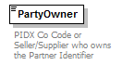
namespace | http://www.pidx.org/schema/ds/v5.02
type | string
properties | content simple
annotation | documentation  PIDX Co Code or Seller/Supplier who owns the Partner Identifier
source | <element name="PartyOwner" type="string">  <annotation>  <documentation>PIDX Co Code or Seller/Supplier who owns the Partner Identifier</documentation>  </annotation>  </element>

element PartySecondaryIdentifier
diagram | 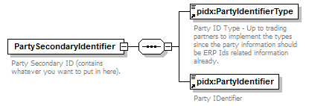
namespace | http://www.pidx.org/schema/ds/v5.02
properties | content complex
children | pidx:PartyIdentifierType pidx:PartyIdentifier
used by | element Party
annotation | documentation  Party Secondary ID (contains whatever you want to put in here).
source | <element name="PartySecondaryIdentifier">  <annotation>  <documentation>Party Secondary ID (contains whatever you want to put in here).</documentation>  </annotation>  <complexType>  <sequence>  <element ref="pidx:PartyIdentifierType"/>  <element ref="pidx:PartyIdentifier"/>  </sequence>  </complexType>  </element>

element PeriodQuantity
diagram | 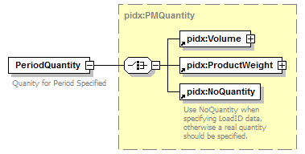
namespace | http://www.pidx.org/schema/ds/v5.02
type | pidx:PMQuantity
properties | content complex
children | pidx:Volume pidx:ProductWeight pidx:NoQuantity
used by | complexType QuantityScheduleType
annotation | documentation  Quanity for Period Specified
source | <element name="PeriodQuantity" type="pidx:PMQuantity">  <annotation>  <documentation>Quanity for Period Specified</documentation>  </annotation>  </element>

element PIDXProductID
diagram | 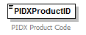
namespace | http://www.pidx.org/schema/ds/v5.02
type | string
properties | content simple
annotation | documentation  PIDX Product Code
source | <element name="PIDXProductID" type="string">  <annotation>  <documentation>PIDX Product Code</documentation>  </annotation>  </element>

element PIDXTerminalIdentifier
diagram | 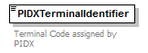
namespace | http://www.pidx.org/schema/ds/v5.02
type | string
properties | content simple
used by | element Location  complexType PIDXPlannedMovementReq
annotation | documentation  Terminal Code assigned by PIDX
source | <element name="PIDXTerminalIdentifier" type="string">  <annotation>  <documentation>Terminal Code assigned by PIDX</documentation>  </annotation>  </element>

element PIDXTerminalOwner
diagram | 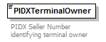
namespace | http://www.pidx.org/schema/ds/v5.02
type | string
properties | content simple
used by | element Location
annotation | documentation  PIDX Seller Number identifying terminal owner
source | <element name="PIDXTerminalOwner" type="string">  <annotation>  <documentation>PIDX Seller Number identifying terminal owner</documentation>  </annotation>  </element>

element PlannedLifting
diagram | 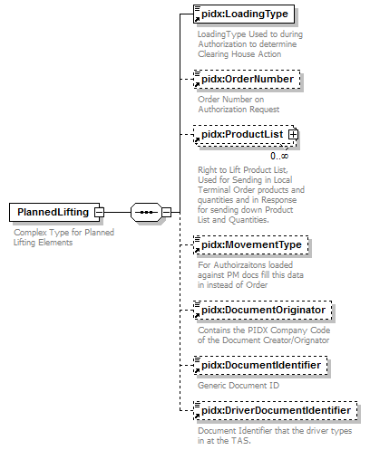
namespace | http://www.pidx.org/schema/ds/v5.02
properties | content complex
children | pidx:LoadingType pidx:OrderNumber pidx:ProductList pidx:MovementType pidx:DocumentOriginator pidx:DocumentIdentifier pidx:DriverDocumentIdentifier
used by | complexType AuthRequestData
annotation | documentation  Complex Type for Planned Lifting Elements
source | <element name="PlannedLifting">  <annotation>  <documentation>Complex Type for Planned Lifting Elements</documentation>  </annotation>  <complexType>  <sequence>  <element ref="pidx:LoadingType"/>  <element ref="pidx:OrderNumber" minOccurs="0"/>  <element ref="pidx:ProductList" minOccurs="0" maxOccurs="unbounded"/>  <element ref="pidx:MovementType" minOccurs="0">  <annotation>  <documentation>For Authoirzaitons loaded against PM docs fill this data in instead of Order</documentation>  </annotation>  </element>  <element ref="pidx:DocumentOriginator" minOccurs="0"/>  <element ref="pidx:DocumentIdentifier" minOccurs="0"/>  <element ref="pidx:DriverDocumentIdentifier" minOccurs="0"/>  </sequence>  </complexType>  </element>

element PlannedModeOfTransport
diagram | 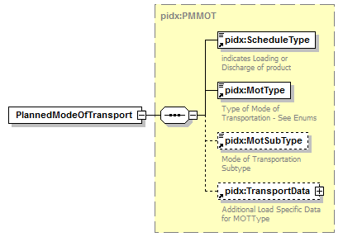
namespace | http://www.pidx.org/schema/ds/v5.02
type | pidx:PMMOT
properties | content complex
children | pidx:ScheduleType pidx:MotType pidx:MotSubType pidx:TransportData
used by | elements DocumentHeader DocumentLineItem
source | <element name="PlannedModeOfTransport" type="pidx:PMMOT"/>

element PlannedMovementRequest
diagram | 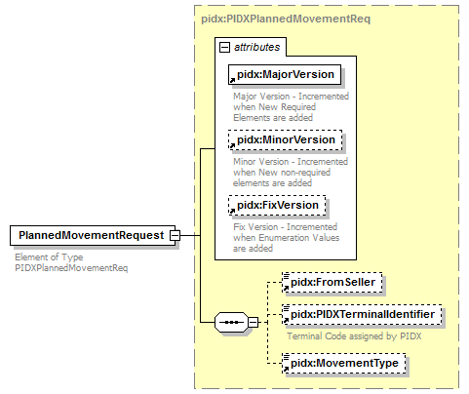
namespace | http://www.pidx.org/schema/ds/v5.02
type | pidx:PIDXPlannedMovementReq
properties | content complex
children | pidx:FromSeller pidx:PIDXTerminalIdentifier pidx:MovementType
attributes | Name Type Use Default Fixed annotation  MajorVersion required 05 documentation Major Version - Incremented when New Required Elements are added  MinorVersion optional 02 documentation Minor Version - Incremented when New non-required elements are added  FixVersion optional 01 documentation Fix Version - Incremented when Enumeration Values are added
annotation | documentation  Element of Type PIDXPlannedMovementReq
source | <element name="PlannedMovementRequest" type="pidx:PIDXPlannedMovementReq">  <annotation>  <documentation>Element of Type PIDXPlannedMovementReq</documentation>  </annotation>  </element>

element PlannedProduct
diagram | 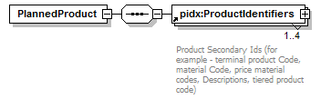
namespace | http://www.pidx.org/schema/ds/v5.02
properties | content complex
children | pidx:ProductIdentifiers
used by | elements DocumentLineItem LoadCompartment
source | <element name="PlannedProduct">  <complexType>  <sequence>  <element ref="pidx:ProductIdentifiers" maxOccurs="4"/>  </sequence>  </complexType>  </element>

element PlannedQuantity
diagram | 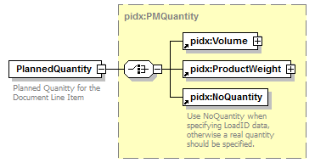
namespace | http://www.pidx.org/schema/ds/v5.02
type | pidx:PMQuantity
properties | content complex
children | pidx:Volume pidx:ProductWeight pidx:NoQuantity
used by | element DocumentLineItem
annotation | documentation  Planned Quanitty for the Document Line Item
source | <element name="PlannedQuantity" type="pidx:PMQuantity">  <annotation>  <documentation>Planned Quanitty for the Document Line Item</documentation>  </annotation>  </element>

element PMReceivedDateTime
diagram | 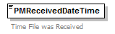
namespace | http://www.pidx.org/schema/ds/v5.02
type | dateTime
properties | content simple
used by | complexType PMResponseBody
annotation | documentation  Time File was Received
source | <element name="PMReceivedDateTime" type="dateTime">  <annotation>  <documentation>Time File was Received</documentation>  </annotation>  </element>

element PostalCode
diagram | 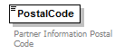
namespace | http://www.pidx.org/schema/ds/v5.02
type | string
properties | content simple
used by | element Location  complexType PartnerInformation
annotation | documentation  Partner Information Postal Code
source | <element name="PostalCode" type="string">  <annotation>  <documentation>Partner Information Postal Code</documentation>  </annotation>  </element>

element PostalCountry
diagram
namespace | http://www.pidx.org/schema/ds/v5.02
type | string
properties | content simple
used by | element Location  complexType PartnerInformation
annotation | documentation  Partner Information Country
source | <element name="PostalCountry" type="string">  <annotation>  <documentation>Partner Information Country</documentation>  </annotation>  </element>

element Posting
diagram | 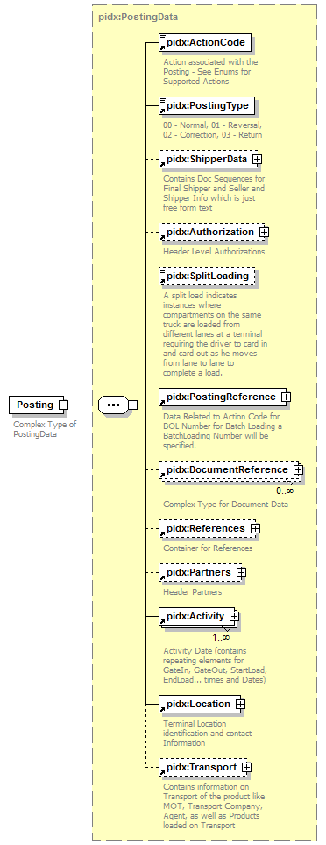
namespace | http://www.pidx.org/schema/ds/v5.02
type | pidx:PostingData
properties | content complex
children | pidx:ActionCode pidx:PostingType pidx:ShipperData pidx:Authorization pidx:SplitLoading pidx:PostingReference pidx:DocumentReference pidx:References pidx:Partners pidx:Activity pidx:Location pidx:Transport
used by | elements Body OrderInfo
annotation | documentation  Complex Type of PostingData
source | <element name="Posting" type="pidx:PostingData">  <annotation>  <documentation>Complex Type of PostingData</documentation>  </annotation>  </element>

element PostingReference
diagram | 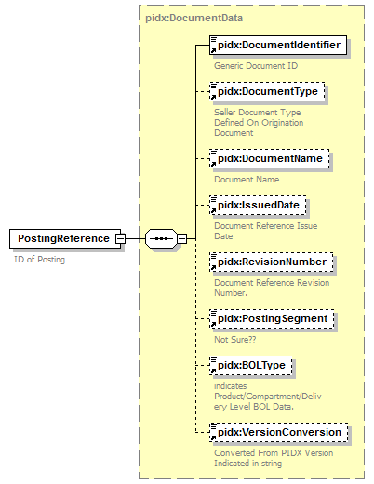
namespace | http://www.pidx.org/schema/ds/v5.02
type | pidx:DocumentData
properties | content complex
children | pidx:DocumentIdentifier pidx:DocumentType pidx:DocumentName pidx:IssuedDate pidx:RevisionNumber pidx:PostingSegment pidx:BOLType pidx:VersionConversion
used by | complexType PostingData
annotation | documentation  ID of Posting
source | <element name="PostingReference" type="pidx:DocumentData">  <annotation>  <documentation>ID of Posting</documentation>  </annotation>  </element>

element PostingReferenceDetail
diagram | 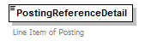
namespace | http://www.pidx.org/schema/ds/v5.02
type | short
properties | content simple
used by | element Compartment
annotation | documentation  Line Item of Posting
source | <element name="PostingReferenceDetail" type="short">  <annotation>  <documentation>Line Item of Posting</documentation>  </annotation>  </element>

element PostingSegment
diagram | 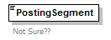
namespace | http://www.pidx.org/schema/ds/v5.02
type | string
properties | content simple
used by | complexType DocumentData
annotation | documentation  Not Sure??
source | <element name="PostingSegment" type="string">  <annotation>  <documentation>Not Sure??</documentation>  </annotation>  </element>

element PostingType
diagram | 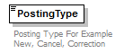
namespace | http://www.pidx.org/schema/ds/v5.02
type | pidx:PostingTypeEnum
properties | content simple  default 00
used by | complexType PostingData
facets | enumeration 00  enumeration 01  enumeration 02  enumeration 03
annotation | documentation  Posting Type For Example New, Cancel, Correction
source | <element name="PostingType" type="pidx:PostingTypeEnum" default="00">  <annotation>  <documentation>Posting Type For Example New, Cancel, Correction</documentation>  </annotation>  </element>

element Pressure
diagram | 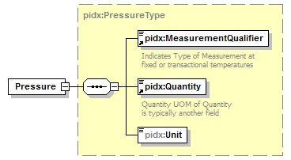
namespace | http://www.pidx.org/schema/ds/v5.02
type | pidx:PressureType
properties | content complex
children | pidx:MeasurementQualifier pidx:Quantity pidx:Unit
source | <element name="Pressure" type="pidx:PressureType"/>

element PriorToLoad
diagram | 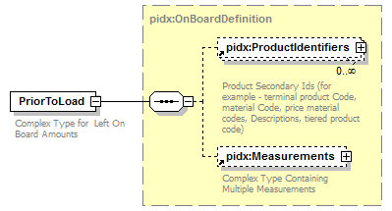
namespace | http://www.pidx.org/schema/ds/v5.02
type | pidx:OnBoardDefinition
properties | content complex
children | pidx:ProductIdentifiers pidx:Measurements
used by | element Compartment
annotation | documentation  Complex Type for Left On Board Amounts
source | <element name="PriorToLoad" type="pidx:OnBoardDefinition">  <annotation>  <documentation>Complex Type for Left On Board Amounts</documentation>  </annotation>  </element>

element ProcessingCompleteDateTime
diagram | 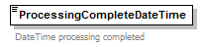
namespace | http://www.pidx.org/schema/ds/v5.02
type | dateTime
properties | content simple
used by | complexType PMResponseBody
annotation | documentation  DateTime processing completed
source | <element name="ProcessingCompleteDateTime" type="dateTime">  <annotation>  <documentation>DateTime processing completed</documentation>  </annotation>  </element>

element Product
diagram | 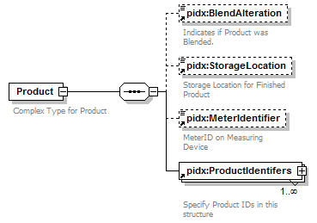
namespace | http://www.pidx.org/schema/ds/v5.02
properties | content complex
children | pidx:BlendAlteration pidx:StorageLocation pidx:MeterIdentifier pidx:ProductIdentifers
used by | elements Compartment ProductList
annotation | documentation  Complex Type for Product
source | <element name="Product">  <annotation>  <documentation>Complex Type for Product</documentation>  </annotation>  <complexType>  <sequence>  <element ref="pidx:BlendAlteration" minOccurs="0"/>  <element ref="pidx:StorageLocation" minOccurs="0"/>  <element ref="pidx:MeterIdentifier" minOccurs="0"/>  <element ref="pidx:ProductIdentifers" maxOccurs="unbounded">  <annotation>  <documentation>Specify Product IDs in this structure</documentation>  </annotation>  </element>  </sequence>  </complexType>  </element>

element ProductIdentifer
diagram | 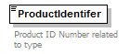
namespace | http://www.pidx.org/schema/ds/v5.02
type | string
properties | content simple
used by | complexType ProductData
annotation | documentation  Product ID Number related to type
source | <element name="ProductIdentifer" type="string">  <annotation>  <documentation>Product ID Number related to type</documentation>  </annotation>  </element>

element ProductIdentifers
diagram | 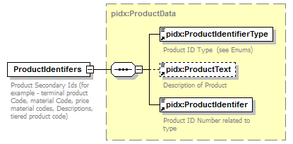
namespace | http://www.pidx.org/schema/ds/v5.02
type | pidx:ProductData
properties | content complex
children | pidx:ProductIdentifierType pidx:ProductText pidx:ProductIdentifer
used by | element Product
annotation | documentation  Product Secondary Ids (for example - terminal product Code, material Code, price material codes, Descriptions, tiered product code)
source | <element name="ProductIdentifers" type="pidx:ProductData">  <annotation>  <documentation>Product Secondary Ids (for example - terminal product Code, material Code, price material codes, Descriptions, tiered product code)</documentation>  </annotation>  </element>

element ProductIdentifier
diagram | 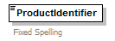
namespace | http://www.pidx.org/schema/ds/v5.02
type | string
properties | content simple
used by | complexType ProductDataV1
annotation | documentation  Fixed Spelling
source | <element name="ProductIdentifier" type="string">  <annotation>  <documentation>Fixed Spelling</documentation>  </annotation>  </element>

element ProductIdentifiers
diagram | 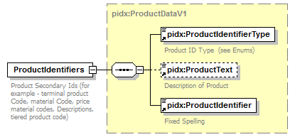
namespace | http://www.pidx.org/schema/ds/v5.02
type | pidx:ProductDataV1
properties | content complex
children | pidx:ProductIdentifierType pidx:ProductText pidx:ProductIdentifier
used by | element PlannedProduct  complexType OnBoardDefinition
annotation | documentation  Product Secondary Ids (for example - terminal product Code, material Code, price material codes, Descriptions, tiered product code)
source | <element name="ProductIdentifiers" type="pidx:ProductDataV1">  <annotation>  <documentation>Product Secondary Ids (for example - terminal product Code, material Code, price material codes, Descriptions, tiered product code)</documentation>  </annotation>  </element>

element ProductIdentifierType
diagram | 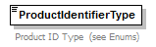
namespace | http://www.pidx.org/schema/ds/v5.02
type | pidx:ProductIdentifierTypes
properties | content simple
used by | complexTypes ProductData ProductDataV1
facets | enumeration PIDXProductID  enumeration TerminalProductID  enumeration MaterialCode  enumeration GlobalCatalogProduct
annotation | documentation  Product ID Type (see Enums)
source | <element name="ProductIdentifierType" type="pidx:ProductIdentifierTypes">  <annotation>  <documentation>Product ID Type (see Enums)</documentation>  </annotation>  </element>

element ProductList
diagram | 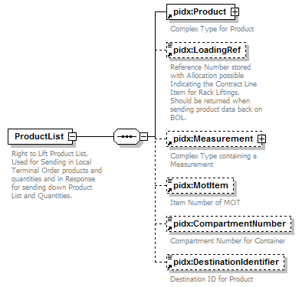
namespace | http://www.pidx.org/schema/ds/v5.02
properties | content complex
children | pidx:Product pidx:LoadingRef pidx:Measurement pidx:MotItem pidx:CompartmentNumber pidx:DestinationIdentifier
used by | element PlannedLifting  complexType AuthResponseData
annotation | documentation  Right to Lift Product List, Used for Sending in Local Terminal Order products and quantities and in Response for sending down Product List and Quantities.
source | <element name="ProductList">  <annotation>  <documentation>Right to Lift Product List, Used for Sending in Local Terminal Order products and quantities and in Response for sending down Product List and Quantities.</documentation>  </annotation>  <complexType>  <sequence>  <element ref="pidx:Product"/>  <element ref="pidx:LoadingRef" minOccurs="0"/>  <element ref="pidx:Measurement" minOccurs="0"/>  <element ref="pidx:MotItem" minOccurs="0"/>  <element ref="pidx:CompartmentNumber" minOccurs="0"/>  <element ref="pidx:DestinationIdentifier" minOccurs="0"/>  </sequence>  </complexType>  </element>

element ProductText
diagram | 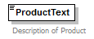
namespace | http://www.pidx.org/schema/ds/v5.02
type | string
properties | content simple
used by | complexTypes ProductData ProductDataV1
annotation | documentation  Description of Product
source | <element name="ProductText" type="string">  <annotation>  <documentation>Description of Product</documentation>  </annotation>  </element>

element ProductWeight
diagram | 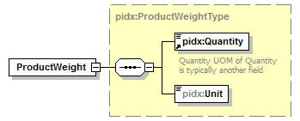
namespace | http://www.pidx.org/schema/ds/v5.02
type | pidx:ProductWeightType
properties | content complex
children | pidx:Quantity pidx:Unit
used by | complexType PMQuantity
source | <element name="ProductWeight" type="pidx:ProductWeightType"/>

element Quantity
diagram | 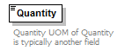
namespace | http://www.pidx.org/schema/ds/v5.02
type | decimal
properties | content simple
used by | element TaxDetail  complexTypes DensityType GravityType MeasurementComplexType MixPercentageType PressureType ProductWeightType TemperatureType VolumeType
annotation | documentation  Quantity UOM of Quantity is typically another field
source | <element name="Quantity" type="decimal">  <annotation>  <documentation>Quantity UOM of Quantity is typically another field</documentation>  </annotation>  </element>

element QuantitySchedule
diagram | 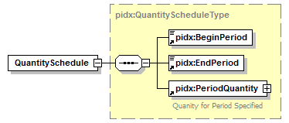
namespace | http://www.pidx.org/schema/ds/v5.02
type | pidx:QuantityScheduleType
properties | content complex
children | pidx:BeginPeriod pidx:EndPeriod pidx:PeriodQuantity
used by | element QuantitySchedules
source | <element name="QuantitySchedule" type="pidx:QuantityScheduleType"/>

element QuantitySchedules
diagram | 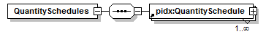
namespace | http://www.pidx.org/schema/ds/v5.02
properties | content complex
children | pidx:QuantitySchedule
used by | element DocumentLineItem
source | <element name="QuantitySchedules">  <complexType>  <sequence>  <element ref="pidx:QuantitySchedule" maxOccurs="unbounded"/>  </sequence>  </complexType>  </element>

element QuantityUnit
diagram | 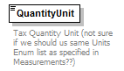
namespace | http://www.pidx.org/schema/ds/v5.02
type | string
properties | content simple
annotation | documentation  Tax Quantity Unit (not sure if we should us same Units Enum list as specified in Measurements??)
source | <element name="QuantityUnit" type="string">  <annotation>  <documentation>Tax Quantity Unit (not sure if we should us same Units Enum list as specified in Measurements??)</documentation>  </annotation>  </element>

element Rail
diagram | 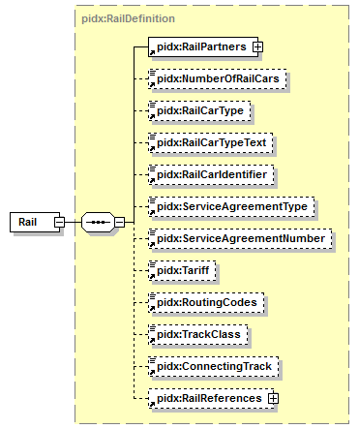
namespace | http://www.pidx.org/schema/ds/v5.02
type | pidx:RailDefinition
properties | content complex
children | pidx:RailPartners pidx:NumberOfRailCars pidx:RailCarType pidx:RailCarTypeText pidx:RailCarIdentifier pidx:ServiceAgreementType pidx:ServiceAgreementNumber pidx:Tariff pidx:RoutingCodes pidx:TrackClass pidx:ConnectingTrack pidx:RailReferences
used by | element TransportData
source | <element name="Rail" type="pidx:RailDefinition"/>

element RailCarIdentifier
diagram | 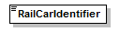
namespace | http://www.pidx.org/schema/ds/v5.02
type | string
properties | content simple
used by | complexType RailDefinition
source | <element name="RailCarIdentifier" type="string"/>

element RailCarType
diagram | 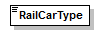
namespace | http://www.pidx.org/schema/ds/v5.02
type | string
properties | content simple
used by | complexType RailDefinition
source | <element name="RailCarType" type="string"/>

element RailCarTypeText
diagram | 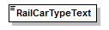
namespace | http://www.pidx.org/schema/ds/v5.02
type | string
properties | content simple
used by | complexType RailDefinition
source | <element name="RailCarTypeText" type="string"/>

element RailPartners
diagram | 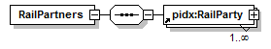
namespace | http://www.pidx.org/schema/ds/v5.02
properties | content complex
children | pidx:RailParty
used by | complexType RailDefinition
source | <element name="RailPartners">  <complexType>  <sequence>  <element ref="pidx:RailParty" maxOccurs="unbounded"/>  </sequence>  </complexType>  </element>

element RailParty
diagram | 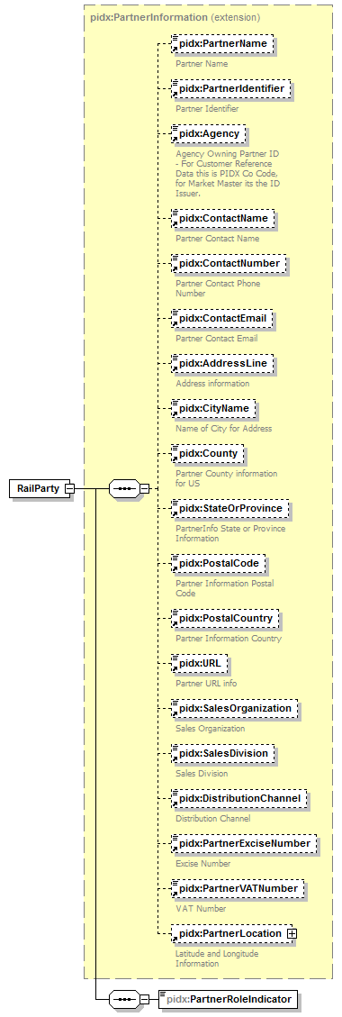
namespace | http://www.pidx.org/schema/ds/v5.02
type | extension of pidx:PartnerInformation
properties | content complex
children | pidx:PartnerName pidx:PartnerIdentifier pidx:Agency pidx:ContactName pidx:ContactNumber pidx:ContactEmail pidx:AddressLine pidx:CityName pidx:County pidx:StateOrProvince pidx:PostalCode pidx:PostalCountry pidx:URL pidx:SalesOrganization pidx:SalesDivision pidx:DistributionChannel pidx:PartnerExciseNumber pidx:PartnerVATNumber pidx:PartnerLocation pidx:PartnerRoleIndicator
used by | element RailPartners
source | <element name="RailParty">  <complexType>  <complexContent>  <extension base="pidx:PartnerInformation">  <sequence>  <element name="PartnerRoleIndicator" type="pidx:RailPartnerRoles"/>  </sequence>  </extension>  </complexContent>  </complexType>  </element>

element RailParty/PartnerRoleIndicator
diagram | 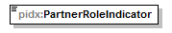
namespace | http://www.pidx.org/schema/ds/v5.02
type | pidx:RailPartnerRoles
properties | isRef 0  content simple
used by | complexType PartnerRoleInformation
facets | enumeration AlternateSender  enumeration AlternateReceiver  enumeration DestinationStation  enumeration FreightPayor  enumeration RailCarCompany  enumeration RailCompany  enumeration RailReceiver  enumeration RailSender
source | <element name="PartnerRoleIndicator" type="pidx:RailPartnerRoles"/>

element RailReference
diagram | 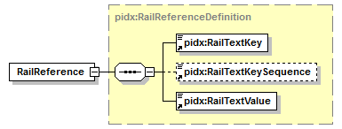
namespace | http://www.pidx.org/schema/ds/v5.02
type | pidx:RailReferenceDefinition
properties | content complex
children | pidx:RailTextKey pidx:RailTextKeySequence pidx:RailTextValue
used by | element RailReferences
source | <element name="RailReference" type="pidx:RailReferenceDefinition"/>

element RailReferences
diagram | 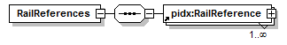
namespace | http://www.pidx.org/schema/ds/v5.02
properties | content complex
children | pidx:RailReference
used by | complexType RailDefinition
source | <element name="RailReferences">  <complexType>  <sequence>  <element ref="pidx:RailReference" maxOccurs="unbounded"/>  </sequence>  </complexType>  </element>

element RailTextKey
diagram | 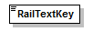
namespace | http://www.pidx.org/schema/ds/v5.02
type | string
properties | content simple
used by | complexType RailReferenceDefinition
source | <element name="RailTextKey" type="string"/>

element RailTextKeySequence
diagram | 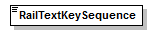
namespace | http://www.pidx.org/schema/ds/v5.02
type | integer
properties | content simple
used by | complexType RailReferenceDefinition
source | <element name="RailTextKeySequence" type="integer"/>

element RailTextValue
diagram | 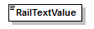
namespace | http://www.pidx.org/schema/ds/v5.02
type | string
properties | content simple
used by | complexType RailReferenceDefinition
source | <element name="RailTextValue" type="string"/>

element Rate
diagram | 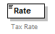
namespace | http://www.pidx.org/schema/ds/v5.02
type | decimal
properties | content simple
used by | element TaxDetail
annotation | documentation  Tax Rate
source | <element name="Rate" type="decimal">  <annotation>  <documentation>Tax Rate</documentation>  </annotation>  </element>

element ReasonCode
diagram | 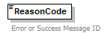
namespace | http://www.pidx.org/schema/ds/v5.02
type | string
properties | content simple  default 00
used by | element LineItemResponse
annotation | documentation  Error or Success Message ID
source | <element name="ReasonCode" type="string" default="00">  <annotation>  <documentation>Error or Success Message ID</documentation>  </annotation>  </element>

element Recipe
diagram | 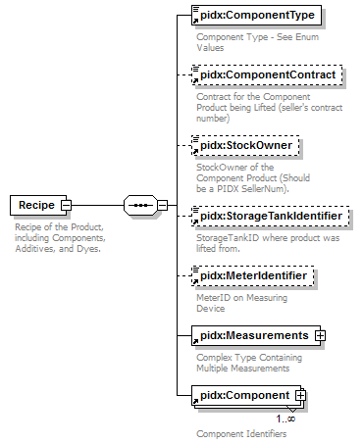
namespace | http://www.pidx.org/schema/ds/v5.02
properties | content complex
children | pidx:ComponentType pidx:ComponentContract pidx:StockOwner pidx:StorageTankIdentifier pidx:MeterIdentifier pidx:Measurements pidx:Component
used by | element Recipes
annotation | documentation  Recipe of the Product, including Components, Additives, and Dyes.
source | <element name="Recipe">  <annotation>  <documentation>Recipe of the Product, including Components, Additives, and Dyes.</documentation>  </annotation>  <complexType>  <sequence>  <element ref="pidx:ComponentType"/>  <element ref="pidx:ComponentContract" minOccurs="0"/>  <element ref="pidx:StockOwner" minOccurs="0"/>  <element ref="pidx:StorageTankIdentifier" minOccurs="0"/>  <element ref="pidx:MeterIdentifier" minOccurs="0"/>  <element ref="pidx:Measurements"/>  <element ref="pidx:Component" maxOccurs="unbounded"/>  </sequence>  </complexType>  </element>

element Recipes
diagram | 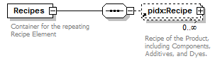
namespace | http://www.pidx.org/schema/ds/v5.02
properties | content complex
children | pidx:Recipe
used by | element MeasurementInformation
annotation | documentation  Container for the repeating Recipe Element
source | <element name="Recipes">  <annotation>  <documentation>Container for the repeating Recipe Element</documentation>  </annotation>  <complexType>  <sequence>  <element ref="pidx:Recipe" minOccurs="0" maxOccurs="unbounded"/>  </sequence>  </complexType>  </element>

element RecipientDocumentIdentifier
diagram | 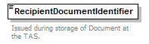
namespace | http://www.pidx.org/schema/ds/v5.02
type | string
properties | content simple
used by | complexType PMResponseSucessData
annotation | documentation  Issued during storage of Document at the TAS.
source | <element name="RecipientDocumentIdentifier" type="string">  <annotation>  <documentation>Issued during storage of Document at the TAS.</documentation>  </annotation>  </element>

element Reference
diagram | 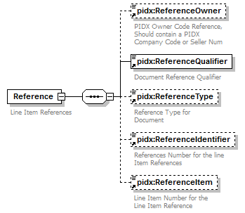
namespace | http://www.pidx.org/schema/ds/v5.02
properties | content complex
children | pidx:ReferenceOwner pidx:ReferenceQualifier pidx:ReferenceType pidx:ReferenceIdentifier pidx:ReferenceItem
used by | elements Compartment DetailReferences References
annotation | documentation  Line Item References
source | <element name="Reference">  <annotation>  <documentation>Line Item References</documentation>  </annotation>  <complexType>  <sequence>  <element ref="pidx:ReferenceOwner" minOccurs="0"/>  <element ref="pidx:ReferenceQualifier"/>  <element ref="pidx:ReferenceType" minOccurs="0"/>  <element ref="pidx:ReferenceIdentifier" minOccurs="0"/>  <element ref="pidx:ReferenceItem" minOccurs="0"/>  </sequence>  </complexType>  </element>

element ReferenceIdentifier
diagram | 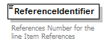
namespace | http://www.pidx.org/schema/ds/v5.02
type | string
properties | content simple
used by | element Reference
annotation | documentation  References Number for the line Item References
source | <element name="ReferenceIdentifier" type="string">  <annotation>  <documentation>References Number for the line Item References</documentation>  </annotation>  </element>

element ReferenceItem
diagram | 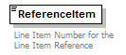
namespace | http://www.pidx.org/schema/ds/v5.02
type | string
properties | content simple
used by | element Reference
annotation | documentation  Line Item Number for the Line Item Reference
source | <element name="ReferenceItem" type="string">  <annotation>  <documentation>Line Item Number for the Line Item Reference</documentation>  </annotation>  </element>

element ReferenceOwner
diagram | 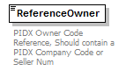
namespace | http://www.pidx.org/schema/ds/v5.02
type | string
properties | content simple
used by | element Reference
annotation | documentation  PIDX Owner Code Reference, Should contain a PIDX Company Code or Seller Num
source | <element name="ReferenceOwner" type="string">  <annotation>  <documentation>PIDX Owner Code Reference, Should contain a PIDX Company Code or Seller Num</documentation>  </annotation>  </element>

element ReferenceQualifier
diagram
namespace | http://www.pidx.org/schema/ds/v5.02
type | union of (pidx:ReferenceTypes)
properties | content simple
used by | element Reference
annotation | documentation  Document Reference Qualifier
source | <element name="ReferenceQualifier">  <annotation>  <documentation>Document Reference Qualifier</documentation>  </annotation>  <simpleType>  <union memberTypes="pidx:ReferenceTypes"/>  </simpleType>  </element>

element References
diagram | 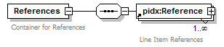
namespace | http://www.pidx.org/schema/ds/v5.02
properties | content complex
children | pidx:Reference
used by | element DocumentHeader  complexType PostingData
annotation | documentation  Container for References
source | <element name="References">  <annotation>  <documentation>Container for References</documentation>  </annotation>  <complexType>  <sequence>  <element ref="pidx:Reference" maxOccurs="unbounded"/>  </sequence>  </complexType>  </element>

element ReferenceType
diagram | 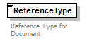
namespace | http://www.pidx.org/schema/ds/v5.02
type | string
properties | content simple
used by | element Reference
annotation | documentation  Reference Type for Document
source | <element name="ReferenceType" type="string">  <annotation>  <documentation>Reference Type for Document</documentation>  </annotation>  </element>

element RegionCode
diagram | 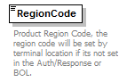
namespace | http://www.pidx.org/schema/ds/v5.02
type | restriction of string
properties | content simple
facets | enumeration Africa  enumeration Antarctica  enumeration Asia  enumeration Oceania  enumeration Europe  enumeration NorthAmerica  enumeration SouthAmerica
annotation | documentation  Product Region Code, the region code will be set by terminal location if its not set in the Auth/Response or BOL.
source | <element name="RegionCode">  <annotation>  <documentation>Product Region Code, the region code will be set by terminal location if its not set in the Auth/Response or BOL.</documentation>  </annotation>  <simpleType>  <restriction base="string">  <enumeration value="Africa"/>  <enumeration value="Antarctica"/>  <enumeration value="Asia"/>  <enumeration value="Oceania"/>  <enumeration value="Europe"/>  <enumeration value="NorthAmerica"/>  <enumeration value="SouthAmerica"/>  </restriction>  </simpleType>  </element>

element RenewalDate
diagram | 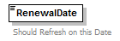
namespace | http://www.pidx.org/schema/ds/v5.02
type | date
properties | content simple
used by | complexType AgentData
annotation | documentation  Should Refresh on this Date
source | <element name="RenewalDate" type="date">  <annotation>  <documentation>Should Refresh on this Date</documentation>  </annotation>  </element>

element Required
diagram | 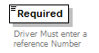
namespace | http://www.pidx.org/schema/ds/v5.02
type | pidx:YesNo
properties | content simple  default No
used by | complexType SecondaryLoadReferenceCT
facets | enumeration Yes  enumeration No
annotation | documentation  Driver Must enter a reference Number
source | <element name="Required" type="pidx:YesNo" default="No">  <annotation>  <documentation>Driver Must enter a reference Number</documentation>  </annotation>  </element>

element Response
diagram | 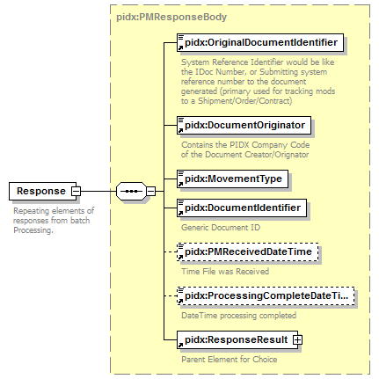
namespace | http://www.pidx.org/schema/ds/v5.02
type | pidx:PMResponseBody
properties | content complex
children | pidx:OriginalDocumentIdentifier pidx:DocumentOriginator pidx:MovementType pidx:DocumentIdentifier pidx:PMReceivedDateTime pidx:ProcessingCompleteDateTime pidx:ResponseResult
used by | element PMResponseComplex/Body
annotation | documentation  Repeating elements of responses from batch Processing.
source | <element name="Response" type="pidx:PMResponseBody">  <annotation>  <documentation>Repeating elements of responses from batch Processing.</documentation>  </annotation>  </element>

element ResponseInfo
diagram | 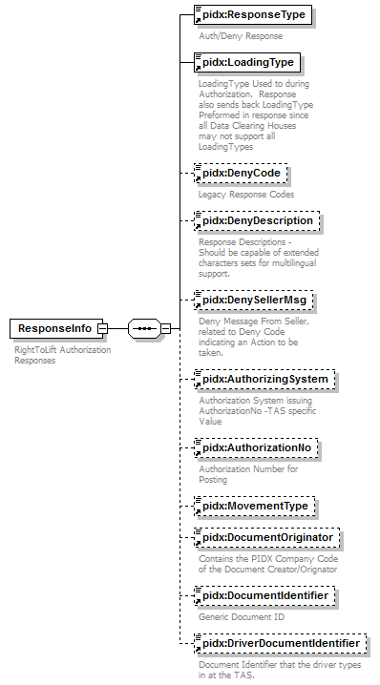
namespace | http://www.pidx.org/schema/ds/v5.02
properties | content complex
children | pidx:ResponseType pidx:LoadingType pidx:DenyCode pidx:DenyDescription pidx:DenySellerMsg pidx:AuthorizingSystem pidx:AuthorizationNo pidx:MovementType pidx:DocumentOriginator pidx:DocumentIdentifier pidx:DriverDocumentIdentifier
used by | complexType AuthResponseData
annotation | documentation  RightToLift Authorization Responses
source | <element name="ResponseInfo">  <annotation>  <documentation>RightToLift Authorization Responses</documentation>  </annotation>  <complexType>  <sequence>  <element ref="pidx:ResponseType"/>  <element ref="pidx:LoadingType">  <annotation>  <documentation>LoadingType Used to during Authorization. Response also sends back LoadingType Preformed in response since all Data Clearing Houses may not support all LoadingTypes</documentation>  </annotation>  </element>  <element ref="pidx:DenyCode" minOccurs="0"/>  <element ref="pidx:DenyDescription" minOccurs="0"/>  <element ref="pidx:DenySellerMsg" minOccurs="0"/>  <element ref="pidx:AuthorizingSystem" minOccurs="0"/>  <element ref="pidx:AuthorizationNo" minOccurs="0"/>  <element ref="pidx:MovementType" minOccurs="0"/>  <element ref="pidx:DocumentOriginator" minOccurs="0"/>  <element ref="pidx:DocumentIdentifier" minOccurs="0"/>  <element ref="pidx:DriverDocumentIdentifier" minOccurs="0"/>  </sequence>  </complexType>  </element>

element ResponseResult
diagram | 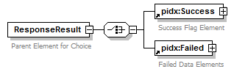
namespace | http://www.pidx.org/schema/ds/v5.02
type | extension of pidx:PMResponseBaseClass
properties | content complex
children | pidx:Success pidx:Failed
used by | complexType PMResponseBody
annotation | documentation  Parent Element for Choice
source | <element name="ResponseResult">  <annotation>  <documentation>Parent Element for Choice</documentation>  </annotation>  <complexType>  <complexContent>  <extension base="pidx:PMResponseBaseClass">  <choice>  <element ref="pidx:Success"/>  <element ref="pidx:Failed"/>  </choice>  </extension>  </complexContent>  </complexType>  </element>

element ResponseType
diagram | 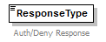
namespace | http://www.pidx.org/schema/ds/v5.02
type | restriction of string
properties | content simple
used by | element ResponseInfo
facets | enumeration AUTH  enumeration DENY
annotation | documentation  Auth/Deny Response
source | <element name="ResponseType">  <annotation>  <documentation>Auth/Deny Response</documentation>  </annotation>  <simpleType>  <restriction base="string">  <enumeration value="AUTH"/>  <enumeration value="DENY"/>  </restriction>  </simpleType>  </element>

element Revision
diagram | 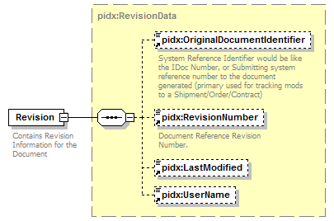
namespace | http://www.pidx.org/schema/ds/v5.02
type | pidx:RevisionData
properties | content complex
children | pidx:OriginalDocumentIdentifier pidx:RevisionNumber pidx:LastModified pidx:UserName
used by | elements DocumentHeader DocumentReference
annotation | documentation  Contains Revision Information for the Document
source | <element name="Revision" type="pidx:RevisionData">  <annotation>  <documentation>Contains Revision Information for the Document</documentation>  </annotation>  </element>

element RevisionNumber
diagram | 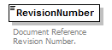
namespace | http://www.pidx.org/schema/ds/v5.02
type | string
properties | content simple
used by | element DocumentReference  complexTypes DocumentData RevisionData
annotation | documentation  Document Reference Revision Number.
source | <element name="RevisionNumber" type="string">  <annotation>  <documentation>Document Reference Revision Number.</documentation>  </annotation>  </element>

element RightToLiftCheck
diagram | 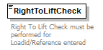
namespace | http://www.pidx.org/schema/ds/v5.02
type | pidx:RightToLIftEnum
properties | content simple  default NotRequired
used by | element AuthorizationSetting
facets | enumeration AtLiftingTime  enumeration OnReceipt  enumeration NotRequired
annotation | documentation  Right To Lift Check must be performed for Loadid/Reference entered
source | <element name="RightToLiftCheck" type="pidx:RightToLIftEnum" default="NotRequired">  <annotation>  <documentation>Right To Lift Check must be performed for Loadid/Reference entered</documentation>  </annotation>  </element>

element RightToLiftSystem
diagram | 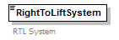
namespace | http://www.pidx.org/schema/ds/v5.02
type | string
properties | content simple
annotation | documentation  RTL System
source | <element name="RightToLiftSystem" type="string">  <annotation>  <documentation>RTL System</documentation>  </annotation>  </element>

element RoutingCodes
diagram | 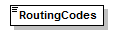
namespace | http://www.pidx.org/schema/ds/v5.02
type | string
properties | content simple
used by | complexType RailDefinition
source | <element name="RoutingCodes" type="string"/>

element SalesDivision
diagram | 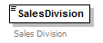
namespace | http://www.pidx.org/schema/ds/v5.02
type | string
properties | content simple
used by | complexType PartnerInformation
annotation | documentation  Sales Division
source | <element name="SalesDivision" type="string">  <annotation>  <documentation>Sales Division</documentation>  </annotation>  </element>

element SalesOrganization
diagram | 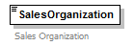
namespace | http://www.pidx.org/schema/ds/v5.02
type | string
properties | content simple
used by | complexType PartnerInformation
annotation | documentation  Sales Organization
source | <element name="SalesOrganization" type="string">  <annotation>  <documentation>Sales Organization </documentation>  </annotation>  </element>

element ScheduleType
diagram | 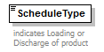
namespace | http://www.pidx.org/schema/ds/v5.02
type | pidx:ScheduleTypeEnum
properties | content simple  default Outbound
used by | element ModeOfTransport  complexType PMMOT
facets | enumeration Inbound  enumeration Outbound  enumeration Internal
annotation | documentation  indicates Loading or Discharge of product
source | <element name="ScheduleType" type="pidx:ScheduleTypeEnum" default="Outbound">  <annotation>  <documentation>indicates Loading or Discharge of product</documentation>  </annotation>  </element>

element Seal
diagram | 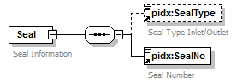
namespace | http://www.pidx.org/schema/ds/v5.02
properties | content complex
children | pidx:SealType pidx:SealNo
used by | element Seals
annotation | documentation  Seal Information
source | <element name="Seal">  <annotation>  <documentation>Seal Information</documentation>  </annotation>  <complexType>  <sequence>  <element ref="pidx:SealType" minOccurs="0"/>  <element ref="pidx:SealNo"/>  </sequence>  </complexType>  </element>

element SealNo
diagram | 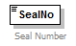
namespace | http://www.pidx.org/schema/ds/v5.02
type | string
properties | content simple
used by | element Seal
annotation | documentation  Seal Number
source | <element name="SealNo" type="string">  <annotation>  <documentation>Seal Number</documentation>  </annotation>  </element>

element Seals
diagram | 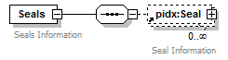
namespace | http://www.pidx.org/schema/ds/v5.02
properties | content complex
children | pidx:Seal
used by | elements Compartment LoadCompartment
annotation | documentation  Seals Information
source | <element name="Seals">  <annotation>  <documentation>Seals Information</documentation>  </annotation>  <complexType>  <sequence>  <element ref="pidx:Seal" minOccurs="0" maxOccurs="unbounded"/>  </sequence>  </complexType>  </element>

element SealString
diagram | 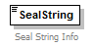
namespace | http://www.pidx.org/schema/ds/v5.02
type | string
properties | content simple
used by | elements ConfiguredVehicle ModeOfTransport
annotation | documentation  Seal String Info
source | <element name="SealString" type="string">  <annotation>  <documentation>Seal String Info</documentation>  </annotation>  </element>

element SealType
diagram | 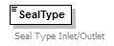
namespace | http://www.pidx.org/schema/ds/v5.02
type | restriction of string
properties | content simple
used by | element Seal
annotation | documentation  Seal Type Inlet/Outlet
source | <element name="SealType">  <annotation>  <documentation>Seal Type Inlet/Outlet</documentation>  </annotation>  <simpleType>  <restriction base="string"/>  </simpleType>  </element>

element SecondaryLoadReference
diagram | 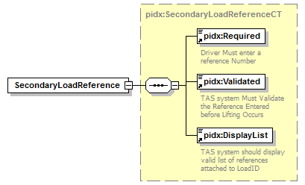
namespace | http://www.pidx.org/schema/ds/v5.02
type | pidx:SecondaryLoadReferenceCT
properties | content complex
children | pidx:Required pidx:Validated pidx:DisplayList
used by | element DocumentHeader
source | <element name="SecondaryLoadReference" type="pidx:SecondaryLoadReferenceCT"/>

element SellerDocumentSequence
diagram | 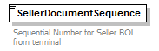
namespace | http://www.pidx.org/schema/ds/v5.02
type | integer
properties | content simple
used by | element ShipperData
annotation | documentation  Sequential Number for Seller BOL from terminal
source | <element name="SellerDocumentSequence" type="integer">  <annotation>  <documentation>Sequential Number for Seller BOL from terminal</documentation>  </annotation>  </element>

element SellerNum
diagram | 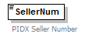
namespace | http://www.pidx.org/schema/ds/v5.02
type | string
properties | content simple
used by | element AuthParties
annotation | documentation  PIDX Seller Number
source | <element name="SellerNum" type="string">  <annotation>  <documentation>PIDX Seller Number</documentation>  </annotation>  </element>

element ServiceAgreementNumber
diagram | 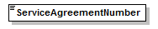
namespace | http://www.pidx.org/schema/ds/v5.02
type | string
properties | content simple
used by | complexType RailDefinition
source | <element name="ServiceAgreementNumber" type="string"/>

element ServiceAgreementType
diagram | 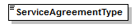
namespace | http://www.pidx.org/schema/ds/v5.02
type | string
properties | content simple
used by | complexType RailDefinition
source | <element name="ServiceAgreementType" type="string"/>

element Shift
diagram | 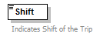
namespace | http://www.pidx.org/schema/ds/v5.02
type | string
properties | content simple
used by | elements ConfiguredVehicle DocumentReference
annotation | documentation  Indicates Shift of the Trip
source | <element name="Shift" type="string">  <annotation>  <documentation>Indicates Shift of the Trip</documentation>  </annotation>  </element>

element ShiftSeq
diagram | 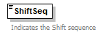
namespace | http://www.pidx.org/schema/ds/v5.02
type | string
properties | content simple
used by | elements ConfiguredVehicle DocumentReference
annotation | documentation  Indicates the Shift sequence
source | <element name="ShiftSeq" type="string">  <annotation>  <documentation>Indicates the Shift sequence</documentation>  </annotation>  </element>

element ShipperData
diagram | 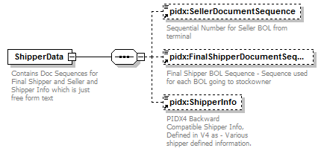
namespace | http://www.pidx.org/schema/ds/v5.02
properties | content complex
children | pidx:SellerDocumentSequence pidx:FinalShipperDocumentSequence pidx:ShipperInfo
used by | complexType PostingData
annotation | documentation  Contains Doc Sequences for Final Shipper and Seller and Shipper Info which is just free form text
source | <element name="ShipperData">  <annotation>  <documentation>Contains Doc Sequences for Final Shipper and Seller and Shipper Info which is just free form text</documentation>  </annotation>  <complexType>  <sequence>  <element ref="pidx:SellerDocumentSequence" minOccurs="0"/>  <element ref="pidx:FinalShipperDocumentSequence" minOccurs="0"/>  <element ref="pidx:ShipperInfo" minOccurs="0"/>  </sequence>  </complexType>  </element>

element ShipperInfo
diagram | 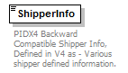
namespace | http://www.pidx.org/schema/ds/v5.02
type | string
properties | content simple
used by | element ShipperData
annotation | documentation  PIDX4 Backward Compatible Shipper Info, Defined in V4 as - Various shipper defined information.
source | <element name="ShipperInfo" type="string">  <annotation>  <documentation>PIDX4 Backward Compatible Shipper Info, Defined in V4 as - Various shipper defined information. </documentation>  </annotation>  </element>

element SoldToIdentifier
diagram | 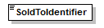
namespace | http://www.pidx.org/schema/ds/v5.02
type | string
properties | content simple
source | <element name="SoldToIdentifier" type="string"/>

element Source
diagram | 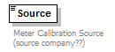
namespace | http://www.pidx.org/schema/ds/v5.02
type | string
properties | content simple
used by | element MeasurementInformation
annotation | documentation  Meter Calibration Source (source company??)
source | <element name="Source" type="string">  <annotation>  <documentation>Meter Calibration Source (source company??)</documentation>  </annotation>  </element>

element SourceDocument
diagram | 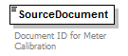
namespace | http://www.pidx.org/schema/ds/v5.02
type | integer
properties | content simple
used by | element MeasurementInformation
annotation | documentation  Document ID for Meter Calibration
source | <element name="SourceDocument" type="integer">  <annotation>  <documentation>Document ID for Meter Calibration </documentation>  </annotation>  </element>

element SplitLoading
diagram | 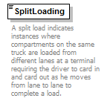
namespace | http://www.pidx.org/schema/ds/v5.02
type | pidx:YesNo
properties | content simple
used by | complexType PostingData
facets | enumeration Yes  enumeration No
annotation | documentation  A split load indicates instances where compartments on the same truck are loaded from different lanes at a terminal requiring the driver to card in and card out as he moves from lane to lane to complete a load.
source | <element name="SplitLoading" type="pidx:YesNo">  <annotation>  <documentation>A split load indicates instances where compartments on the same truck are loaded from different lanes at a terminal requiring the driver to card in and card out as he moves from lane to lane to complete a load.</documentation>  </annotation>  </element>

element StateOrProvince
diagram | 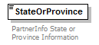
namespace | http://www.pidx.org/schema/ds/v5.02
type | string
properties | content simple
used by | element Location  complexType PartnerInformation
annotation | documentation  PartnerInfo State or Province Information
source | <element name="StateOrProvince" type="string">  <annotation>  <documentation>PartnerInfo State or Province Information</documentation>  </annotation>  </element>

element StockOwner
diagram | 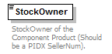
namespace | http://www.pidx.org/schema/ds/v5.02
type | string
properties | content simple
used by | element Recipe
annotation | documentation  StockOwner of the Component Product (Should be a PIDX SellerNum).
source | <element name="StockOwner" type="string">  <annotation>  <documentation>StockOwner of the Component Product (Should be a PIDX SellerNum).</documentation>  </annotation>  </element>

element StockStatus
diagram | 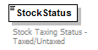
namespace | http://www.pidx.org/schema/ds/v5.02
type | restriction of string
properties | content simple
used by | element Tax
facets | enumeration TAXED  enumeration UNTAXED
annotation | documentation  Stock Taxing Status - Taxed/Untaxed
source | <element name="StockStatus">  <annotation>  <documentation>Stock Taxing Status - Taxed/Untaxed</documentation>  </annotation>  <simpleType>  <restriction base="string">  <enumeration value="TAXED"/>  <enumeration value="UNTAXED"/>  </restriction>  </simpleType>  </element>

element StorageLocation
diagram | 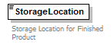
namespace | http://www.pidx.org/schema/ds/v5.02
type | string
properties | content simple
used by | element Product
annotation | documentation  Storage Location for Finished Product
source | <element name="StorageLocation" type="string">  <annotation>  <documentation>Storage Location for Finished Product </documentation>  </annotation>  </element>

element StorageTankIdentifier
diagram | 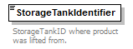
namespace | http://www.pidx.org/schema/ds/v5.02
type | string
properties | content simple
used by | element Recipe
annotation | documentation  StorageTankID where product was lifted from.
source | <element name="StorageTankIdentifier" type="string">  <annotation>  <documentation>StorageTankID where product was lifted from.</documentation>  </annotation>  </element>

element SubmissionMessageType
diagram | 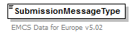
namespace | http://www.pidx.org/schema/ds/v5.02
type | pidx:EMCSSubmissionMessageEnum
properties | content simple  default 1
used by | element EMCS
facets | enumeration 1  enumeration 2
annotation | documentation  EMCS Data for Europe v5.02
source | <element name="SubmissionMessageType" type="pidx:EMCSSubmissionMessageEnum" default="1">  <annotation>  <documentation>EMCS Data for Europe v5.02</documentation>  </annotation>  </element>

element Success
diagram | 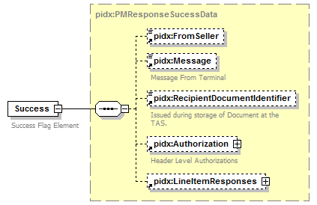
namespace | http://www.pidx.org/schema/ds/v5.02
type | pidx:PMResponseSucessData
properties | content complex
children | pidx:FromSeller pidx:Message pidx:RecipientDocumentIdentifier pidx:Authorization pidx:LineItemResponses
used by | element ResponseResult
annotation | documentation  Success Flag Element
source | <element name="Success" type="pidx:PMResponseSucessData">  <annotation>  <documentation>Success Flag Element</documentation>  </annotation>  </element>

element TankCapacity
diagram | 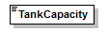
namespace | http://www.pidx.org/schema/ds/v5.02
type | double
properties | content simple
used by | complexType TankDeliveryData
source | <element name="TankCapacity" type="double"/>

element TankDelivery
diagram | 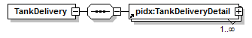
namespace | http://www.pidx.org/schema/ds/v5.02
properties | content complex
children | pidx:TankDeliveryDetail
used by | element DocumentLineItem
source | <element name="TankDelivery">  <complexType>  <sequence>  <element ref="pidx:TankDeliveryDetail" maxOccurs="unbounded"/>  </sequence>  </complexType>  </element>

element TankDeliveryDetail
diagram | 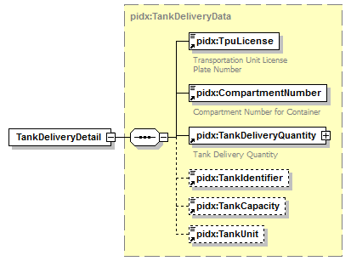
namespace | http://www.pidx.org/schema/ds/v5.02
type | pidx:TankDeliveryData
properties | content complex
children | pidx:TpuLicense pidx:CompartmentNumber pidx:TankDeliveryQuantity pidx:TankIdentifier pidx:TankCapacity pidx:TankUnit
used by | element TankDelivery
source | <element name="TankDeliveryDetail" type="pidx:TankDeliveryData"/>

element TankDeliveryQuantity
diagram | 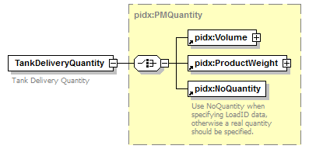
namespace | http://www.pidx.org/schema/ds/v5.02
type | pidx:PMQuantity
properties | content complex
children | pidx:Volume pidx:ProductWeight pidx:NoQuantity
used by | complexType TankDeliveryData
annotation | documentation  Tank Delivery Quantity
source | <element name="TankDeliveryQuantity" type="pidx:PMQuantity">  <annotation>  <documentation>Tank Delivery Quantity</documentation>  </annotation>  </element>

element TankIdentifier
diagram | 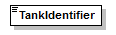
namespace | http://www.pidx.org/schema/ds/v5.02
type | string
properties | content simple
used by | complexType TankDeliveryData
source | <element name="TankIdentifier" type="string"/>

element TankUnit
diagram | 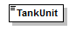
namespace | http://www.pidx.org/schema/ds/v5.02
type | pidx:VolumeUnits
properties | content simple  default LTR
used by | complexType TankDeliveryData
facets | enumeration LTR  enumeration ML  enumeration OZ  enumeration GAL  enumeration IGL  enumeration BBL  enumeration KB  enumeration CBM  enumeration HLT
source | <element name="TankUnit" type="pidx:VolumeUnits" default="LTR"/>

element Tariff
diagram | 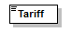
namespace | http://www.pidx.org/schema/ds/v5.02
type | string
properties | content simple
used by | complexType RailDefinition
source | <element name="Tariff" type="string"/>

element Tax
diagram | 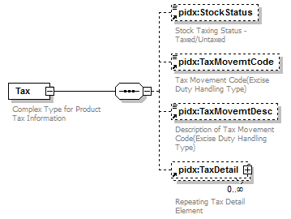
namespace | http://www.pidx.org/schema/ds/v5.02
properties | content complex
children | pidx:StockStatus pidx:TaxMovemtCode pidx:TaxMovemtDesc pidx:TaxDetail
used by | elements Compartment DocumentLineItem
annotation | documentation  Complex Type for Product Tax Information
source | <element name="Tax">  <annotation>  <documentation>Complex Type for Product Tax Information</documentation>  </annotation>  <complexType>  <sequence>  <element ref="pidx:StockStatus" minOccurs="0"/>  <element ref="pidx:TaxMovemtCode" minOccurs="0"/>  <element ref="pidx:TaxMovemtDesc" minOccurs="0"/>  <element ref="pidx:TaxDetail" minOccurs="0" maxOccurs="unbounded"/>  </sequence>  </complexType>  </element>

element TaxCode
diagram | 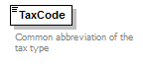
namespace | http://www.pidx.org/schema/ds/v5.02
type | string
properties | content simple
used by | element TaxDetail
annotation | documentation  Common abbreviation of the tax type
source | <element name="TaxCode" type="string">  <annotation>  <documentation>Common abbreviation of the tax type  </documentation>  </annotation>  </element>

element TaxDetail
diagram | 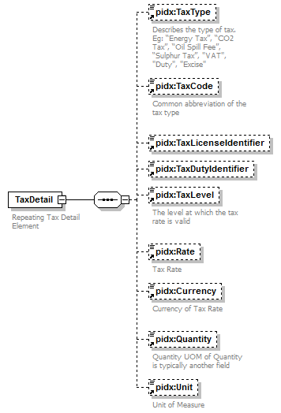
namespace | http://www.pidx.org/schema/ds/v5.02
properties | content complex
children | pidx:TaxType pidx:TaxCode pidx:TaxLicenseIdentifier pidx:TaxDutyIdentifier pidx:TaxLevel pidx:Rate pidx:Currency pidx:Quantity pidx:Unit
used by | element Tax
annotation | documentation  Repeating Tax Detail Element
source | <element name="TaxDetail">  <annotation>  <documentation>Repeating Tax Detail Element</documentation>  </annotation>  <complexType>  <sequence>  <element ref="pidx:TaxType" minOccurs="0"/>  <element ref="pidx:TaxCode" minOccurs="0"/>  <element ref="pidx:TaxLicenseIdentifier" minOccurs="0"/>  <element ref="pidx:TaxDutyIdentifier" minOccurs="0"/>  <element ref="pidx:TaxLevel" minOccurs="0"/>  <element ref="pidx:Rate" minOccurs="0"/>  <element ref="pidx:Currency" minOccurs="0"/>  <element ref="pidx:Quantity" minOccurs="0"/>  <element ref="pidx:Unit" minOccurs="0"/>  </sequence>  </complexType>  </element>

element TaxDutyIdentifier
diagram | 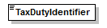
namespace | http://www.pidx.org/schema/ds/v5.02
type | string
properties | content simple
used by | element TaxDetail
source | <element name="TaxDutyIdentifier" type="string"/>

element TaxLevel
diagram | 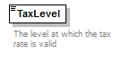
namespace | http://www.pidx.org/schema/ds/v5.02
type | string
properties | content simple
used by | element TaxDetail
annotation | documentation  The level at which the tax rate is valid
source | <element name="TaxLevel" type="string">  <annotation>  <documentation>The level at which the tax rate is valid  </documentation>  </annotation>  </element>

element TaxLicenseIdentifier
diagram | 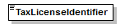
namespace | http://www.pidx.org/schema/ds/v5.02
type | string
properties | content simple
used by | element TaxDetail
source | <element name="TaxLicenseIdentifier" type="string"/>

element TaxMovemtCode
diagram | 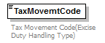
namespace | http://www.pidx.org/schema/ds/v5.02
type | string
properties | content simple
used by | element Tax
annotation | documentation  Tax Movement Code(Excise Duty Handling Type)
source | <element name="TaxMovemtCode" type="string">  <annotation>  <documentation>Tax Movement Code(Excise Duty Handling Type)</documentation>  </annotation>  </element>

element TaxMovemtDesc
diagram | 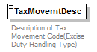
namespace | http://www.pidx.org/schema/ds/v5.02
type | string
properties | content simple
used by | element Tax
annotation | documentation  Description of Tax Movement Code(Excise Duty Handling Type)
source | <element name="TaxMovemtDesc" type="string">  <annotation>  <documentation>Description of Tax Movement Code(Excise Duty Handling Type)</documentation>  </annotation>  </element>

element TaxType
diagram | 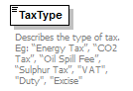
namespace | http://www.pidx.org/schema/ds/v5.02
type | string
properties | content simple
used by | element TaxDetail
annotation | documentation  Describes the type of tax. Eg: “Energy Tax”, “CO2 Tax”, “Oil Spill Fee”, “Sulphur Tax”, "VAT", "Duty", "Excise"
source | <element name="TaxType" type="string">  <annotation>  <documentation>Describes the type of tax. Eg: “Energy Tax”, “CO2 Tax”, “Oil Spill Fee”, “Sulphur Tax”, "VAT", "Duty", "Excise"</documentation>  </annotation>  </element>

element Temperature
diagram | 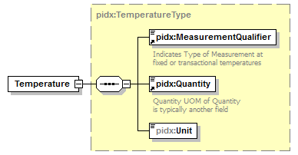
namespace | http://www.pidx.org/schema/ds/v5.02
type | pidx:TemperatureType
properties | content complex
children | pidx:MeasurementQualifier pidx:Quantity pidx:Unit
source | <element name="Temperature" type="pidx:TemperatureType"/>

element Terms
diagram | 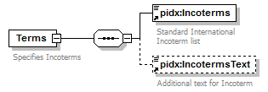
namespace | http://www.pidx.org/schema/ds/v5.02
properties | content complex
children | pidx:Incoterms pidx:IncotermsText
used by | element DocumentLineItem
annotation | documentation  Specifies Incoterms
source | <element name="Terms">  <annotation>  <documentation>Specifies Incoterms</documentation>  </annotation>  <complexType>  <sequence>  <element ref="pidx:Incoterms"/>  <element ref="pidx:IncotermsText" minOccurs="0"/>  </sequence>  </complexType>  </element>

element ThirdParty
diagram | 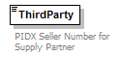
namespace | http://www.pidx.org/schema/ds/v5.02
type | string
properties | content simple
used by | element AuthParties
annotation | documentation  PIDX Seller Number for Supply Partner
source | <element name="ThirdParty" type="string">  <annotation>  <documentation>PIDX Seller Number for Supply Partner</documentation>  </annotation>  </element>

element ThirdPartyConsignee
diagram | 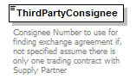
namespace | http://www.pidx.org/schema/ds/v5.02
type | string
properties | content simple
used by | element AuthParties
annotation | documentation  Consignee Number to use for finding exchange agreement if, not specified assume there is only one trading contract with Supply Partner
source | <element name="ThirdPartyConsignee" type="string">  <annotation>  <documentation>Consignee Number to use for finding exchange agreement if, not specified assume there is only one trading contract with Supply Partner</documentation>  </annotation>  </element>

element To
diagram | 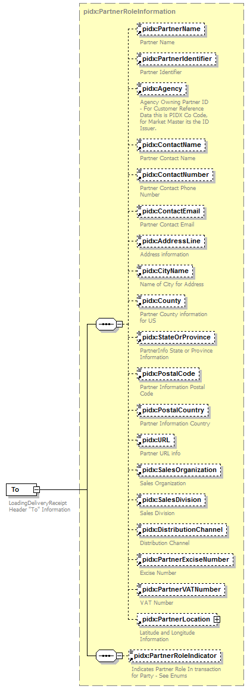
namespace | http://www.pidx.org/schema/ds/v5.02
type | pidx:PartnerRoleInformation
properties | content complex  mixed false
children | pidx:PartnerName pidx:PartnerIdentifier pidx:Agency pidx:ContactName pidx:ContactNumber pidx:ContactEmail pidx:AddressLine pidx:CityName pidx:County pidx:StateOrProvince pidx:PostalCode pidx:PostalCountry pidx:URL pidx:SalesOrganization pidx:SalesDivision pidx:DistributionChannel pidx:PartnerExciseNumber pidx:PartnerVATNumber pidx:PartnerLocation pidx:PartnerRoleIndicator
used by | element Header
annotation | documentation  LoadingDeliveryReceipt Header "To" Information
source | <element name="To" type="pidx:PartnerRoleInformation">  <annotation>  <documentation>LoadingDeliveryReceipt Header "To" Information</documentation>  </annotation>  </element>

element TpuIdentifierCard
diagram | 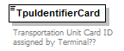
namespace | http://www.pidx.org/schema/ds/v5.02
type | string
properties | content simple
used by | elements Engine LoadPartIdentification
annotation | documentation  Transportation Unit Card ID assigned by Terminal??
source | <element name="TpuIdentifierCard" type="string">  <annotation>  <documentation>Transportation Unit Card ID assigned by Terminal??</documentation>  </annotation>  </element>

element TpuLicense
diagram | 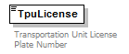
namespace | http://www.pidx.org/schema/ds/v5.02
type | string
properties | content simple
used by | elements Engine LoadPartIdentification  complexType TankDeliveryData
annotation | documentation  Transportation Unit License Plate Number
source | <element name="TpuLicense" type="string">  <annotation>  <documentation>Transportation Unit License Plate Number</documentation>  </annotation>  </element>

element TpuType
diagram | 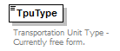
namespace | http://www.pidx.org/schema/ds/v5.02
type | string
properties | content simple
used by | elements Engine LoadPartIdentification
annotation | documentation  Transportation Unit Type - Currently free form.
source | <element name="TpuType" type="string">  <annotation>  <documentation>Transportation Unit Type - Currently free form.</documentation>  </annotation>  </element>

element TrackClass
diagram | 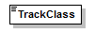
namespace | http://www.pidx.org/schema/ds/v5.02
type | string
properties | content simple
used by | complexType RailDefinition
source | <element name="TrackClass" type="string"/>

element Transport
diagram | 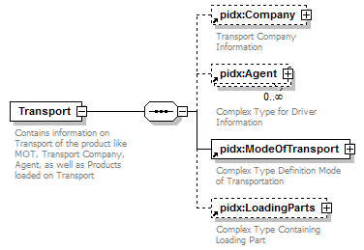
namespace | http://www.pidx.org/schema/ds/v5.02
properties | content complex
children | pidx:Company pidx:Agent pidx:ModeOfTransport pidx:LoadingParts
used by | complexType PostingData
annotation | documentation  Contains information on Transport of the product like MOT, Transport Company, Agent, as well as Products loaded on Transport
source | <element name="Transport">  <annotation>  <documentation>Contains information on Transport of the product like MOT, Transport Company, Agent, as well as Products loaded on Transport</documentation>  </annotation>  <complexType>  <sequence>  <element ref="pidx:Company" minOccurs="0"/>  <element ref="pidx:Agent" minOccurs="0" maxOccurs="unbounded"/>  <element ref="pidx:ModeOfTransport"/>  <element ref="pidx:LoadingParts" minOccurs="0"/>  </sequence>  </complexType>  </element>

element TransportArrangerCode
diagram | 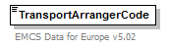
namespace | http://www.pidx.org/schema/ds/v5.02
type | pidx:EMCSTransportArrangerEnum
properties | content simple
used by | element EMCS
facets | enumeration 1  enumeration 2  enumeration 3  enumeration 4
annotation | documentation  EMCS Data for Europe v5.02
source | <element name="TransportArrangerCode" type="pidx:EMCSTransportArrangerEnum">  <annotation>  <documentation>EMCS Data for Europe v5.02</documentation>  </annotation>  </element>

element TransportData
diagram | 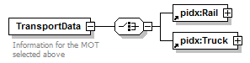
namespace | http://www.pidx.org/schema/ds/v5.02
properties | content complex
children | pidx:Rail pidx:Truck
used by | complexType PMMOT
annotation | documentation  Information for the MOT selected above
source | <element name="TransportData">  <annotation>  <documentation>Information for the MOT selected above</documentation>  </annotation>  <complexType>  <choice>  <element ref="pidx:Rail"/>  <element ref="pidx:Truck"/>  </choice>  </complexType>  </element>

element TransportIdentifier
diagram | 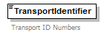
namespace | http://www.pidx.org/schema/ds/v5.02
type | string
properties | content simple
used by | element TransportSecondaryIdentifier
annotation | documentation  Transport ID Numbers
source | <element name="TransportIdentifier" type="string">  <annotation>  <documentation>Transport ID Numbers</documentation>  </annotation>  </element>

element TransportIdentifierType
diagram | 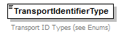
namespace | http://www.pidx.org/schema/ds/v5.02
type | pidx:TransportSecondaryTypes
properties | content simple
used by | element TransportSecondaryIdentifier
facets | enumeration DUNSNumber  enumeration PartnerHaulierID  enumeration TerminalHaulierID  enumeration CarrierFEIN  enumeration SCAC
annotation | documentation  Transport ID Types (see Enums)
source | <element name="TransportIdentifierType" type="pidx:TransportSecondaryTypes">  <annotation>  <documentation>Transport ID Types (see Enums)</documentation>  </annotation>  </element>

element TransportModeCode
diagram | 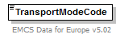
namespace | http://www.pidx.org/schema/ds/v5.02
type | pidx:EMCSTransportEnum
properties | content simple
used by | element EMCS
facets | enumeration 0  enumeration 1  enumeration 2  enumeration 3  enumeration 4  enumeration 5  enumeration 7  enumeration 8
annotation | documentation  EMCS Data for Europe v5.02
source | <element name="TransportModeCode" type="pidx:EMCSTransportEnum">  <annotation>  <documentation>EMCS Data for Europe v5.02</documentation>  </annotation>  </element>

element TransportSecondaryIdentifier
diagram | 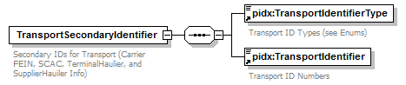
namespace | http://www.pidx.org/schema/ds/v5.02
properties | content complex
children | pidx:TransportIdentifierType pidx:TransportIdentifier
used by | element Company
annotation | documentation  Secondary IDs for Transport (Carrier FEIN, SCAC, TerminalHaulier, and SupplierHauiler Info)
source | <element name="TransportSecondaryIdentifier">  <annotation>  <documentation>Secondary IDs for Transport (Carrier FEIN, SCAC, TerminalHaulier, and SupplierHauiler Info)</documentation>  </annotation>  <complexType>  <sequence>  <element ref="pidx:TransportIdentifierType"/>  <element ref="pidx:TransportIdentifier"/>  </sequence>  </complexType>  </element>

element Truck
diagram | 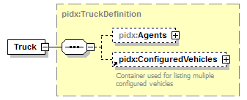
namespace | http://www.pidx.org/schema/ds/v5.02
type | pidx:TruckDefinition
properties | content complex
children | pidx:Agents pidx:ConfiguredVehicles
used by | element TransportData
source | <element name="Truck" type="pidx:TruckDefinition"/>

element Unit
diagram | 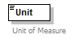
namespace | http://www.pidx.org/schema/ds/v5.02
type | union of (pidx:VolumeUnits, pidx:WeightUnits, pidx:TemperatureUnits, pidx:PressureUnits, pidx:GravityUnits, pidx:RatioUnits, pidx:DensityUnits, pidx:EnergyContentUnits)
properties | content simple
used by | element TaxDetail  complexType MeasurementComplexType
annotation | documentation  Unit of Measure
source | <element name="Unit">  <annotation>  <documentation>Unit of Measure</documentation>  </annotation>  <simpleType>  <union memberTypes="pidx:VolumeUnits pidx:WeightUnits pidx:TemperatureUnits pidx:PressureUnits pidx:GravityUnits pidx:RatioUnits pidx:DensityUnits pidx:EnergyContentUnits"/>  </simpleType>  </element>

element UnitQualifier
diagram | 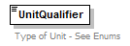
namespace | http://www.pidx.org/schema/ds/v5.02
type | pidx:MeasurementUnitQualf
properties | content simple
used by | complexType MeasurementComplexType
facets | enumeration Volume  enumeration Temperature  enumeration Pressure  enumeration Gravity  enumeration TareWeight  enumeration GrossWeight  enumeration ProductWeight  enumeration Density  enumeration MixPercentage  enumeration EnergyContent
annotation | documentation  Type of Unit - See Enums
source | <element name="UnitQualifier" type="pidx:MeasurementUnitQualf">  <annotation>  <documentation>Type of Unit - See Enums</documentation>  </annotation>  </element>

element UnladenWeight
diagram | 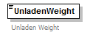
namespace | http://www.pidx.org/schema/ds/v5.02
type | double
properties | content simple
used by | element Engine  complexType VechicleSpecificationData
annotation | documentation  Unladen Weight
source | <element name="UnladenWeight" type="double">  <annotation>  <documentation>Unladen Weight</documentation>  </annotation>  </element>

element URL
diagram | 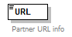
namespace | http://www.pidx.org/schema/ds/v5.02
type | string
properties | content simple
used by | element Location  complexType PartnerInformation
annotation | documentation  Partner URL info
source | <element name="URL" type="string">  <annotation>  <documentation>Partner URL info</documentation>  </annotation>  </element>

element UserName
diagram | 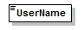
namespace | http://www.pidx.org/schema/ds/v5.02
type | string
properties | content simple
used by | complexType RevisionData
source | <element name="UserName" type="string"/>

element Validated
diagram | 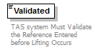
namespace | http://www.pidx.org/schema/ds/v5.02
type | pidx:YesNo
properties | content simple  default No
used by | complexType SecondaryLoadReferenceCT
facets | enumeration Yes  enumeration No
annotation | documentation  TAS system Must Validate the Reference Entered before Lifting Occurs
source | <element name="Validated" type="pidx:YesNo" default="No">  <annotation>  <documentation>TAS system Must Validate the Reference Entered before Lifting Occurs</documentation>  </annotation>  </element>

element VehicleIdentifier
diagram | 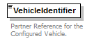
namespace | http://www.pidx.org/schema/ds/v5.02
type | string
properties | content simple
used by | element ConfiguredVehicle
annotation | documentation  Partner Reference for the Configured Vehicle.
source | <element name="VehicleIdentifier" type="string">  <annotation>  <documentation>Partner Reference for the Configured Vehicle.</documentation>  </annotation>  </element>

element VersionConversion
diagram | 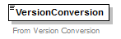
namespace | http://www.pidx.org/schema/ds/v5.02
type | string
properties | content simple
used by | complexType DocumentData
annotation | documentation  From Version Conversion
source | <element name="VersionConversion" type="string">  <annotation>  <documentation>From Version Conversion</documentation>  </annotation>  </element>

element Volume
diagram | 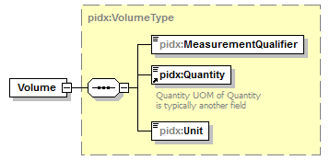
namespace | http://www.pidx.org/schema/ds/v5.02
type | pidx:VolumeType
properties | content complex
children | pidx:MeasurementQualifier pidx:Quantity pidx:Unit
used by | complexType PMQuantity
source | <element name="Volume" type="pidx:VolumeType"/>

element VolumeUnit
diagram | 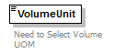
namespace | http://www.pidx.org/schema/ds/v5.02
type | pidx:VolumeUnits
properties | content simple
used by | complexType MaxFillLevels
facets | enumeration LTR  enumeration ML  enumeration OZ  enumeration GAL  enumeration IGL  enumeration BBL  enumeration KB  enumeration CBM  enumeration HLT
annotation | documentation  Need to Select Volume UOM
source | <element name="VolumeUnit" type="pidx:VolumeUnits">  <annotation>  <documentation>Need to Select Volume UOM</documentation>  </annotation>  </element>

element WeightUnit
diagram | 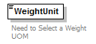
namespace | http://www.pidx.org/schema/ds/v5.02
type | pidx:WeightUnits
properties | content simple
used by | element Engine  complexTypes MaxFillLevels VechicleSpecificationData
facets | enumeration LBS  enumeration MG  enumeration KGS  enumeration TON  enumeration MTN  enumeration LTN
annotation | documentation  Need to Select a Weight UOM
source | <element name="WeightUnit" type="pidx:WeightUnits">  <annotation>  <documentation>Need to Select a Weight UOM</documentation>  </annotation>  </element>

complexType AgentData
diagram | 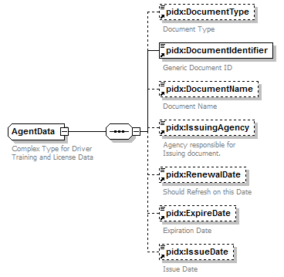
namespace | http://www.pidx.org/schema/ds/v5.02
children | pidx:DocumentType pidx:DocumentIdentifier pidx:DocumentName pidx:IssuingAgency pidx:RenewalDate pidx:ExpireDate pidx:IssueDate
used by | element AgentDocument
annotation | documentation  Complex Type for Driver Training and License Data
source | <complexType name="AgentData">  <annotation>  <documentation>Complex Type for Driver Training and License Data</documentation>  </annotation>  <sequence>  <element ref="pidx:DocumentType" minOccurs="0">  <annotation>  <documentation>Document Type</documentation>  </annotation>  </element>  <element ref="pidx:DocumentIdentifier"/>  <element ref="pidx:DocumentName" minOccurs="0"/>  <element ref="pidx:IssuingAgency" minOccurs="0"/>  <element ref="pidx:RenewalDate" minOccurs="0"/>  <element ref="pidx:ExpireDate" minOccurs="0"/>  <element ref="pidx:IssueDate" minOccurs="0"/>  </sequence>  </complexType>

complexType AuthorizationData
diagram | 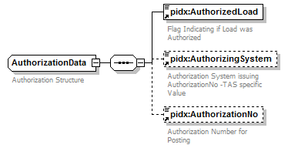
namespace | http://www.pidx.org/schema/ds/v5.02
children | pidx:AuthorizedLoad pidx:AuthorizingSystem pidx:AuthorizationNo
used by | elements Authorization DetailAuthorization
annotation | documentation  Authorization Structure
source | <complexType name="AuthorizationData">  <annotation>  <documentation>Authorization Structure</documentation>  </annotation>  <sequence>  <element ref="pidx:AuthorizedLoad"/>  <element ref="pidx:AuthorizingSystem" minOccurs="0"/>  <element ref="pidx:AuthorizationNo" minOccurs="0"/>  </sequence>  </complexType>

complexType AuthRequestData
diagram | 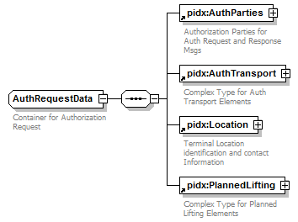
namespace | http://www.pidx.org/schema/ds/v5.02
children | pidx:AuthParties pidx:AuthTransport pidx:Location pidx:PlannedLifting
used by | element AuthRequests
annotation | documentation  Container for Authorization Request
source | <complexType name="AuthRequestData">  <annotation>  <documentation>Container for Authorization Request</documentation>  </annotation>  <sequence>  <element ref="pidx:AuthParties"/>  <element ref="pidx:AuthTransport"/>  <element ref="pidx:Location"/>  <element ref="pidx:PlannedLifting"/>  </sequence>  </complexType>

complexType AuthResponseData
diagram | 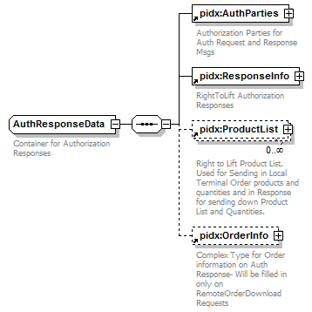
namespace | http://www.pidx.org/schema/ds/v5.02
children | pidx:AuthParties pidx:ResponseInfo pidx:ProductList pidx:OrderInfo
used by | element AuthResponses
annotation | documentation  Container for Authorization Responses
source | <complexType name="AuthResponseData">  <annotation>  <documentation>Container for Authorization Responses</documentation>  </annotation>  <sequence>  <element ref="pidx:AuthParties"/>  <element ref="pidx:ResponseInfo"/>  <element ref="pidx:ProductList" minOccurs="0" maxOccurs="unbounded"/>  <element ref="pidx:OrderInfo" minOccurs="0"/>  </sequence>  </complexType>

complexType DensityType
diagram | 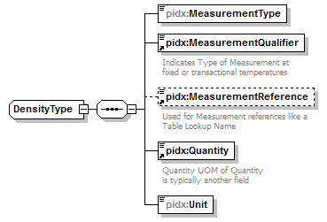
namespace | http://www.pidx.org/schema/ds/v5.02
type | extension of pidx:MeasurementBaseClass
properties | base pidx:MeasurementBaseClass
children | pidx:MeasurementType pidx:MeasurementQualifier pidx:MeasurementReference pidx:Quantity pidx:Unit
used by | element Density
source | <complexType name="DensityType">  <complexContent>  <extension base="pidx:MeasurementBaseClass">  <sequence>  <element name="MeasurementType" type="pidx:MeasurementTypeEnum"/>  <element ref="pidx:MeasurementQualifier"/>  <element ref="pidx:MeasurementReference" minOccurs="0"/>  <element ref="pidx:Quantity"/>  <element name="Unit" type="pidx:DensityUnits"/>  </sequence>  </extension>  </complexContent>  </complexType>

element DensityType/MeasurementType
diagram | 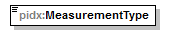
namespace | http://www.pidx.org/schema/ds/v5.02
type | pidx:MeasurementTypeEnum
properties | isRef 0  content simple
used by | complexType MeasurementComplexType
facets | enumeration MeasuredinAir  enumeration MeasuredInVacuum  enumeration Calculated  enumeration Ordered  enumeration TableLookup
source | <element name="MeasurementType" type="pidx:MeasurementTypeEnum"/>

element DensityType/Unit
diagram | 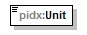
namespace | http://www.pidx.org/schema/ds/v5.02
type | pidx:DensityUnits
properties | isRef 0  content simple
used by | element TaxDetail  complexType MeasurementComplexType
facets | enumeration KGL  enumeration KGM  enumeration PGA
source | <element name="Unit" type="pidx:DensityUnits"/>

complexType DocumentBaseClass
diagram | 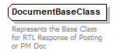
namespace | http://www.pidx.org/schema/ds/v5.02
used by | element OrderInfo  complexTypes LoadDocumentType PostingData
annotation | documentation  Represents the Base Class for RTL Response of Posting or PM Doc
source | <complexType name="DocumentBaseClass">  <annotation>  <documentation>Represents the Base Class for RTL Response of Posting or PM Doc</documentation>  </annotation>  </complexType>

complexType DocumentData
diagram | 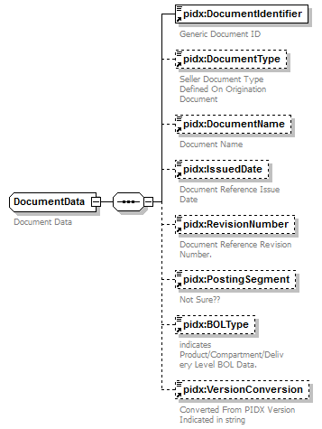
namespace | http://www.pidx.org/schema/ds/v5.02
children | pidx:DocumentIdentifier pidx:DocumentType pidx:DocumentName pidx:IssuedDate pidx:RevisionNumber pidx:PostingSegment pidx:BOLType pidx:VersionConversion
used by | elements DetailPostingReference PostingReference
annotation | documentation  Document Data
source | <complexType name="DocumentData">  <annotation>  <documentation>Document Data</documentation>  </annotation>  <sequence>  <element ref="pidx:DocumentIdentifier"/>  <element ref="pidx:DocumentType" minOccurs="0"/>  <element ref="pidx:DocumentName" minOccurs="0"/>  <element ref="pidx:IssuedDate" minOccurs="0"/>  <element ref="pidx:RevisionNumber" minOccurs="0"/>  <element ref="pidx:PostingSegment" minOccurs="0"/>  <element ref="pidx:BOLType" minOccurs="0"/>  <element ref="pidx:VersionConversion" minOccurs="0">  <annotation>  <documentation>Converted From PIDX Version Indicated in string</documentation>  </annotation>  </element>  </sequence>  </complexType>

complexType EquipmentData
diagram | 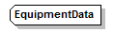
namespace | http://www.pidx.org/schema/ds/v5.02
used by | complexTypes RailDefinition TruckDefinition
source | <complexType name="EquipmentData"/>

complexType GeoLocation
diagram | 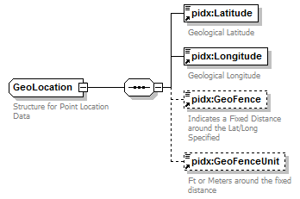
namespace | http://www.pidx.org/schema/ds/v5.02
children | pidx:Latitude pidx:Longitude pidx:GeoFence pidx:GeoFenceUnit
used by | element PartnerLocation
annotation | documentation  Structure for Point Location Data
source | <complexType name="GeoLocation">  <annotation>  <documentation>Structure for Point Location Data</documentation>  </annotation>  <sequence>  <element ref="pidx:Latitude"/>  <element ref="pidx:Longitude"/>  <element ref="pidx:GeoFence" minOccurs="0"/>  <element ref="pidx:GeoFenceUnit" minOccurs="0"/>  </sequence>  </complexType>

complexType GravityType
diagram | 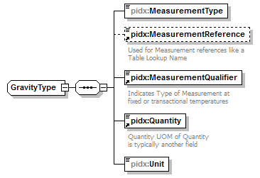
namespace | http://www.pidx.org/schema/ds/v5.02
type | extension of pidx:MeasurementBaseClass
properties | base pidx:MeasurementBaseClass
children | pidx:MeasurementType pidx:MeasurementReference pidx:MeasurementQualifier pidx:Quantity pidx:Unit
used by | element Gravity
source | <complexType name="GravityType">  <complexContent>  <extension base="pidx:MeasurementBaseClass">  <sequence>  <element name="MeasurementType" type="pidx:MeasurementTypeEnum"/>  <element ref="pidx:MeasurementReference" minOccurs="0"/>  <element ref="pidx:MeasurementQualifier"/>  <element ref="pidx:Quantity"/>  <element name="Unit" type="pidx:GravityUnits"/>  </sequence>  </extension>  </complexContent>  </complexType>

element GravityType/MeasurementType
diagram | 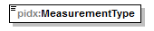
namespace | http://www.pidx.org/schema/ds/v5.02
type | pidx:MeasurementTypeEnum
properties | isRef 0  content simple
used by | complexType MeasurementComplexType
facets | enumeration MeasuredinAir  enumeration MeasuredInVacuum  enumeration Calculated  enumeration Ordered  enumeration TableLookup
source | <element name="MeasurementType" type="pidx:MeasurementTypeEnum"/>

element GravityType/Unit
diagram | 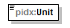
namespace | http://www.pidx.org/schema/ds/v5.02
type | pidx:GravityUnits
properties | isRef 0  content simple
used by | element TaxDetail  complexType MeasurementComplexType
facets | enumeration API  enumeration SG
source | <element name="Unit" type="pidx:GravityUnits"/>

complexType LoadDocumentType
diagram | 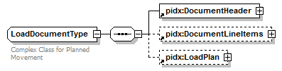
namespace | http://www.pidx.org/schema/ds/v5.02
type | extension of pidx:DocumentBaseClass
properties | base pidx:DocumentBaseClass
children | pidx:DocumentHeader pidx:DocumentLineItems pidx:LoadPlan
used by | element Document
annotation | documentation  Complex Class for Planned Movement
source | <complexType name="LoadDocumentType">  <annotation>  <documentation>Complex Class for Planned Movement</documentation>  </annotation>  <complexContent>  <extension base="pidx:DocumentBaseClass">  <annotation>  <documentation>Complex Class for Planned Movement</documentation>  </annotation>  <sequence>  <element ref="pidx:DocumentHeader"/>  <element ref="pidx:DocumentLineItems" minOccurs="0"/>  <element ref="pidx:LoadPlan" minOccurs="0"/>  </sequence>  </extension>  </complexContent>  </complexType>

complexType LoadPlanInfo
diagram | 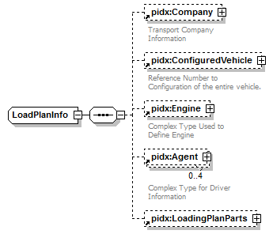
namespace | http://www.pidx.org/schema/ds/v5.02
children | pidx:Company pidx:ConfiguredVehicle pidx:Engine pidx:Agent pidx:LoadingPlanParts
used by | element LoadPlan
source | <complexType name="LoadPlanInfo">  <sequence>  <element ref="pidx:Company" minOccurs="0"/>  <element ref="pidx:ConfiguredVehicle" minOccurs="0"/>  <element ref="pidx:Engine" minOccurs="0"/>  <element ref="pidx:Agent" minOccurs="0" maxOccurs="4"/>  <element ref="pidx:LoadingPlanParts" minOccurs="0"/>  </sequence>  </complexType>

complexType MaxFillLevels
diagram | 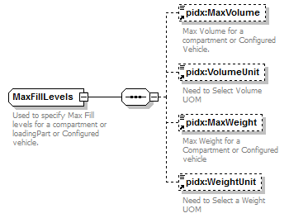
namespace | http://www.pidx.org/schema/ds/v5.02
children | pidx:MaxVolume pidx:VolumeUnit pidx:MaxWeight pidx:WeightUnit
used by | elements CompartmentSpecification MaxAmounts
annotation | documentation  Used to specify Max Fill levels for a compartment or loadingPart or Configured vehicle.
source | <complexType name="MaxFillLevels">  <annotation>  <documentation>Used to specify Max Fill levels for a compartment or loadingPart or Configured vehicle.</documentation>  </annotation>  <sequence>  <element ref="pidx:MaxVolume" minOccurs="0"/>  <element ref="pidx:VolumeUnit" minOccurs="0"/>  <element ref="pidx:MaxWeight" minOccurs="0"/>  <element ref="pidx:WeightUnit" minOccurs="0"/>  </sequence>  </complexType>

complexType MeasurementBaseClass
diagram | 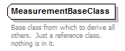
namespace | http://www.pidx.org/schema/ds/v5.02
used by | complexTypes DensityType GravityType MeasurementComplexType MixPercentageType NoQuantityType PressureType ProductWeightType TemperatureType VolumeType
annotation | documentation  Base class from which to derive all others. Just a reference class, nothing is in it.
source | <complexType name="MeasurementBaseClass">  <annotation>  <documentation>Base class from which to derive all others. Just a reference class, nothing is in it.</documentation>  </annotation>  </complexType>

complexType MeasurementComplexType
diagram | 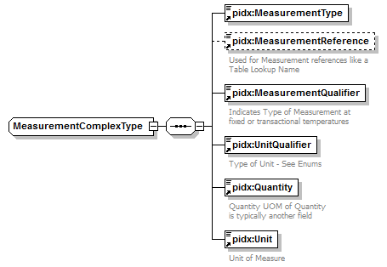
namespace | http://www.pidx.org/schema/ds/v5.02
type | extension of pidx:MeasurementBaseClass
properties | base pidx:MeasurementBaseClass
children | pidx:MeasurementType pidx:MeasurementReference pidx:MeasurementQualifier pidx:UnitQualifier pidx:Quantity pidx:Unit
used by | element Measurement
source | <complexType name="MeasurementComplexType">  <complexContent>  <extension base="pidx:MeasurementBaseClass">  <sequence>  <element ref="pidx:MeasurementType"/>  <element ref="pidx:MeasurementReference" minOccurs="0"/>  <element ref="pidx:MeasurementQualifier"/>  <element ref="pidx:UnitQualifier"/>  <element ref="pidx:Quantity"/>  <element ref="pidx:Unit"/>  </sequence>  </extension>  </complexContent>  </complexType>

complexType MixPercentageType
diagram | 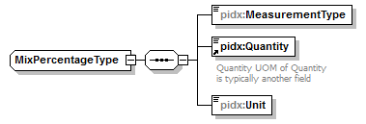
namespace | http://www.pidx.org/schema/ds/v5.02
type | extension of pidx:MeasurementBaseClass
properties | base pidx:MeasurementBaseClass
children | pidx:MeasurementType pidx:Quantity pidx:Unit
used by | element MixPercentage
source | <complexType name="MixPercentageType">  <complexContent>  <extension base="pidx:MeasurementBaseClass">  <sequence>  <element name="MeasurementType" type="pidx:MeasurementTypeEnum"/>  <element ref="pidx:Quantity"/>  <element name="Unit" type="pidx:RatioUnits"/>  </sequence>  </extension>  </complexContent>  </complexType>

element MixPercentageType/MeasurementType
diagram | 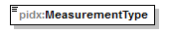
namespace | http://www.pidx.org/schema/ds/v5.02
type | pidx:MeasurementTypeEnum
properties | isRef 0  content simple
used by | complexType MeasurementComplexType
facets | enumeration MeasuredinAir  enumeration MeasuredInVacuum  enumeration Calculated  enumeration Ordered  enumeration TableLookup
source | <element name="MeasurementType" type="pidx:MeasurementTypeEnum"/>

element MixPercentageType/Unit
diagram | 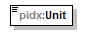
namespace | http://www.pidx.org/schema/ds/v5.02
type | pidx:RatioUnits
properties | isRef 0  content simple
used by | element TaxDetail  complexType MeasurementComplexType
facets | enumeration EA  enumeration RAT  enumeration PPM
source | <element name="Unit" type="pidx:RatioUnits"/>

complexType MOTBaseClass
diagram | 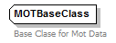
namespace | http://www.pidx.org/schema/ds/v5.02
annotation | documentation  Base Clase for Mot Data
source | <complexType name="MOTBaseClass">  <annotation>  <documentation>Base Clase for Mot Data</documentation>  </annotation>  </complexType>

complexType NoQuantityType
diagram | 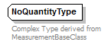
namespace | http://www.pidx.org/schema/ds/v5.02
type | extension of pidx:MeasurementBaseClass
properties | base pidx:MeasurementBaseClass
used by | element NoQuantity
annotation | documentation  Complex Type derived from MeasurementBaseClass
source | <complexType name="NoQuantityType">  <annotation>  <documentation>Complex Type derived from MeasurementBaseClass</documentation>  </annotation>  <complexContent>  <extension base="pidx:MeasurementBaseClass"/>  </complexContent>  </complexType>

complexType OnBoardDefinition
diagram | 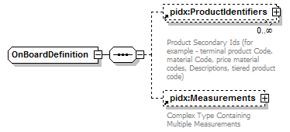
namespace | http://www.pidx.org/schema/ds/v5.02
children | pidx:ProductIdentifiers pidx:Measurements
used by | elements LeftOnBoard PriorToLoad
source | <complexType name="OnBoardDefinition">  <sequence>  <element ref="pidx:ProductIdentifiers" minOccurs="0" maxOccurs="unbounded"/>  <element ref="pidx:Measurements" minOccurs="0"/>  </sequence>  </complexType>

complexType PartnerInformation
diagram | 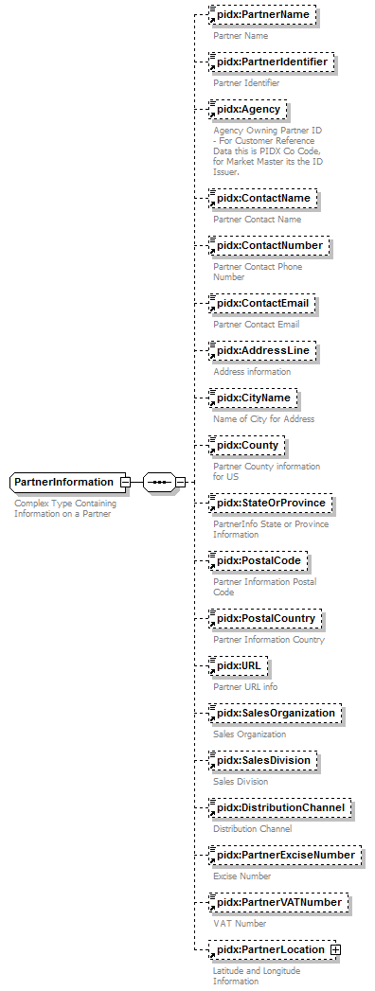
namespace | http://www.pidx.org/schema/ds/v5.02
children | pidx:PartnerName pidx:PartnerIdentifier pidx:Agency pidx:ContactName pidx:ContactNumber pidx:ContactEmail pidx:AddressLine pidx:CityName pidx:County pidx:StateOrProvince pidx:PostalCode pidx:PostalCountry pidx:URL pidx:SalesOrganization pidx:SalesDivision pidx:DistributionChannel pidx:PartnerExciseNumber pidx:PartnerVATNumber pidx:PartnerLocation
used by | elements Company Exporter Guarantor RailParty  complexType PartnerRoleInformation
annotation | documentation  Complex Type Containing Information on a Partner
source | <complexType name="PartnerInformation">  <annotation>  <documentation>Complex Type Containing Information on a Partner</documentation>  </annotation>  <sequence>  <element ref="pidx:PartnerName" minOccurs="0"/>  <element ref="pidx:PartnerIdentifier" minOccurs="0"/>  <element ref="pidx:Agency" minOccurs="0">  <annotation>  <documentation>Agency Owning Partner ID - For Customer Reference Data this is PIDX Co Code, for Market Master its the ID Issuer.</documentation>  </annotation>  </element>  <element ref="pidx:ContactName" minOccurs="0"/>  <element ref="pidx:ContactNumber" minOccurs="0"/>  <element ref="pidx:ContactEmail" minOccurs="0"/>  <element ref="pidx:AddressLine" minOccurs="0"/>  <element ref="pidx:CityName" minOccurs="0"/>  <element ref="pidx:County" minOccurs="0"/>  <element ref="pidx:StateOrProvince" minOccurs="0"/>  <element ref="pidx:PostalCode" minOccurs="0"/>  <element ref="pidx:PostalCountry" minOccurs="0"/>  <element ref="pidx:URL" minOccurs="0"/>  <element ref="pidx:SalesOrganization" minOccurs="0"/>  <element ref="pidx:SalesDivision" minOccurs="0"/>  <element ref="pidx:DistributionChannel" minOccurs="0"/>  <element ref="pidx:PartnerExciseNumber" minOccurs="0"/>  <element ref="pidx:PartnerVATNumber" minOccurs="0"/>  <element ref="pidx:PartnerLocation" minOccurs="0"/>  </sequence>  </complexType>

complexType PartnerRoleInformation
diagram | 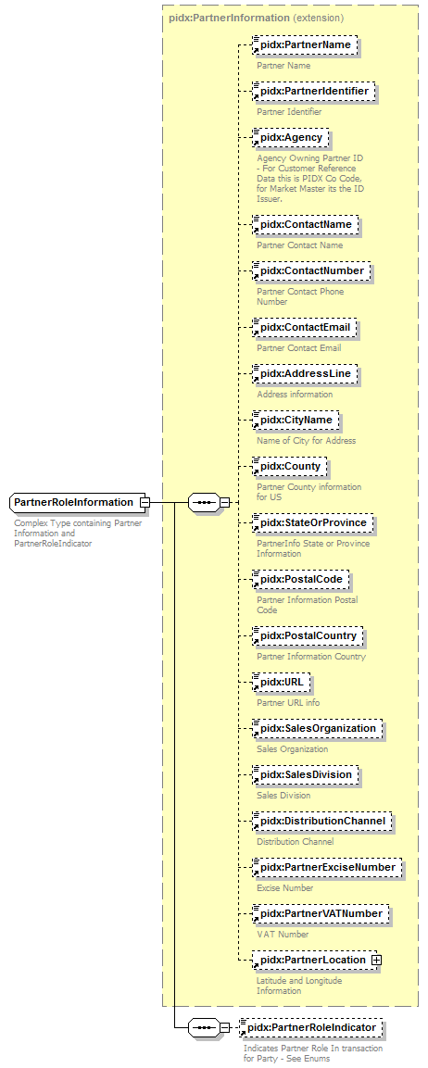
namespace | http://www.pidx.org/schema/ds/v5.02
type | extension of pidx:PartnerInformation
properties | base pidx:PartnerInformation  mixed false
children | pidx:PartnerName pidx:PartnerIdentifier pidx:Agency pidx:ContactName pidx:ContactNumber pidx:ContactEmail pidx:AddressLine pidx:CityName pidx:County pidx:StateOrProvince pidx:PostalCode pidx:PostalCountry pidx:URL pidx:SalesOrganization pidx:SalesDivision pidx:DistributionChannel pidx:PartnerExciseNumber pidx:PartnerVATNumber pidx:PartnerLocation pidx:PartnerRoleIndicator
used by | elements From Party To
annotation | documentation  Complex Type containing Partner Information and PartnerRoleIndicator
source | <complexType name="PartnerRoleInformation" mixed="false">  <annotation>  <documentation>Complex Type containing Partner Information and PartnerRoleIndicator</documentation>  </annotation>  <complexContent mixed="false">  <extension base="pidx:PartnerInformation">  <sequence>  <element ref="pidx:PartnerRoleIndicator" minOccurs="0"/>  </sequence>  </extension>  </complexContent>  </complexType>

complexType PIDXPlannedMovementReq
diagram | 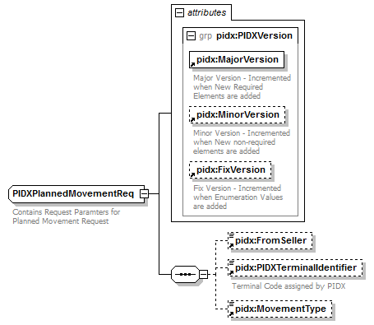
namespace | http://www.pidx.org/schema/ds/v5.02
children | pidx:FromSeller pidx:PIDXTerminalIdentifier pidx:MovementType
used by | element PlannedMovementRequest
attributes | Name Type Use Default Fixed annotation  MajorVersion required 05 documentation Major Version - Incremented when New Required Elements are added  MinorVersion optional 02 documentation Minor Version - Incremented when New non-required elements are added  FixVersion optional 01 documentation Fix Version - Incremented when Enumeration Values are added
annotation | documentation  Contains Request Paramters for Planned Movement Request
source | <complexType name="PIDXPlannedMovementReq">  <annotation>  <documentation>Contains Request Paramters for Planned Movement Request</documentation>  </annotation>  <sequence>  <element ref="pidx:FromSeller" minOccurs="0"/>  <element ref="pidx:PIDXTerminalIdentifier" minOccurs="0"/>  <element ref="pidx:MovementType" minOccurs="0"/>  </sequence>  <attributeGroup ref="pidx:PIDXVersion"/>  </complexType>

complexType PMMOT
diagram | 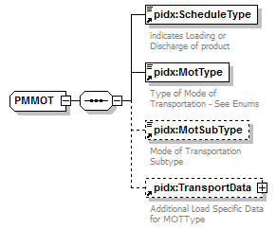
namespace | http://www.pidx.org/schema/ds/v5.02
children | pidx:ScheduleType pidx:MotType pidx:MotSubType pidx:TransportData
used by | element PlannedModeOfTransport
source | <complexType name="PMMOT">  <sequence>  <element ref="pidx:ScheduleType"/>  <element ref="pidx:MotType"/>  <element ref="pidx:MotSubType" minOccurs="0"/>  <element ref="pidx:TransportData" minOccurs="0">  <annotation>  <documentation>Additional Load Specific Data for MOTType</documentation>  </annotation>  </element>  </sequence>  </complexType>

complexType PMQuantity
diagram | 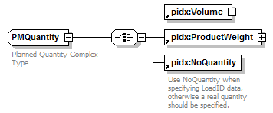
namespace | http://www.pidx.org/schema/ds/v5.02
children | pidx:Volume pidx:ProductWeight pidx:NoQuantity
used by | elements CompartmentQuantity PeriodQuantity PlannedQuantity TankDeliveryQuantity
annotation | documentation  Planned Quantity Complex Type
source | <complexType name="PMQuantity">  <annotation>  <documentation>Planned Quantity Complex Type</documentation>  </annotation>  <choice>  <element ref="pidx:Volume"/>  <element ref="pidx:ProductWeight"/>  <element ref="pidx:NoQuantity"/>  </choice>  </complexType>

complexType PMResponseBaseClass
diagram | 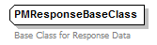
namespace | http://www.pidx.org/schema/ds/v5.02
used by | element ResponseResult  complexTypes PMResponseFailedData PMResponseSucessData
annotation | documentation  Base Class for Response Data
source | <complexType name="PMResponseBaseClass">  <annotation>  <documentation>Base Class for Response Data</documentation>  </annotation>  </complexType>

complexType PMResponseBody
diagram | 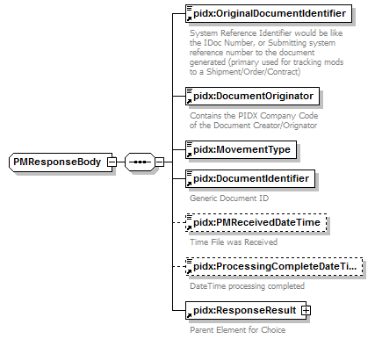
namespace | http://www.pidx.org/schema/ds/v5.02
children | pidx:OriginalDocumentIdentifier pidx:DocumentOriginator pidx:MovementType pidx:DocumentIdentifier pidx:PMReceivedDateTime pidx:ProcessingCompleteDateTime pidx:ResponseResult
used by | element Response
source | <complexType name="PMResponseBody">  <sequence>  <element ref="pidx:OriginalDocumentIdentifier"/>  <element ref="pidx:DocumentOriginator"/>  <element ref="pidx:MovementType"/>  <element ref="pidx:DocumentIdentifier"/>  <element ref="pidx:PMReceivedDateTime" minOccurs="0"/>  <element ref="pidx:ProcessingCompleteDateTime" minOccurs="0"/>  <element ref="pidx:ResponseResult"/>  </sequence>  </complexType>

complexType PMResponseComplex
diagram | 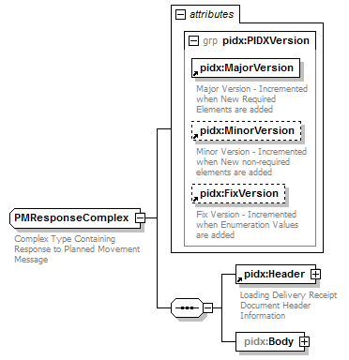
namespace | http://www.pidx.org/schema/ds/v5.02
children | pidx:Header pidx:Body
attributes | Name Type Use Default Fixed annotation  MajorVersion required 05 documentation Major Version - Incremented when New Required Elements are added  MinorVersion optional 02 documentation Minor Version - Incremented when New non-required elements are added  FixVersion optional 01 documentation Fix Version - Incremented when Enumeration Values are added
annotation | documentation  Complex Type Containing Response to Planned Movement Message
source | <complexType name="PMResponseComplex">  <annotation>  <documentation>Complex Type Containing Response to Planned Movement Message</documentation>  </annotation>  <sequence>  <element ref="pidx:Header"/>  <element name="Body">  <complexType>  <sequence>  <element ref="pidx:Response" maxOccurs="unbounded"/>  </sequence>  </complexType>  </element>  </sequence>  <attributeGroup ref="pidx:PIDXVersion"/>  </complexType>

element PMResponseComplex/Body
diagram | 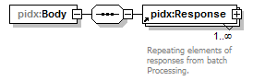
namespace | http://www.pidx.org/schema/ds/v5.02
properties | isRef 0  content complex
children | pidx:Response
source | <element name="Body">  <complexType>  <sequence>  <element ref="pidx:Response" maxOccurs="unbounded"/>  </sequence>  </complexType>  </element>

complexType PMResponseFailedData
diagram | 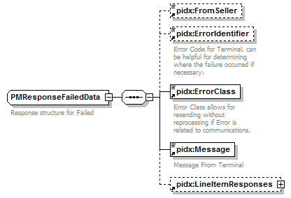
namespace | http://www.pidx.org/schema/ds/v5.02
type | extension of pidx:PMResponseBaseClass
properties | base pidx:PMResponseBaseClass
children | pidx:FromSeller pidx:ErrorIdentifier pidx:ErrorClass pidx:Message pidx:LineItemResponses
used by | element Failed
annotation | documentation  Response structure for Failed
source | <complexType name="PMResponseFailedData">  <annotation>  <documentation>Response structure for Failed</documentation>  </annotation>  <complexContent>  <extension base="pidx:PMResponseBaseClass">  <sequence>  <element ref="pidx:FromSeller" minOccurs="0"/>  <element ref="pidx:ErrorIdentifier" minOccurs="0"/>  <element ref="pidx:ErrorClass"/>  <element ref="pidx:Message"/>  <element ref="pidx:LineItemResponses" minOccurs="0"/>  </sequence>  </extension>  </complexContent>  </complexType>

complexType PMResponseSucessData
diagram | 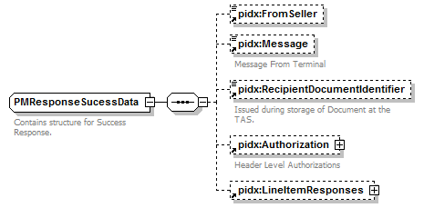
namespace | http://www.pidx.org/schema/ds/v5.02
type | extension of pidx:PMResponseBaseClass
properties | base pidx:PMResponseBaseClass
children | pidx:FromSeller pidx:Message pidx:RecipientDocumentIdentifier pidx:Authorization pidx:LineItemResponses
used by | element Success
annotation | documentation  Contains structure for Success Response.
source | <complexType name="PMResponseSucessData">  <annotation>  <documentation>Contains structure for Success Response.</documentation>  </annotation>  <complexContent>  <extension base="pidx:PMResponseBaseClass">  <sequence>  <element ref="pidx:FromSeller" minOccurs="0"/>  <element ref="pidx:Message" minOccurs="0"/>  <element ref="pidx:RecipientDocumentIdentifier" minOccurs="0"/>  <element ref="pidx:Authorization" minOccurs="0"/>  <element ref="pidx:LineItemResponses" minOccurs="0"/>  </sequence>  </extension>  </complexContent>  </complexType>

complexType PostingData
diagram | 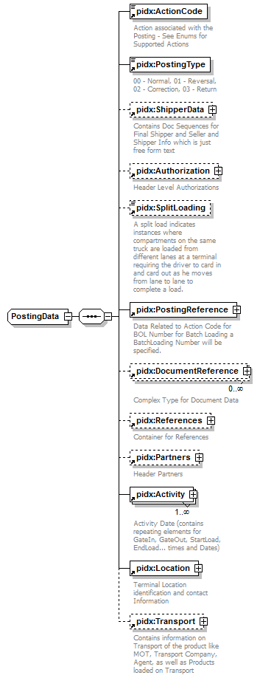
namespace | http://www.pidx.org/schema/ds/v5.02
type | extension of pidx:DocumentBaseClass
properties | base pidx:DocumentBaseClass
children | pidx:ActionCode pidx:PostingType pidx:ShipperData pidx:Authorization pidx:SplitLoading pidx:PostingReference pidx:DocumentReference pidx:References pidx:Partners pidx:Activity pidx:Location pidx:Transport
used by | element Posting
source | <complexType name="PostingData">  <complexContent>  <extension base="pidx:DocumentBaseClass">  <annotation>  <documentation>Complex Type for Posting</documentation>  </annotation>  <sequence>  <element ref="pidx:ActionCode"/>  <element ref="pidx:PostingType">  <annotation>  <documentation>00 - Normal, 01 - Reversal, 02 - Correction, 03 - Return </documentation>  </annotation>  </element>  <element ref="pidx:ShipperData" minOccurs="0"/>  <element ref="pidx:Authorization" minOccurs="0"/>  <element ref="pidx:SplitLoading" minOccurs="0"/>  <element ref="pidx:PostingReference">  <annotation>  <documentation>Data Related to Action Code for BOL Number for Batch Loading a BatchLoading Number will be specified.</documentation>  </annotation>  </element>  <element ref="pidx:DocumentReference" minOccurs="0" maxOccurs="unbounded"/>  <element ref="pidx:References" minOccurs="0"/>  <element ref="pidx:Partners" minOccurs="0"/>  <element ref="pidx:Activity" maxOccurs="unbounded"/>  <element ref="pidx:Location"/>  <element ref="pidx:Transport" minOccurs="0"/>  </sequence>  </extension>  </complexContent>  </complexType>

complexType PressureType
diagram | 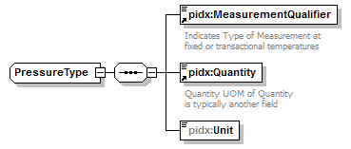
namespace | http://www.pidx.org/schema/ds/v5.02
type | extension of pidx:MeasurementBaseClass
properties | base pidx:MeasurementBaseClass
children | pidx:MeasurementQualifier pidx:Quantity pidx:Unit
used by | element Pressure
source | <complexType name="PressureType">  <complexContent>  <extension base="pidx:MeasurementBaseClass">  <sequence>  <element ref="pidx:MeasurementQualifier"/>  <element ref="pidx:Quantity"/>  <element name="Unit" type="pidx:PressureUnits"/>  </sequence>  </extension>  </complexContent>  </complexType>

element PressureType/Unit
diagram | 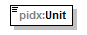
namespace | http://www.pidx.org/schema/ds/v5.02
type | pidx:PressureUnits
properties | isRef 0  content simple
used by | element TaxDetail  complexType MeasurementComplexType
facets | enumeration KPA  enumeration BAR  enumeration PSI
source | <element name="Unit" type="pidx:PressureUnits"/>

complexType ProductData
diagram | 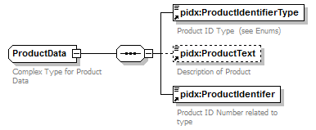
namespace | http://www.pidx.org/schema/ds/v5.02
children | pidx:ProductIdentifierType pidx:ProductText pidx:ProductIdentifer
used by | elements Component ProductIdentifers
annotation | documentation  Complex Type for Product Data
source | <complexType name="ProductData">  <annotation>  <documentation>Complex Type for Product Data</documentation>  </annotation>  <sequence>  <element ref="pidx:ProductIdentifierType"/>  <element ref="pidx:ProductText" minOccurs="0"/>  <element ref="pidx:ProductIdentifer"/>  </sequence>  </complexType>

complexType ProductDataV1
diagram | 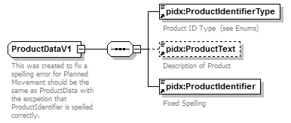
namespace | http://www.pidx.org/schema/ds/v5.02
children | pidx:ProductIdentifierType pidx:ProductText pidx:ProductIdentifier
used by | element ProductIdentifiers
annotation | documentation  This was created to fix a spelling error for Planned Movement should be the same as ProductData with the excpetion that ProductIdentifier is spelled correctly.
source | <complexType name="ProductDataV1">  <annotation>  <documentation>This was created to fix a spelling error for Planned Movement should be the same as ProductData with the excpetion that ProductIdentifier is spelled correctly.</documentation>  </annotation>  <sequence>  <element ref="pidx:ProductIdentifierType"/>  <element ref="pidx:ProductText" minOccurs="0"/>  <element ref="pidx:ProductIdentifier"/>  </sequence>  </complexType>

complexType ProductWeightType
diagram | 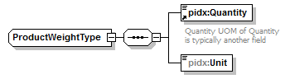
namespace | http://www.pidx.org/schema/ds/v5.02
type | extension of pidx:MeasurementBaseClass
properties | base pidx:MeasurementBaseClass
children | pidx:Quantity pidx:Unit
used by | element ProductWeight
source | <complexType name="ProductWeightType">  <complexContent>  <extension base="pidx:MeasurementBaseClass">  <sequence>  <element ref="pidx:Quantity"/>  <element name="Unit" type="pidx:WeightUnits"/>  </sequence>  </extension>  </complexContent>  </complexType>

element ProductWeightType/Unit
diagram | 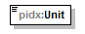
namespace | http://www.pidx.org/schema/ds/v5.02
type | pidx:WeightUnits
properties | isRef 0  content simple
used by | element TaxDetail  complexType MeasurementComplexType
facets | enumeration LBS  enumeration MG  enumeration KGS  enumeration TON  enumeration MTN  enumeration LTN
source | <element name="Unit" type="pidx:WeightUnits"/>

complexType QuantityScheduleType
diagram | 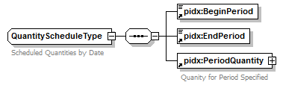
namespace | http://www.pidx.org/schema/ds/v5.02
children | pidx:BeginPeriod pidx:EndPeriod pidx:PeriodQuantity
used by | element QuantitySchedule
annotation | documentation  Scheduled Quantities by Date
source | <complexType name="QuantityScheduleType">  <annotation>  <documentation>Scheduled Quantities by Date</documentation>  </annotation>  <sequence>  <element ref="pidx:BeginPeriod"/>  <element ref="pidx:EndPeriod"/>  <element ref="pidx:PeriodQuantity"/>  </sequence>  </complexType>

complexType RailDefinition
diagram | 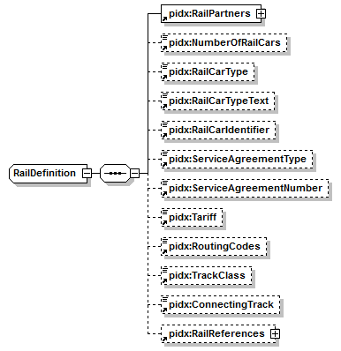
namespace | http://www.pidx.org/schema/ds/v5.02
type | extension of pidx:EquipmentData
properties | base pidx:EquipmentData
children | pidx:RailPartners pidx:NumberOfRailCars pidx:RailCarType pidx:RailCarTypeText pidx:RailCarIdentifier pidx:ServiceAgreementType pidx:ServiceAgreementNumber pidx:Tariff pidx:RoutingCodes pidx:TrackClass pidx:ConnectingTrack pidx:RailReferences
used by | element Rail
source | <complexType name="RailDefinition">  <complexContent>  <extension base="pidx:EquipmentData">  <sequence>  <element ref="pidx:RailPartners"/>  <element ref="pidx:NumberOfRailCars" minOccurs="0"/>  <element ref="pidx:RailCarType" minOccurs="0"/>  <element ref="pidx:RailCarTypeText" minOccurs="0"/>  <element ref="pidx:RailCarIdentifier" minOccurs="0"/>  <element ref="pidx:ServiceAgreementType" minOccurs="0"/>  <element ref="pidx:ServiceAgreementNumber" minOccurs="0"/>  <element ref="pidx:Tariff" minOccurs="0"/>  <element ref="pidx:RoutingCodes" minOccurs="0"/>  <element ref="pidx:TrackClass" minOccurs="0"/>  <element ref="pidx:ConnectingTrack" minOccurs="0"/>  <element ref="pidx:RailReferences" minOccurs="0"/>  </sequence>  </extension>  </complexContent>  </complexType>

complexType RailReferenceDefinition
diagram | 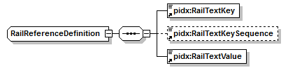
namespace | http://www.pidx.org/schema/ds/v5.02
children | pidx:RailTextKey pidx:RailTextKeySequence pidx:RailTextValue
used by | element RailReference
source | <complexType name="RailReferenceDefinition">  <sequence>  <element ref="pidx:RailTextKey"/>  <element ref="pidx:RailTextKeySequence" minOccurs="0"/>  <element ref="pidx:RailTextValue"/>  </sequence>  </complexType>

complexType RevisionData
diagram | 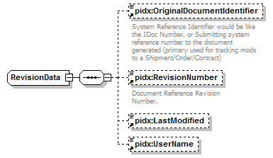
namespace | http://www.pidx.org/schema/ds/v5.02
children | pidx:OriginalDocumentIdentifier pidx:RevisionNumber pidx:LastModified pidx:UserName
used by | element Revision
source | <complexType name="RevisionData">  <sequence>  <element ref="pidx:OriginalDocumentIdentifier" minOccurs="0"/>  <element ref="pidx:RevisionNumber" minOccurs="0"/>  <element ref="pidx:LastModified" minOccurs="0"/>  <element ref="pidx:UserName" minOccurs="0"/>  </sequence>  </complexType>

complexType SecondaryLoadReferenceCT
diagram | 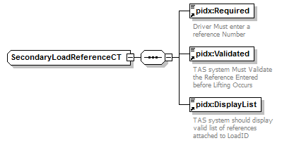
namespace | http://www.pidx.org/schema/ds/v5.02
children | pidx:Required pidx:Validated pidx:DisplayList
used by | element SecondaryLoadReference
source | <complexType name="SecondaryLoadReferenceCT">  <sequence>  <element ref="pidx:Required"/>  <element ref="pidx:Validated"/>  <element ref="pidx:DisplayList"/>  </sequence>  </complexType>

complexType TankDeliveryData
diagram | 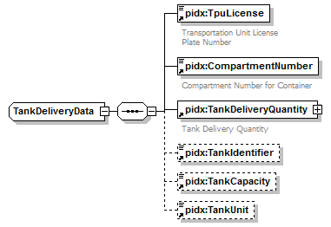
namespace | http://www.pidx.org/schema/ds/v5.02
children | pidx:TpuLicense pidx:CompartmentNumber pidx:TankDeliveryQuantity pidx:TankIdentifier pidx:TankCapacity pidx:TankUnit
used by | element TankDeliveryDetail
source | <complexType name="TankDeliveryData">  <sequence>  <element ref="pidx:TpuLicense"/>  <element ref="pidx:CompartmentNumber"/>  <element ref="pidx:TankDeliveryQuantity"/>  <element ref="pidx:TankIdentifier" minOccurs="0"/>  <element ref="pidx:TankCapacity" minOccurs="0"/>  <element ref="pidx:TankUnit" minOccurs="0"/>  </sequence>  </complexType>

complexType TemperatureType
diagram | 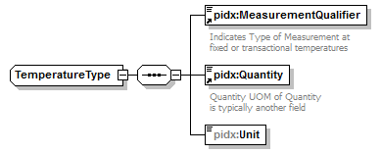
namespace | http://www.pidx.org/schema/ds/v5.02
type | extension of pidx:MeasurementBaseClass
properties | base pidx:MeasurementBaseClass
children | pidx:MeasurementQualifier pidx:Quantity pidx:Unit
used by | element Temperature
source | <complexType name="TemperatureType">  <complexContent>  <extension base="pidx:MeasurementBaseClass">  <sequence>  <element ref="pidx:MeasurementQualifier"/>  <element ref="pidx:Quantity"/>  <element name="Unit" type="pidx:TemperatureUnits"/>  </sequence>  </extension>  </complexContent>  </complexType>

element TemperatureType/Unit
diagram | 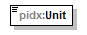
namespace | http://www.pidx.org/schema/ds/v5.02
type | pidx:TemperatureUnits
properties | isRef 0  content simple
used by | element TaxDetail  complexType MeasurementComplexType
facets | enumeration C  enumeration F
source | <element name="Unit" type="pidx:TemperatureUnits"/>

complexType TruckDefinition
diagram | 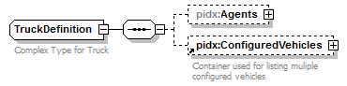
namespace | http://www.pidx.org/schema/ds/v5.02
type | extension of pidx:EquipmentData
properties | base pidx:EquipmentData
children | pidx:Agents pidx:ConfiguredVehicles
used by | element Truck
annotation | documentation  Complex Type for Truck
source | <complexType name="TruckDefinition">  <annotation>  <documentation>Complex Type for Truck</documentation>  </annotation>  <complexContent>  <extension base="pidx:EquipmentData">  <sequence>  <element name="Agents" minOccurs="0">  <complexType>  <sequence>  <element ref="pidx:Agent" maxOccurs="10"/>  </sequence>  </complexType>  </element>  <element ref="pidx:ConfiguredVehicles" minOccurs="0"/>  </sequence>  </extension>  </complexContent>  </complexType>

element TruckDefinition/Agents
diagram | 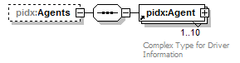
namespace | http://www.pidx.org/schema/ds/v5.02
properties | isRef 0  minOcc 0  maxOcc 1  content complex
children | pidx:Agent
source | <element name="Agents" minOccurs="0">  <complexType>  <sequence>  <element ref="pidx:Agent" maxOccurs="10"/>  </sequence>  </complexType>  </element>

complexType VechicleSpecificationData
diagram | 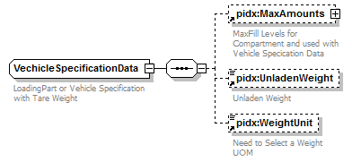
namespace | http://www.pidx.org/schema/ds/v5.02
children | pidx:MaxAmounts pidx:UnladenWeight pidx:WeightUnit
used by | element EquipmentSpecification
annotation | documentation  LoadingPart or Vehicle Specification with Tare Weight
source | <complexType name="VechicleSpecificationData">  <annotation>  <documentation>LoadingPart or Vehicle Specification with Tare Weight</documentation>  </annotation>  <sequence>  <element ref="pidx:MaxAmounts" minOccurs="0"/>  <element ref="pidx:UnladenWeight" minOccurs="0"/>  <element ref="pidx:WeightUnit" minOccurs="0"/>  </sequence>  </complexType>

complexType VolumeType
diagram | 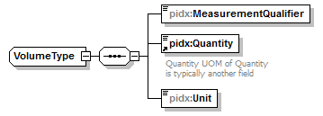
namespace | http://www.pidx.org/schema/ds/v5.02
type | extension of pidx:MeasurementBaseClass
properties | base pidx:MeasurementBaseClass
children | pidx:MeasurementQualifier pidx:Quantity pidx:Unit
used by | element Volume
source | <complexType name="VolumeType">  <complexContent>  <extension base="pidx:MeasurementBaseClass">  <sequence>  <element name="MeasurementQualifier" type="pidx:MeasurementQualifierEnum"/>  <element ref="pidx:Quantity"/>  <element name="Unit" type="pidx:VolumeUnits"/>  </sequence>  </extension>  </complexContent>  </complexType>

element VolumeType/MeasurementQualifier
diagram | 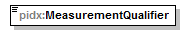
namespace | http://www.pidx.org/schema/ds/v5.02
type | pidx:MeasurementQualifierEnum
properties | isRef 0  content simple
used by | complexTypes DensityType GravityType MeasurementComplexType PressureType TemperatureType
facets | enumeration Ambient  enumeration Standard
source | <element name="MeasurementQualifier" type="pidx:MeasurementQualifierEnum"/>

element VolumeType/Unit
diagram | 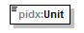
namespace | http://www.pidx.org/schema/ds/v5.02
type | pidx:VolumeUnits
properties | isRef 0  content simple
used by | element TaxDetail  complexType MeasurementComplexType
facets | enumeration LTR  enumeration ML  enumeration OZ  enumeration GAL  enumeration IGL  enumeration BBL  enumeration KB  enumeration CBM  enumeration HLT
source | <element name="Unit" type="pidx:VolumeUnits"/>

simpleType ActionCodeEnum
namespace | http://www.pidx.org/schema/ds/v5.02
type | restriction of string
used by | element ActionCode
facets | enumeration Loading  enumeration BatchLoading  enumeration Delivery  enumeration Unload  enumeration Stockresult  enumeration Inventory  enumeration Transfers  enumeration Orders  enumeration ShipmentOrder  enumeration Contract  enumeration LoadID  enumeration Nomination  enumeration SalesOrder
annotation | documentation  Action Code list for Loading Delivery Type
source | <simpleType name="ActionCodeEnum">  <annotation>  <documentation>Action Code list for Loading Delivery Type</documentation>  </annotation>  <restriction base="string">  <enumeration value="Loading">  <annotation>  <documentation>Actual Loading or BOL information Contained in Document- Single BOL data so PostingRefernce will contain BOL data. In BatchLoading BOL number data is reference in detail section.</documentation>  </annotation>  </enumeration>  <enumeration value="BatchLoading">  <annotation>  <documentation>BatchLoaing - Used for LoadID loading - BOL Numbers appear in Detail section along with potential consignee and seller information.</documentation>  </annotation>  </enumeration>  <enumeration value="Delivery">  <annotation>  <documentation>BOL Data based on Shipment or Delivery</documentation>  </annotation>  </enumeration>  <enumeration value="Unload">  <annotation>  <documentation>Unloading of Product</documentation>  </annotation>  </enumeration>  <enumeration value="Stockresult">  <annotation>  <documentation>Need Definition ??</documentation>  </annotation>  </enumeration>  <enumeration value="Inventory">  <annotation>  <documentation>Need Definition ??</documentation>  </annotation>  </enumeration>  <enumeration value="Transfers">  <annotation>  <documentation>Need Definition ??</documentation>  </annotation>  </enumeration>  <enumeration value="Orders">  <annotation>  <documentation>Posting Section Contains an Order, not Actuals - Buyer Order against Contract</documentation>  </annotation>  </enumeration>  <enumeration value="ShipmentOrder">  <annotation>  <documentation>Shipment Order is related to Delivery Business from a Supplier</documentation>  </annotation>  </enumeration>  <enumeration value="Contract"/>  <enumeration value="LoadID"/>  <enumeration value="Nomination"/>  <enumeration value="SalesOrder">  <annotation>  <documentation>Seller Order Number</documentation>  </annotation>  </enumeration>  </restriction>  </simpleType>

simpleType ActivityTypeEnum
namespace | http://www.pidx.org/schema/ds/v5.02
type | restriction of string
used by | element ActivityType
facets | enumeration ArchiveDate  enumeration BookStart  enumeration BookEnd  enumeration BayIn  enumeration BayOut  enumeration DocPrint  enumeration EndLoad  enumeration EstDeliveryStart  enumeration EstDeliveryEnd  enumeration EstPickupDate  enumeration EstStartLoad  enumeration ExpireDate  enumeration GateIn  enumeration GateOut  enumeration Staging  enumeration StartLoad  enumeration ValidDate  enumeration WeighIn  enumeration WeightOut
annotation | documentation  Date Activity Enumeration Definitions
source | <simpleType name="ActivityTypeEnum">  <annotation>  <documentation>Date Activity Enumeration Definitions</documentation>  </annotation>  <restriction base="string">  <enumeration value="ArchiveDate">  <annotation>  <documentation>Date the Planned Movement document should be removed from the TAS or DCH.</documentation>  </annotation>  </enumeration>  <enumeration value="BookStart">  <annotation>  <documentation>Used for TAS Systems which support Booking a Loading Time</documentation>  </annotation>  </enumeration>  <enumeration value="BookEnd">  <annotation>  <documentation>Used for TAS Systems which support Booking a Loading Time</documentation>  </annotation>  </enumeration>  <enumeration value="BayIn">  <annotation>  <documentation>Time Truck drives into the loading bay</documentation>  </annotation>  </enumeration>  <enumeration value="BayOut">  <annotation>  <documentation>Time Logged for Leaving the loading bay</documentation>  </annotation>  </enumeration>  <enumeration value="DocPrint">  <annotation>  <documentation>Time the document was printed</documentation>  </annotation>  </enumeration>  <enumeration value="EndLoad">  <annotation>  <documentation>End of Loading Time stamp - Used for Billing</documentation>  </annotation>  </enumeration>  <enumeration value="EstDeliveryStart">  <annotation>  <documentation>Estimated Delivery Start Date for Trip</documentation>  </annotation>  </enumeration>  <enumeration value="EstDeliveryEnd">  <annotation>  <documentation>Estimated Delivery Completed Date</documentation>  </annotation>  </enumeration>  <enumeration value="EstPickupDate">  <annotation>  <documentation>Estimated Pickup Terminal Pickup Date and Time</documentation>  </annotation>  </enumeration>  <enumeration value="EstStartLoad"/>  <enumeration value="ExpireDate">  <annotation>  <documentation>Expiration time stamp of Order or Shipment</documentation>  </annotation>  </enumeration>  <enumeration value="GateIn">  <annotation>  <documentation>Gate Entry Time stamp</documentation>  </annotation>  </enumeration>  <enumeration value="GateOut">  <annotation>  <documentation>Gate Exit Time stamp</documentation>  </annotation>  </enumeration>  <enumeration value="Staging">  <annotation>  <documentation>Time Staging started</documentation>  </annotation>  </enumeration>  <enumeration value="StartLoad">  <annotation>  <documentation>Start of Loading Time stamp</documentation>  </annotation>  </enumeration>  <enumeration value="ValidDate">  <annotation>  <documentation>Validate Until Date Time of Order or Shipment</documentation>  </annotation>  </enumeration>  <enumeration value="WeighIn">  <annotation>  <documentation>Weigh Bridge Scale Start</documentation>  </annotation>  </enumeration>  <enumeration value="WeightOut">  <annotation>  <documentation>Weigh Bridge End Time</documentation>  </annotation>  </enumeration>  </restriction>  </simpleType>

simpleType AgentTypeEnum
namespace | http://www.pidx.org/schema/ds/v5.02
type | restriction of string
used by | element AgentType
facets | enumeration DeliveryAgent  enumeration LoadingAgent
annotation | documentation  Driver Type Definitions
source | <simpleType name="AgentTypeEnum">  <annotation>  <documentation>Driver Type Definitions</documentation>  </annotation>  <restriction base="string">  <enumeration value="DeliveryAgent"/>  <enumeration value="LoadingAgent"/>  </restriction>  </simpleType>

simpleType BlockValues
namespace | http://www.pidx.org/schema/ds/v5.02
type | restriction of string
used by | element BlockIndicator
facets | enumeration Blocked  enumeration Unblocked
source | <simpleType name="BlockValues">  <restriction base="string">  <enumeration value="Blocked"/>  <enumeration value="Unblocked"/>  </restriction>  </simpleType>

simpleType BOLTypeEnum
namespace | http://www.pidx.org/schema/ds/v5.02
type | restriction of string
used by | element BOLType
facets | enumeration Product  enumeration Compartment  enumeration Delivery
annotation | documentation  Type of BOLs
source | <simpleType name="BOLTypeEnum">  <annotation>  <documentation>Type of BOLs</documentation>  </annotation>  <restriction base="string">  <enumeration value="Product"/>  <enumeration value="Compartment"/>  <enumeration value="Delivery"/>  </restriction>  </simpleType>

simpleType CustomsRoleEnum
namespace | http://www.pidx.org/schema/ds/v5.02
type | restriction of string
used by | elements PartnerRoleIndicator Exporter/PartnerRoleIndicator
facets | enumeration BorderCrossingPoint  enumeration CustomsOffice  enumeration Exporter
annotation | documentation  Customs Party Data
source | <simpleType name="CustomsRoleEnum">  <annotation>  <documentation>Customs Party Data</documentation>  </annotation>  <restriction base="string">  <enumeration value="BorderCrossingPoint">  <annotation>  <documentation>Type of Customs Office</documentation>  </annotation>  </enumeration>  <enumeration value="CustomsOffice"/>  <enumeration value="Exporter">  <annotation>  <documentation>Exporter - Assuming Exporting Company  Added V5.02</documentation>  </annotation>  </enumeration>  </restriction>  </simpleType>

simpleType DensityUnits
namespace | http://www.pidx.org/schema/ds/v5.02
type | restriction of string
used by | elements DensityType/Unit Unit
facets | enumeration KGL  enumeration KGM  enumeration PGA
annotation | documentation  Density UOMs
source | <simpleType name="DensityUnits">  <annotation>  <documentation>Density UOMs</documentation>  </annotation>  <restriction base="string">  <enumeration value="KGL">  <annotation>  <documentation>Density - Kilograms per Liter</documentation>  </annotation>  </enumeration>  <enumeration value="KGM">  <annotation>  <documentation>Density - Kilogram per Cubic Meter</documentation>  </annotation>  </enumeration>  <enumeration value="PGA">  <annotation>  <documentation>Density - Pounds per Gallon  </documentation>  </annotation>  </enumeration>  </restriction>  </simpleType>

simpleType DocumentTypes
namespace | http://www.pidx.org/schema/ds/v5.02
type | restriction of string
used by | element DocumentReferenceType
facets | enumeration LoadID  enumeration Nomination  enumeration PurchaseContract  enumeration PurchaseOrder  enumeration SalesContract  enumeration SalesOrder  enumeration Shipment
annotation | documentation  DocumentType Definitions
source | <simpleType name="DocumentTypes">  <annotation>  <documentation>DocumentType Definitions</documentation>  </annotation>  <restriction base="string">  <enumeration value="LoadID"/>  <enumeration value="Nomination">  <annotation>  <documentation>Nominations - Support Nominations  Added V5.02</documentation>  </annotation>  </enumeration>  <enumeration value="PurchaseContract">  <annotation>  <documentation>Buyer Contract Number</documentation>  </annotation>  </enumeration>  <enumeration value="PurchaseOrder">  <annotation>  <documentation>Buyer or Consignee ERP Purchase Order</documentation>  </annotation>  </enumeration>  <enumeration value="SalesContract">  <annotation>  <documentation>Seller Sales Contract Number</documentation>  </annotation>  </enumeration>  <enumeration value="SalesOrder">  <annotation>  <documentation>Seller Sales Order Information</documentation>  </annotation>  </enumeration>  <enumeration value="Shipment">  <annotation>  <documentation>Shipment Document - ERP System Document</documentation>  </annotation>  </enumeration>  </restriction>  </simpleType>

simpleType DriverEnteredData
namespace | http://www.pidx.org/schema/ds/v5.02
type | restriction of string
used by | element DocumentReferenceType
facets | enumeration CustomerReference
annotation | documentation  Contains Enumeration for Driver Entered Text
source | <simpleType name="DriverEnteredData">  <annotation>  <documentation>Contains Enumeration for Driver Entered Text</documentation>  </annotation>  <restriction base="string">  <enumeration value="CustomerReference">  <annotation>  <documentation>Assuming this is the Trip Number</documentation>  </annotation>  </enumeration>  </restriction>  </simpleType>

simpleType EMCSDestinationEnum
namespace | http://www.pidx.org/schema/ds/v5.02
type | restriction of string
used by | element DestinationTypeCode
facets | enumeration 1  enumeration 2  enumeration 3  enumeration 4  enumeration 5  enumeration 6  enumeration 8
source | <simpleType name="EMCSDestinationEnum">  <restriction base="string">  <enumeration value="1">  <annotation>  <documentation>1 - Tax Warehouse</documentation>  </annotation>  </enumeration>  <enumeration value="2">  <annotation>  <documentation>2 - Registered Consignee</documentation>  </annotation>  </enumeration>  <enumeration value="3">  <annotation>  <documentation>3 - Temporary Registered Consignee</documentation>  </annotation>  </enumeration>  <enumeration value="4">  <annotation>  <documentation>4 - Direct Delivery</documentation>  </annotation>  </enumeration>  <enumeration value="5">  <annotation>  <documentation>5 - Exempted Consignee</documentation>  </annotation>  </enumeration>  <enumeration value="6">  <annotation>  <documentation>6 - Export</documentation>  </annotation>  </enumeration>  <enumeration value="8">  <annotation>  <documentation>8 - Unknown Destination</documentation>  </annotation>  </enumeration>  </restriction>  </simpleType>

simpleType EMCSGuarantorEnum
namespace | http://www.pidx.org/schema/ds/v5.02
type | restriction of string
used by | element GuarantorTypeCode
facets | enumeration 0  enumeration 1  enumeration 2  enumeration 3  enumeration 4  enumeration 12  enumeration 13  enumeration 14  enumeration 23  enumeration 24  enumeration 34  enumeration 123  enumeration 124  enumeration 134  enumeration 234  enumeration 1234
source | <simpleType name="EMCSGuarantorEnum">  <restriction base="string">  <enumeration value="0"/>  <enumeration value="1">  <annotation>  <documentation>1- Consignor</documentation>  </annotation>  </enumeration>  <enumeration value="2">  <annotation>  <documentation>2 - Transporter</documentation>  </annotation>  </enumeration>  <enumeration value="3">  <annotation>  <documentation>3 - Owner</documentation>  </annotation>  </enumeration>  <enumeration value="4">  <annotation>  <documentation>4 - Consignee</documentation>  </annotation>  </enumeration>  <enumeration value="12">  <annotation>  <documentation>12 - Consignor and Transporter</documentation>  </annotation>  </enumeration>  <enumeration value="13">  <annotation>  <documentation>13 - Consignor and Owner</documentation>  </annotation>  </enumeration>  <enumeration value="14">  <annotation>  <documentation>14 - Consignor and Consignee</documentation>  </annotation>  </enumeration>  <enumeration value="23">  <annotation>  <documentation>23 - Transporter and Owner</documentation>  </annotation>  </enumeration>  <enumeration value="24">  <annotation>  <documentation>24 - Transporter and Consignee</documentation>  </annotation>  </enumeration>  <enumeration value="34">  <annotation>  <documentation>34 - Owner and Consignee</documentation>  </annotation>  </enumeration>  <enumeration value="123">  <annotation>  <documentation>123 - Consignor and Transporter and Owner</documentation>  </annotation>  </enumeration>  <enumeration value="124">  <annotation>  <documentation>124 - Consignor and Transporter and Consignee</documentation>  </annotation>  </enumeration>  <enumeration value="134">  <annotation>  <documentation>134 - Consignor and Owner and Consignee</documentation>  </annotation>  </enumeration>  <enumeration value="234">  <annotation>  <documentation>234 - Transporter and Owner and Consignee</documentation>  </annotation>  </enumeration>  <enumeration value="1234">  <annotation>  <documentation>1234 - Consignor and Transporter and Consignee and Owner</documentation>  </annotation>  </enumeration>  </restriction>  </simpleType>

simpleType EMCSSubmissionMessageEnum
namespace | http://www.pidx.org/schema/ds/v5.02
type | restriction of string
used by | element SubmissionMessageType
facets | enumeration 1  enumeration 2
source | <simpleType name="EMCSSubmissionMessageEnum">  <restriction base="string">  <enumeration value="1">  <annotation>  <documentation> 1 = Standard Transmission</documentation>  </annotation>  </enumeration>  <enumeration value="2">  <annotation>  <documentation>2 = Submission for Export with local Clearance</documentation>  </annotation>  </enumeration>  </restriction>  </simpleType>

simpleType EMCSTransportArrangerEnum
namespace | http://www.pidx.org/schema/ds/v5.02
type | restriction of string
used by | element TransportArrangerCode
facets | enumeration 1  enumeration 2  enumeration 3  enumeration 4
source | <simpleType name="EMCSTransportArrangerEnum">  <restriction base="string">  <enumeration value="1">  <annotation>  <documentation>1 - Consignor</documentation>  </annotation>  </enumeration>  <enumeration value="2">  <annotation>  <documentation>2 - Consignee</documentation>  </annotation>  </enumeration>  <enumeration value="3">  <annotation>  <documentation>3 - Owner</documentation>  </annotation>  </enumeration>  <enumeration value="4">  <annotation>  <documentation>4 - Other</documentation>  </annotation>  </enumeration>  </restriction>  </simpleType>

simpleType EMCSTransportEnum
namespace | http://www.pidx.org/schema/ds/v5.02
type | restriction of string
used by | element TransportModeCode
facets | enumeration 0  enumeration 1  enumeration 2  enumeration 3  enumeration 4  enumeration 5  enumeration 7  enumeration 8
source | <simpleType name="EMCSTransportEnum">  <restriction base="string">  <enumeration value="0">  <annotation>  <documentation>0 - Other</documentation>  </annotation>  </enumeration>  <enumeration value="1">  <annotation>  <documentation>1 - Sea Transport</documentation>  </annotation>  </enumeration>  <enumeration value="2">  <annotation>  <documentation>2 - Rail Transport</documentation>  </annotation>  </enumeration>  <enumeration value="3">  <annotation>  <documentation>3 - Road Transport</documentation>  </annotation>  </enumeration>  <enumeration value="4">  <annotation>  <documentation>4 -Air Transport</documentation>  </annotation>  </enumeration>  <enumeration value="5">  <annotation>  <documentation>5 - Postal Consignment</documentation>  </annotation>  </enumeration>  <enumeration value="7">  <annotation>  <documentation>7 - Fixed Transport Installations</documentation>  </annotation>  </enumeration>  <enumeration value="8">  <annotation>  <documentation>8 - Inland Waterway Transport</documentation>  </annotation>  </enumeration>  </restriction>  </simpleType>

simpleType EnergyContentUnits
namespace | http://www.pidx.org/schema/ds/v5.02
type | restriction of string
used by | element Unit
facets | enumeration MWH
annotation | documentation  EnergyContentUnits
source | <simpleType name="EnergyContentUnits">  <annotation>  <documentation>EnergyContentUnits</documentation>  </annotation>  <restriction base="string">  <enumeration value="MWH">  <annotation>  <documentation>Mega-Watt Hours</documentation>  </annotation>  </enumeration>  </restriction>  </simpleType>

simpleType ErrorClaseEnum
namespace | http://www.pidx.org/schema/ds/v5.02
type | restriction of string
used by | element ErrorClass
facets | enumeration Communications  enumeration MasterData  enumeration AuthorizationFailed  enumeration DocumentRestriction
annotation | documentation  Enumerations for supported Error Types
source | <simpleType name="ErrorClaseEnum">  <annotation>  <documentation>Enumerations for supported Error Types</documentation>  </annotation>  <restriction base="string">  <enumeration value="Communications"/>  <enumeration value="MasterData"/>  <enumeration value="AuthorizationFailed"/>  <enumeration value="DocumentRestriction"/>  </restriction>  </simpleType>

simpleType FenceUnits
namespace | http://www.pidx.org/schema/ds/v5.02
type | pidx:LengthUnits
used by | element GeoFenceUnit
facets | enumeration FT  enumeration YD  enumeration M  enumeration KM
annotation | documentation  Geo Fence Units
source | <simpleType name="FenceUnits">  <annotation>  <documentation>Geo Fence Units</documentation>  </annotation>  <restriction base="pidx:LengthUnits"/>  </simpleType>

simpleType GravityUnits
namespace | http://www.pidx.org/schema/ds/v5.02
type | restriction of string
used by | elements GravityType/Unit Unit
facets | enumeration API  enumeration SG
annotation | documentation  Gravity UOMs
source | <simpleType name="GravityUnits">  <annotation>  <documentation>Gravity UOMs</documentation>  </annotation>  <restriction base="string">  <enumeration value="API">  <annotation>  <documentation>Gravity - Degrees API  </documentation>  </annotation>  </enumeration>  <enumeration value="SG">  <annotation>  <documentation>Specific Gravity</documentation>  </annotation>  </enumeration>  </restriction>  </simpleType>

simpleType IncoTermEnums
namespace | http://www.pidx.org/schema/ds/v5.02
type | restriction of string
used by | element Incoterms
facets | enumeration EXW  enumeration FCA  enumeration CPT  enumeration CIP  enumeration DAT  enumeration DAP  enumeration DDP  enumeration FAS  enumeration FOB  enumeration CFR  enumeration CIF  enumeration DAF  enumeration DES  enumeration DEQ  enumeration DDU
annotation | documentation  Inco Terms
source | <simpleType name="IncoTermEnums">  <annotation>  <documentation>Inco Terms</documentation>  </annotation>  <restriction base="string">  <enumeration value="EXW">  <annotation>  <documentation>EXW – Ex Works (named place of delivery)  The seller makes the goods available at his/her premises. The buyer is responsible for uploading. This term places the maximum obligation on the buyer and minimum obligations on the seller. The Ex Works term is often used when making an initial quotation for the sale of goods without any costs included. EXW means that a seller has the goods ready for collection at his premises (works, factory, warehouse, plant) on the date agreed upon. The buyer pays all transportation costs and also bears the risks for bringing the goods to their final destination. The seller does not load the goods on collecting vehicles and doesn't clear them for export. If the seller does load the goods, he does so at buyer's risk and cost. If parties wish seller to be responsible for the loading of the goods on departure and to bear the risk and all costs of such loading, this must be made clear by adding explicit wording to this effect in the contract of sale..  Added V5.02  </documentation>  </annotation>  </enumeration>  <enumeration value="FCA">  <annotation>  <documentation>FCA – Free Carrier (named place of delivery)  The seller delivers goods, cleared for export, to the buyer-designated carrier at a named location. This is used for any mode of transport. The seller must load goods onto the buyer's carrier. The key document signifying transfer of responsibility is receipt by carrier to exporter.  Added V5.02</documentation>  </annotation>  </enumeration>  <enumeration value="CPT">  <annotation>  <documentation>CPT – Carriage Paid To (named place of destination)  The seller pays for carriage. Risk transfers to buyer upon handing goods over to the first carrier at place of shipment in the country of export.  This term is used for all kind of shipments.  Added V5.02</documentation>  </annotation>  </enumeration>  <enumeration value="CIP">  <annotation>  <documentation>CIP – Carriage and Insurance Paid to (named place of destination)  The containerized transport/multi-modal equivalent of CIF. Seller pays for carriage and insurance to the named destination point, but risk passes when the goods are handed over to the first carrier.  Added V5.02</documentation>  </annotation>  </enumeration>  <enumeration value="DAT">  <annotation>  <documentation>DAT – Delivered at Terminal (named terminal at port or place of destination)  Seller pays for carriage to the terminal, except for costs related to import clearance, and assumes all risks up to the point that the goods are unloaded at the terminal.  Added V5.02</documentation>  </annotation>  </enumeration>  <enumeration value="DAP">  <annotation>  <documentation>DAP – Delivered at Place (named place of destination)  Seller pays for carriage to the named place, except for costs related to import clearance, and assumes all risks prior to the point that the goods are ready for unloading by the buyer.  Added V5.02</documentation>  </annotation>  </enumeration>  <enumeration value="DDP">  <annotation>  <documentation>DDP – Delivered Duty Paid (named place of destination)  Seller is responsible for delivering the goods to the named place in the country of the buyer, and pays all costs in bringing the goods to the destination including import duties and taxes. The seller is not responsible for unloading. This term is often used in place of the non-Incoterm "Free In Store (FIS)". This term places the maximum obligations on the seller and minimum obligations on the buyer. It's called "DDP".  Added V5.02  Added V5.02</documentation>  </annotation>  </enumeration>  <enumeration value="FAS">  <annotation>  <documentation>FAS – Free Alongside Ship (named port of shipment)  Sea and inland waterway transport Term  The seller must place the goods alongside the ship at the named port. The seller must clear the goods for export. Suitable only for maritime transport but NOT for multi-modal sea transport in containers (see Incoterms 2010, ICC publication 715). This term is typically used for heavy-lift or bulk cargo.  Added V5.02</documentation>  </annotation>  </enumeration>  <enumeration value="FOB">  <annotation>  <documentation>FOB – Free on Board (named port of shipment)  Sea and inland waterway transport Term  The seller must load the goods on board the vessel nominated by the buyer. Cost and risk are divided when the goods are actually on board of the vessel. The seller must clear the goods for export. The term is applicable for maritime and inland waterway transport only but NOT for multi-modal sea transport in containers (see Incoterms 2010, ICC publication 715). The buyer must instruct the seller the details of the vessel and the port where the goods are to be loaded, and there is no reference to, or provision for, the use of a carrier or forwarder. This term has been greatly misused over the last three decades ever since Incoterms 1980 explained that FCA should be used for container shipments.  It means the seller pays for transportation of goods to the port of shipment, loading cost. The buyer pays cost of marine freight transportation, insurance, uploading and transportation cost from the arrival port to destination. The passing of risk occurs when the goods pass the ship's rail at port of shipments.  Added V5.02</documentation>  </annotation>  </enumeration>  <enumeration value="CFR">  <annotation>  <documentation>CFR – Cost and Freight (named port of destination)  Sea and inland waterway transport Term  Seller must pay the costs and freight to bring the goods to the port of destination. However, risk is transferred to the buyer once the goods are loaded on the vessel. Insurance for the goods is NOT included. This term is formerly known as CNF. Maritime transport only.  Added V5.02  </documentation>  </annotation>  </enumeration>  <enumeration value="CIF">  <annotation>  <documentation>CIF – Cost, Insurance and Freight (named port of destination)  Sea and inland waterway transport Term  Exactly the same as CFR except that the seller must in addition procure and pay for the insurance. Maritime transport only.  Added V5.02</documentation>  </annotation>  </enumeration>  <enumeration value="DAF">  <annotation>  <documentation>DAF – Delivered at Frontier (named place of delivery)  Previous terms from Incoterms 2000 eliminated from Incoterms 2010  This term can be used when the goods are transported by rail and road. The seller pays for transportation to the named place of delivery at the frontier. The buyer arranges for customs clearance and pays for transportation from the frontier to his factory. The passing of risk occurs at the frontier.  Added V5.02  </documentation>  </annotation>  </enumeration>  <enumeration value="DES">  <annotation>  <documentation>DES – Delivered Ex Ship (named port of delivery)  Previous terms from Incoterms 2000 eliminated from Incoterms 2010  Where goods are delivered ex ship, the passing of risk does not occur until the ship has arrived at the named port of destination and the goods made available for unloading to the buyer. The seller pays the same freight and insurance costs as he would under a CIF arrangement. Unlike CFR and CIF terms, the seller has agreed to bear not just cost, but also Risk and Title up to the arrival of the vessel at the named port. Costs for unloading the goods and any duties, taxes, etc. are for the Buyer. A commonly used term in shipping bulk commodities, such as coal, grain, dry chemicals; and where the seller either owns or has chartered, their own vessel.  Added V5.02</documentation>  </annotation>  </enumeration>  <enumeration value="DEQ">  <annotation>  <documentation>DEQ – Delivered Ex Quay (named port of delivery)  Previous terms from Incoterms 2000 eliminated from Incoterms 2010  This is similar to DES, but the passing of risk does not occur until the goods have been unloaded at the port of discharge.  Added V5.02</documentation>  </annotation>  </enumeration>  <enumeration value="DDU">  <annotation>  <documentation>DDU – Delivered Duty Unpaid (named place of destination)  Previous terms from Incoterms 2000 eliminated from Incoterms 2010  This term means that the seller delivers the goods to the buyer to the named place of destination in the contract of sale. A transaction in international trade where the seller is responsible for making a safe delivery of goods to a named destination, paying all transportation expenses but not the duty. The seller bears the risks and costs associated with supplying the goods to the delivery location, where the buyer becomes responsible for paying the duty and other customs clearing expenses.  Added V5.02</documentation>  </annotation>  </enumeration>  </restriction>  </simpleType>

simpleType LengthUnits
namespace | http://www.pidx.org/schema/ds/v5.02
type | restriction of string
used by | simpleType FenceUnits
facets | enumeration FT  enumeration YD  enumeration M  enumeration KM
annotation | documentation  Length UOMs
source | <simpleType name="LengthUnits">  <annotation>  <documentation>Length UOMs</documentation>  </annotation>  <restriction base="string">  <enumeration value="FT">  <annotation>  <documentation>Foot</documentation>  </annotation>  </enumeration>  <enumeration value="YD">  <annotation>  <documentation>Yard - 3 ft</documentation>  </annotation>  </enumeration>  <enumeration value="M">  <annotation>  <documentation>Meter</documentation>  </annotation>  </enumeration>  <enumeration value="KM">  <annotation>  <documentation>Kilometer - 1000 meters</documentation>  </annotation>  </enumeration>  </restriction>  </simpleType>

simpleType LineItemResponseEnum
namespace | http://www.pidx.org/schema/ds/v5.02
type | restriction of string
used by | element LineItemResponseType
facets | enumeration Failed  enumeration Success  enumeration Warning
annotation | documentation  Enumeration for Type
source | <simpleType name="LineItemResponseEnum">  <annotation>  <documentation>Enumeration for Type</documentation>  </annotation>  <restriction base="string">  <enumeration value="Failed"/>  <enumeration value="Success"/>  <enumeration value="Warning"/>  </restriction>  </simpleType>

simpleType LocationSecondaryTypes
namespace | http://www.pidx.org/schema/ds/v5.02
type | restriction of string
used by | element LocationIdentifierType
facets | enumeration SPLC  enumeration PartnerPlantID  enumeration OtherPlantID
annotation | documentation  Types for Location Secondary Types
source | <simpleType name="LocationSecondaryTypes">  <annotation>  <documentation>Types for Location Secondary Types</documentation>  </annotation>  <restriction base="string">  <enumeration value="SPLC">  <annotation>  <documentation>SPLC - US Freight Region Code</documentation>  </annotation>  </enumeration>  <enumeration value="PartnerPlantID">  <annotation>  <documentation>Plant ID for Seller</documentation>  </annotation>  </enumeration>  <enumeration value="OtherPlantID">  <annotation>  <documentation>Used to store other Plant ID information in Loading Delivery Receipt (see From for Details of which partner sent the original BOL data).</documentation>  </annotation>  </enumeration>  </restriction>  </simpleType>

simpleType MeasurementQualifierEnum
namespace | http://www.pidx.org/schema/ds/v5.02
type | restriction of string
used by | elements MeasurementQualifier VolumeType/MeasurementQualifier
facets | enumeration Ambient  enumeration Standard
annotation | documentation  Measurement Qualifiers Preferred List
source | <simpleType name="MeasurementQualifierEnum">  <annotation>  <documentation>Measurement Qualifiers Preferred List</documentation>  </annotation>  <restriction base="string">  <enumeration value="Ambient"/>  <enumeration value="Standard"/>  </restriction>  </simpleType>

simpleType MeasurementQualifierEnumDeprecated
namespace | http://www.pidx.org/schema/ds/v5.02
type | restriction of string
used by | element MeasurementQualifier
facets | enumeration Transaction  enumeration Test  enumeration Base
annotation | documentation  Measurement Qualifiers to be Deprecated
source | <simpleType name="MeasurementQualifierEnumDeprecated">  <annotation>  <documentation>Measurement Qualifiers to be Deprecated</documentation>  </annotation>  <restriction base="string">  <enumeration value="Transaction">  <annotation>  <documentation>This will be Deprecated in Version 6 - Use Ambient  Transactional temperature reading</documentation>  </annotation>  </enumeration>  <enumeration value="Test">  <annotation>  <documentation>This will be Deprecated in Version 6 - Use Standard  Test is measured from a different temperature reading other than 15 C or 60 F</documentation>  </annotation>  </enumeration>  <enumeration value="Base">  <annotation>  <documentation>This will be Deprecated in Version 6 - Use Standard  Indicates a NET value or measurement from 15 degrees C or 60 Degrees C</documentation>  </annotation>  </enumeration>  </restriction>  </simpleType>

simpleType MeasurementTypeEnum
namespace | http://www.pidx.org/schema/ds/v5.02
type | restriction of string
used by | elements MeasurementType DensityType/MeasurementType GravityType/MeasurementType MixPercentageType/MeasurementType
facets | enumeration MeasuredinAir  enumeration MeasuredInVacuum  enumeration Calculated  enumeration Ordered  enumeration TableLookup
annotation | documentation  Old MeasuremenTypeEnum - Delete it since Measurement Type is now of Type MeasurementTypeDensity and MeasurementTypeMetered
source | <simpleType name="MeasurementTypeEnum">  <annotation>  <documentation>Old MeasuremenTypeEnum - Delete it since Measurement Type is now of Type MeasurementTypeDensity and MeasurementTypeMetered</documentation>  </annotation>  <restriction base="string">  <enumeration value="MeasuredinAir">  <annotation>  <documentation>Quantity was read from a Meter</documentation>  </annotation>  </enumeration>  <enumeration value="MeasuredInVacuum"/>  <enumeration value="Calculated">  <annotation>  <documentation>Measurement was from a calculation</documentation>  </annotation>  </enumeration>  <enumeration value="Ordered">  <annotation>  <documentation>Ordered Measurement, not actual</documentation>  </annotation>  </enumeration>  <enumeration value="TableLookup">  <annotation>  <documentation>Quantity was from a Lookup Table</documentation>  </annotation>  </enumeration>  </restriction>  </simpleType>

simpleType MeasurementUnitQualf
namespace | http://www.pidx.org/schema/ds/v5.02
type | restriction of string
used by | element UnitQualifier
facets | enumeration Volume  enumeration Temperature  enumeration Pressure  enumeration Gravity  enumeration TareWeight  enumeration GrossWeight  enumeration ProductWeight  enumeration Density  enumeration MixPercentage  enumeration EnergyContent
annotation | documentation  Type of Measurement
source | <simpleType name="MeasurementUnitQualf">  <annotation>  <documentation>Type of Measurement</documentation>  </annotation>  <restriction base="string">  <enumeration value="Volume">  <annotation>  <documentation>Quantity Specified is a Volume Measurement</documentation>  </annotation>  </enumeration>  <enumeration value="Temperature">  <annotation>  <documentation>Quantity Specified is a Temperature</documentation>  </annotation>  </enumeration>  <enumeration value="Pressure">  <annotation>  <documentation>Quantity Specified is a Pressure</documentation>  </annotation>  </enumeration>  <enumeration value="Gravity">  <annotation>  <documentation>Quantity Specified is Gravity</documentation>  </annotation>  </enumeration>  <enumeration value="TareWeight">  <annotation>  <documentation>Quantity Specified is the Empty Container Weight in Air</documentation>  </annotation>  </enumeration>  <enumeration value="GrossWeight">  <annotation>  <documentation>Quantity Specified is a Gross or Total Weight in Air</documentation>  </annotation>  </enumeration>  <enumeration value="ProductWeight">  <annotation>  <documentation>Quantity Specified is Product Weight in Air</documentation>  </annotation>  </enumeration>  <enumeration value="Density">  <annotation>  <documentation>Quantity Specified is Density in a Vacuum</documentation>  </annotation>  </enumeration>  <enumeration value="MixPercentage">  <annotation>  <documentation>Quantity specifies Mix Percent of a product Use in recipe section</documentation>  </annotation>  </enumeration>  <enumeration value="EnergyContent">  <annotation>  <documentation>Energy Contents of LNG</documentation>  </annotation>  </enumeration>  </restriction>  </simpleType>

simpleType MOTTypeEnum
namespace | http://www.pidx.org/schema/ds/v5.02
type | restriction of string
used by | element MotType
facets | enumeration Truck  enumeration Rail  enumeration Barge  enumeration Pipeline  enumeration StorageTank  enumeration Vessel  enumeration BookTransfer  enumeration Container
annotation | documentation  Mode of Transport Definitions
source | <simpleType name="MOTTypeEnum">  <annotation>  <documentation>Mode of Transport Definitions</documentation>  </annotation>  <restriction base="string">  <enumeration value="Truck">  <annotation>  <documentation>Truck Based MOT</documentation>  </annotation>  </enumeration>  <enumeration value="Rail">  <annotation>  <documentation>Railroad car based MOT</documentation>  </annotation>  </enumeration>  <enumeration value="Barge">  <annotation>  <documentation>Barge based MOT</documentation>  </annotation>  </enumeration>  <enumeration value="Pipeline">  <annotation>  <documentation>Pipeline base MOT</documentation>  </annotation>  </enumeration>  <enumeration value="StorageTank">  <annotation>  <documentation>StorageTank based MOT</documentation>  </annotation>  </enumeration>  <enumeration value="Vessel">  <annotation>  <documentation>Vessel based MOT</documentation>  </annotation>  </enumeration>  <enumeration value="BookTransfer">  <annotation>  <documentation>Book Transfer Based MOT</documentation>  </annotation>  </enumeration>  <enumeration value="Container">  <annotation>  <documentation>Generic Container based MOT </documentation>  </annotation>  </enumeration>  </restriction>  </simpleType>

simpleType MovementTypes
namespace | http://www.pidx.org/schema/ds/v5.02
type | restriction of string
used by | element MovementType
facets | enumeration LoadID  enumeration Nomination  enumeration Contract  enumeration Order  enumeration Shipment
source | <simpleType name="MovementTypes">  <restriction base="string">  <enumeration value="LoadID"/>  <enumeration value="Nomination">  <annotation>  <documentation>Nominations - Support Nominations  Added V5.02</documentation>  </annotation>  </enumeration>  <enumeration value="Contract">  <annotation>  <documentation>Seller Sales Contract Number</documentation>  </annotation>  </enumeration>  <enumeration value="Order">  <annotation>  <documentation>Seller Sales Order Information</documentation>  </annotation>  </enumeration>  <enumeration value="Shipment">  <annotation>  <documentation>Shipment Document - ERP System Document</documentation>  </annotation>  </enumeration>  </restriction>  </simpleType>

simpleType PartnerRoleCodes
namespace | http://www.pidx.org/schema/ds/v5.02
type | restriction of string
used by | element PartnerRoleIndicator
facets | enumeration Seller  enumeration Consignee  enumeration FinalShipper  enumeration TerminalOwner  enumeration ThirdParty  enumeration ThirdPartyConsignee  enumeration SoldToParty  enumeration ShipToParty  enumeration TaxToParty  enumeration BillToParty  enumeration TransportCompany  enumeration TransportInitiator  enumeration ExportToParty  enumeration DistributorParty  enumeration StockOwner  enumeration SupplyToParty  enumeration ShipFromParty  enumeration FreightDocToParty  enumeration RailstationToParty  enumeration DestinationParty  enumeration DataServices  enumeration Payor  enumeration Agent  enumeration Surveyor  enumeration DUNSNumber  enumeration MPKSPartnerCode  enumeration GXSPartnerCode  enumeration CPDPPartnerCode  enumeration Other  enumeration TaxWarehouse
annotation | documentation  PartnerRoles From V050100 Version
source | <simpleType name="PartnerRoleCodes">  <annotation>  <documentation>PartnerRoles From V050100 Version</documentation>  </annotation>  <restriction base="string">  <enumeration value="Seller">  <annotation>  <documentation>PIDX Assigned Value - Used to Indicate the Seller/Supplier of the Product. </documentation>  </annotation>  </enumeration>  <enumeration value="Consignee">  <annotation>  <documentation>Supplier Value for Buyer - Value assigned at terminal for the Buyers account.</documentation>  </annotation>  </enumeration>  <enumeration value="FinalShipper"/>  <enumeration value="TerminalOwner">  <annotation>  <documentation>PIDX Seller Code for Terminal Owner</documentation>  </annotation>  </enumeration>  <enumeration value="ThirdParty">  <annotation>  <documentation>Third Party - This is the Supplier selling product to the Seller on the BOL. The PartnerIdentifier should be PIDX Seller code. This is also known in some cases as StorageLocation.</documentation>  </annotation>  </enumeration>  <enumeration value="ThirdPartyConsignee"/>  <enumeration value="SoldToParty">  <annotation>  <documentation>ERP Value - Seller SoldTo</documentation>  </annotation>  </enumeration>  <enumeration value="ShipToParty">  <annotation>  <documentation>ERP Value - Seller Ship To </documentation>  </annotation>  </enumeration>  <enumeration value="TaxToParty">  <annotation>  <documentation>ERP Value - Tax Party specified in ERP System</documentation>  </annotation>  </enumeration>  <enumeration value="BillToParty">  <annotation>  <documentation>ERP Value - Code specifying Bill To Party</documentation>  </annotation>  </enumeration>  <enumeration value="TransportCompany">  <annotation>  <documentation>ERP Code - Vendor Code for Transportation Company Transport Company may contain this same value, so it may not need to be specified in Party section.</documentation>  </annotation>  </enumeration>  <enumeration value="TransportInitiator">  <annotation>  <documentation>ERP Code - Transport Initiator for Vessel transport of product</documentation>  </annotation>  </enumeration>  <enumeration value="ExportToParty">  <annotation>  <documentation>ERP Code - Used to specify Export Duties to</documentation>  </annotation>  </enumeration>  <enumeration value="DistributorParty">  <annotation>  <documentation>EPR Code - Distributor/Reseller Party </documentation>  </annotation>  </enumeration>  <enumeration value="StockOwner">  <annotation>  <documentation>StockOwner final product owner at terminal.</documentation>  </annotation>  </enumeration>  <enumeration value="SupplyToParty">  <annotation>  <documentation>Not sure??</documentation>  </annotation>  </enumeration>  <enumeration value="ShipFromParty"/>  <enumeration value="FreightDocToParty">  <annotation>  <documentation>Freight To Party - Indicates who is picking up freight charges (ERP Code)</documentation>  </annotation>  </enumeration>  <enumeration value="RailstationToParty">  <annotation>  <documentation>Rail Station Party - Not sure??</documentation>  </annotation>  </enumeration>  <enumeration value="DestinationParty">  <annotation>  <documentation>TAS/ERP Value for DAS Detail - Indicated is Drop location of Product</documentation>  </annotation>  </enumeration>  <enumeration value="DataServices">  <annotation>  <documentation>Clearing House - data services conduit</documentation>  </annotation>  </enumeration>  <enumeration value="Payor"/>  <enumeration value="Agent"/>  <enumeration value="Surveyor"/>  <enumeration value="DUNSNumber">  <annotation>  <documentation>Dun and Bradstreet Number - Data Universal Numbering System</documentation>  </annotation>  </enumeration>  <enumeration value="MPKSPartnerCode"/>  <enumeration value="GXSPartnerCode"/>  <enumeration value="CPDPPartnerCode"/>  <enumeration value="Other"/>  <enumeration value="TaxWarehouse">  <annotation>  <documentation>TaxWarehouse - ??  Added V5.02</documentation>  </annotation>  </enumeration>  </restriction>  </simpleType>

simpleType PartnerSecondaryCodes
namespace | http://www.pidx.org/schema/ds/v5.02
type | restriction of string
facets | enumeration CPDPPartnerCode  enumeration DUNSNumber  enumeration GXSPartnerCode  enumeration MPKSPartnerCode  enumeration Other
annotation | documentation  Partner Code Secondary ID List and Definitions
source | <simpleType name="PartnerSecondaryCodes">  <annotation>  <documentation>Partner Code Secondary ID List and Definitions</documentation>  </annotation>  <restriction base="string">  <enumeration value="CPDPPartnerCode"/>  <enumeration value="DUNSNumber"/>  <enumeration value="GXSPartnerCode"/>  <enumeration value="MPKSPartnerCode"/>  <enumeration value="Other"/>  </restriction>  </simpleType>

simpleType PostingTypeEnum
namespace | http://www.pidx.org/schema/ds/v5.02
type | restriction of string
used by | element PostingType
facets | enumeration 00  enumeration 01  enumeration 02  enumeration 03
annotation | documentation  Posting Types.
source | <simpleType name="PostingTypeEnum">  <annotation>  <documentation>Posting Types.</documentation>  </annotation>  <restriction base="string">  <enumeration value="00">  <annotation>  <documentation>Normal Posting</documentation>  </annotation>  </enumeration>  <enumeration value="01">  <annotation>  <documentation>Reversal Posting</documentation>  </annotation>  </enumeration>  <enumeration value="02">  <annotation>  <documentation>Correction Posting</documentation>  </annotation>  </enumeration>  <enumeration value="03">  <annotation>  <documentation>Return Posting</documentation>  </annotation>  </enumeration>  </restriction>  </simpleType>

simpleType PressureUnits
namespace | http://www.pidx.org/schema/ds/v5.02
type | restriction of string
used by | elements PressureType/Unit Unit
facets | enumeration KPA  enumeration BAR  enumeration PSI
annotation | documentation  Pressure UOMs
source | <simpleType name="PressureUnits">  <annotation>  <documentation>Pressure UOMs</documentation>  </annotation>  <restriction base="string">  <enumeration value="KPA">  <annotation>  <documentation>Pressure - KiloPascal  </documentation>  </annotation>  </enumeration>  <enumeration value="BAR">  <annotation>  <documentation>Pressure - Bars</documentation>  </annotation>  </enumeration>  <enumeration value="PSI">  <annotation>  <documentation>Pressure - Pounds per Square Inch</documentation>  </annotation>  </enumeration>  </restriction>  </simpleType>

simpleType ProductIdentifierTypes
namespace | http://www.pidx.org/schema/ds/v5.02
type | restriction of string
used by | element ProductIdentifierType
facets | enumeration PIDXProductID  enumeration TerminalProductID  enumeration MaterialCode  enumeration GlobalCatalogProduct
annotation | documentation  Types of Product Identifiers supported
source | <simpleType name="ProductIdentifierTypes">  <annotation>  <documentation>Types of Product Identifiers supported</documentation>  </annotation>  <restriction base="string">  <enumeration value="PIDXProductID"/>  <enumeration value="TerminalProductID">  <annotation>  <documentation>Terminal Specific Product Identifier</documentation>  </annotation>  </enumeration>  <enumeration value="MaterialCode">  <annotation>  <documentation>Seller Specific Product Identifier</documentation>  </annotation>  </enumeration>  <enumeration value="GlobalCatalogProduct">  <annotation>  <documentation>PIDX Attribute Based Product Identifier</documentation>  </annotation>  </enumeration>  </restriction>  </simpleType>

simpleType RailPartnerRoles
namespace | http://www.pidx.org/schema/ds/v5.02
type | restriction of string
used by | elements PartnerRoleIndicator RailParty/PartnerRoleIndicator
facets | enumeration AlternateSender  enumeration AlternateReceiver  enumeration DestinationStation  enumeration FreightPayor  enumeration RailCarCompany  enumeration RailCompany  enumeration RailReceiver  enumeration RailSender
annotation | documentation  Rail Party Data
source | <simpleType name="RailPartnerRoles">  <annotation>  <documentation>Rail Party Data</documentation>  </annotation>  <restriction base="string">  <enumeration value="AlternateSender">  <annotation>  <documentation>DBAlternativeSender - Not sure.  Added V5.02</documentation>  </annotation>  </enumeration>  <enumeration value="AlternateReceiver">  <annotation>  <documentation>DBAlternateReceiver-??  Added V5.02</documentation>  </annotation>  </enumeration>  <enumeration value="DestinationStation"/>  <enumeration value="FreightPayor"/>  <enumeration value="RailCarCompany"/>  <enumeration value="RailCompany"/>  <enumeration value="RailReceiver">  <annotation>  <documentation>Receiver - Generic Header Record Party - Supplier to Supplier Doc Exchange  Added V5.02</documentation>  </annotation>  </enumeration>  <enumeration value="RailSender">  <annotation>  <documentation>Sender - - Generic Header Record Party - Supplier to Supplier Doc Exchange  Added V5.02</documentation>  </annotation>  </enumeration>  </restriction>  </simpleType>

simpleType RatioUnits
namespace | http://www.pidx.org/schema/ds/v5.02
type | restriction of string
used by | elements MixPercentageType/Unit Unit
facets | enumeration EA  enumeration RAT  enumeration PPM
annotation | documentation  Ratio UOMs and Each
source | <simpleType name="RatioUnits">  <annotation>  <documentation>Ratio UOMs and Each</documentation>  </annotation>  <restriction base="string">  <enumeration value="EA">  <annotation>  <documentation>Each Unit of Measure</documentation>  </annotation>  </enumeration>  <enumeration value="RAT">  <annotation>  <documentation>MixPercent - Mix Ratio</documentation>  </annotation>  </enumeration>  <enumeration value="PPM">  <annotation>  <documentation>Part Per Million  </documentation>  </annotation>  </enumeration>  </restriction>  </simpleType>

simpleType ReferenceTypes
namespace | http://www.pidx.org/schema/ds/v5.02
type | restriction of string
used by | element ReferenceQualifier
facets | enumeration CustomerGroup  enumeration CustomerReference  enumeration Delivery  enumeration EMCSARCNumber  enumeration EMCSDeliveryPlaceCode  enumeration EMCSExciseProdCode  enumeration EMCSLRNumber  enumeration EMCSWaiverCode  enumeration LoadId  enumeration LoadIdProcessingGroup  enumeration LoadingRef  enumeration LIDAddOn  enumeration NominationNumberExternal  enumeration NominationNumberInternal  enumeration Notes  enumeration Other  enumeration PurchaseContract  enumeration PurchaseOrder  enumeration SalesContract  enumeration SalesOrder  enumeration Shipment  enumeration ShippingPoint  enumeration TASLoadId  enumeration ThirdPartyLoadId
annotation | documentation  Reference Type Definitions
source | <simpleType name="ReferenceTypes">  <annotation>  <documentation>Reference Type Definitions</documentation>  </annotation>  <restriction base="string">  <enumeration value="CustomerGroup"/>  <enumeration value="CustomerReference">  <annotation>  <documentation>Customer Reference ERP numbers from Orders</documentation>  </annotation>  </enumeration>  <enumeration value="Delivery">  <annotation>  <documentation>Ref = Delivery No Item = Delivery Line Item No</documentation>  </annotation>  </enumeration>  <enumeration value="EMCSARCNumber">  <annotation>  <documentation>EMCS Specific Data - Europe</documentation>  </annotation>  </enumeration>  <enumeration value="EMCSDeliveryPlaceCode">  <annotation>  <documentation>EMCS Specific Data - Europe</documentation>  </annotation>  </enumeration>  <enumeration value="EMCSExciseProdCode">  <annotation>  <documentation>EMCS Specific Data - Europe</documentation>  </annotation>  </enumeration>  <enumeration value="EMCSLRNumber">  <annotation>  <documentation>EMCS Specific Data - Europe</documentation>  </annotation>  </enumeration>  <enumeration value="EMCSWaiverCode">  <annotation>  <documentation>EMCS Specific Data - Europe</documentation>  </annotation>  </enumeration>  <enumeration value="LoadId">  <annotation>  <documentation>LoadID - ERP or SAP specific LoadID in Ref and Item should specify LIDAddOn or ContractLine Item information.</documentation>  </annotation>  </enumeration>  <enumeration value="LoadIdProcessingGroup">  <annotation>  <documentation>LoadIDProcessingGroup - ??  Added V5.02</documentation>  </annotation>  </enumeration>  <enumeration value="LoadingRef">  <annotation>  <documentation>LoadReference usually contract concatenated with contract line item in SAP. Generally this ID will uniquely identify the back end systems Customer, terminal, product, and loading partner.</documentation>  </annotation>  </enumeration>  <enumeration value="LIDAddOn"/>  <enumeration value="NominationNumberExternal">  <annotation>  <documentation>Nomination Number</documentation>  </annotation>  </enumeration>  <enumeration value="NominationNumberInternal">  <annotation>  <documentation>Nomination Number </documentation>  </annotation>  </enumeration>  <enumeration value="Notes">  <annotation>  <documentation>Loading notes - Ref = Notes - Item = Line Number of note, or ordering of of each line.</documentation>  </annotation>  </enumeration>  <enumeration value="Other">  <annotation>  <documentation>Information use only or partner agreed upon use.</documentation>  </annotation>  </enumeration>  <enumeration value="PurchaseContract"/>  <enumeration value="PurchaseOrder"/>  <enumeration value="SalesContract">  <annotation>  <documentation>Ref = Contract Number Item = Contract Line Item</documentation>  </annotation>  </enumeration>  <enumeration value="SalesOrder"/>  <enumeration value="Shipment"/>  <enumeration value="ShippingPoint">  <annotation>  <documentation>Shipping Point - Specifies distinct Pickup Location at a terminal if more than one loading rack at a terminal.</documentation>  </annotation>  </enumeration>  <enumeration value="TASLoadId"/>  <enumeration value="ThirdPartyLoadId"/>  </restriction>  </simpleType>

simpleType RightToLIftEnum
namespace | http://www.pidx.org/schema/ds/v5.02
type | restriction of string
used by | element RightToLiftCheck
facets | enumeration AtLiftingTime  enumeration OnReceipt  enumeration NotRequired
annotation | documentation  Contains Right to Lift Enumerations
source | <simpleType name="RightToLIftEnum">  <annotation>  <documentation>Contains Right to Lift Enumerations</documentation>  </annotation>  <restriction base="string">  <enumeration value="AtLiftingTime"/>  <enumeration value="OnReceipt"/>  <enumeration value="NotRequired"/>  </restriction>  </simpleType>

simpleType ScheduleTypeEnum
namespace | http://www.pidx.org/schema/ds/v5.02
type | restriction of string
used by | element ScheduleType
facets | enumeration Inbound  enumeration Outbound  enumeration Internal
annotation | documentation  Schedule Type Definitions
source | <simpleType name="ScheduleTypeEnum">  <annotation>  <documentation>Schedule Type Definitions</documentation>  </annotation>  <restriction base="string">  <enumeration value="Inbound"/>  <enumeration value="Outbound"/>  <enumeration value="Internal"/>  </restriction>  </simpleType>

simpleType StatusCodes
namespace | http://www.pidx.org/schema/ds/v5.02
type | restriction of string
used by | elements DocumentStatus LineItemStatus
facets | enumeration New  enumeration Changed  enumeration Deleted
annotation | documentation  Status Code Definitions
source | <simpleType name="StatusCodes">  <annotation>  <documentation>Status Code Definitions</documentation>  </annotation>  <restriction base="string">  <enumeration value="New"/>  <enumeration value="Changed"/>  <enumeration value="Deleted"/>  </restriction>  </simpleType>

simpleType TemperatureUnits
namespace | http://www.pidx.org/schema/ds/v5.02
type | restriction of string
used by | elements TemperatureType/Unit Unit
facets | enumeration C  enumeration F
annotation | documentation  Temperature UOMs
source | <simpleType name="TemperatureUnits">  <annotation>  <documentation>Temperature UOMs</documentation>  </annotation>  <restriction base="string">  <enumeration value="C">  <annotation>  <documentation>Temperature in Degrees Celsius</documentation>  </annotation>  </enumeration>  <enumeration value="F">  <annotation>  <documentation>Temperature in Degrees Fahrenheit</documentation>  </annotation>  </enumeration>  </restriction>  </simpleType>

simpleType TransportSecondaryTypes
namespace | http://www.pidx.org/schema/ds/v5.02
type | restriction of string
used by | element TransportIdentifierType
facets | enumeration DUNSNumber  enumeration PartnerHaulierID  enumeration TerminalHaulierID  enumeration CarrierFEIN  enumeration SCAC
annotation | documentation  Types for Transport Secondary Types
source | <simpleType name="TransportSecondaryTypes">  <annotation>  <documentation>Types for Transport Secondary Types</documentation>  </annotation>  <restriction base="string">  <enumeration value="DUNSNumber"/>  <enumeration value="PartnerHaulierID"/>  <enumeration value="TerminalHaulierID"/>  <enumeration value="CarrierFEIN"/>  <enumeration value="SCAC"/>  </restriction>  </simpleType>

simpleType VolumeUnits
namespace | http://www.pidx.org/schema/ds/v5.02
type | restriction of string
used by | elements VolumeType/Unit TankUnit Unit VolumeUnit
facets | enumeration LTR  enumeration ML  enumeration OZ  enumeration GAL  enumeration IGL  enumeration BBL  enumeration KB  enumeration CBM  enumeration HLT
annotation | documentation  Volume UOMs
source | <simpleType name="VolumeUnits">  <annotation>  <documentation>Volume UOMs</documentation>  </annotation>  <restriction base="string">  <enumeration value="LTR">  <annotation>  <documentation>Liter</documentation>  </annotation>  </enumeration>  <enumeration value="ML">  <annotation>  <documentation>Volume - Milliliter</documentation>  </annotation>  </enumeration>  <enumeration value="OZ">  <annotation>  <documentation>Volume - Ounce</documentation>  </annotation>  </enumeration>  <enumeration value="GAL">  <annotation>  <documentation>Gallons</documentation>  </annotation>  </enumeration>  <enumeration value="IGL">  <annotation>  <documentation>Imperial Gallons</documentation>  </annotation>  </enumeration>  <enumeration value="BBL">  <annotation>  <documentation>Barrel</documentation>  </annotation>  </enumeration>  <enumeration value="KB">  <annotation>  <documentation>Kilo Barrel</documentation>  </annotation>  </enumeration>  <enumeration value="CBM">  <annotation>  <documentation>Cubic Meter</documentation>  </annotation>  </enumeration>  <enumeration value="HLT">  <annotation>  <documentation>HectoLiters - 100 Liters</documentation>  </annotation>  </enumeration>  </restriction>  </simpleType>

simpleType WeightUnits
namespace | http://www.pidx.org/schema/ds/v5.02
type | restriction of string
used by | elements ProductWeightType/Unit Unit WeightUnit
facets | enumeration LBS  enumeration MG  enumeration KGS  enumeration TON  enumeration MTN  enumeration LTN
annotation | documentation  Weight UOM
source | <simpleType name="WeightUnits">  <annotation>  <documentation>Weight UOM</documentation>  </annotation>  <restriction base="string">  <enumeration value="LBS">  <annotation>  <documentation>Pounds</documentation>  </annotation>  </enumeration>  <enumeration value="MG">  <annotation>  <documentation>Weight - Milligrams</documentation>  </annotation>  </enumeration>  <enumeration value="KGS">  <annotation>  <documentation>Kilogram</documentation>  </annotation>  </enumeration>  <enumeration value="TON">  <annotation>  <documentation>Ton - 2000 Lbs</documentation>  </annotation>  </enumeration>  <enumeration value="MTN">  <annotation>  <documentation>Metric Ton</documentation>  </annotation>  </enumeration>  <enumeration value="LTN">  <annotation>  <documentation>Imperial Ton -2,240 pounds  </documentation>  </annotation>  </enumeration>  </restriction>  </simpleType>

simpleType YesNo
namespace | http://www.pidx.org/schema/ds/v5.02
type | restriction of string
used by | elements AllocationReserve DisplayList Metered Required SplitLoading Validated
facets | enumeration Yes  enumeration No
annotation | documentation  Boolean Flag - Note Java and .NET have compatibility issues with boolean type so we will implement yes no enumeration.
source | <simpleType name="YesNo">  <annotation>  <documentation>Boolean Flag - Note Java and .NET have compatibility issues with boolean type so we will implement yes no enumeration.</documentation>  </annotation>  <restriction base="string">  <enumeration value="Yes"/>  <enumeration value="No"/>  </restriction>  </simpleType>

attributeGroup PIDXVersion
namespace | http://www.pidx.org/schema/ds/v5.02
used by | complexTypes PIDXPlannedMovementReq PMResponseComplex
attributes | Name Type Use Default Fixed annotation  MajorVersion required 05 documentation Major Version - Incremented when New Required Elements are added  MinorVersion optional 02 documentation Minor Version - Incremented when New non-required elements are added  FixVersion optional 01 documentation Fix Version - Incremented when Enumeration Values are added
source | <attributeGroup name="PIDXVersion">  <attribute ref="pidx:MajorVersion" use="required"/>  <attribute ref="pidx:MinorVersion" use="optional" fixed="02"/>  <attribute ref="pidx:FixVersion" use="optional" fixed="01"/>  </attributeGroup>

XML Schema documentation generated by XMLSpy Schema Editor http://www.altova.com/xmlspy

