Schema PIDXPlannedMovement.xsd

schema location: | \\fsprod01\users\bryan.mcpadden\MyDocs\PIDX5\5.02.01\5.02.01 8-31-2016\XSD Definitions and Diagrams\PIDXPlannedMovement.xsd
attribute form default: | unqualified
element form default: | qualified
targetNamespace: | http://www.pidx.org/schema/ds/v5.02

Elements
PIDXPlannedMovement
PIDXPlannedMovementRequest
PIDXPlannedMovementResponse

element PIDXPlannedMovement
diagram | 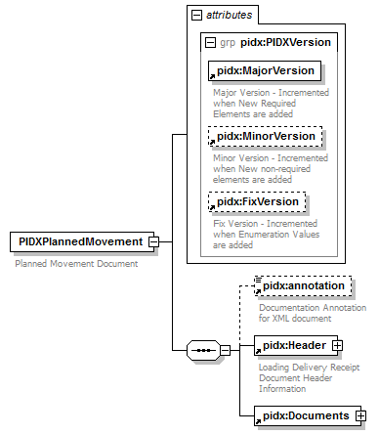
namespace | http://www.pidx.org/schema/ds/v5.02
properties | content complex
children | pidx:annotation pidx:Header pidx:Documents
attributes | Name Type Use Default Fixed annotation  MajorVersion required 05 documentation Major Version - Incremented when New Required Elements are added  MinorVersion optional 02 documentation Minor Version - Incremented when New non-required elements are added  FixVersion optional 01 documentation Fix Version - Incremented when Enumeration Values are added
annotation | documentation  Planned Movement Document
source | <element name="PIDXPlannedMovement">  <annotation>  <documentation>Planned Movement Document</documentation>  </annotation>  <complexType>  <sequence>  <element ref="pidx:annotation" minOccurs="0"/>  <element ref="pidx:Header"/>  <element ref="pidx:Documents"/>  </sequence>  <attributeGroup ref="pidx:PIDXVersion"/>  </complexType>  </element>

element PIDXPlannedMovementRequest
diagram | 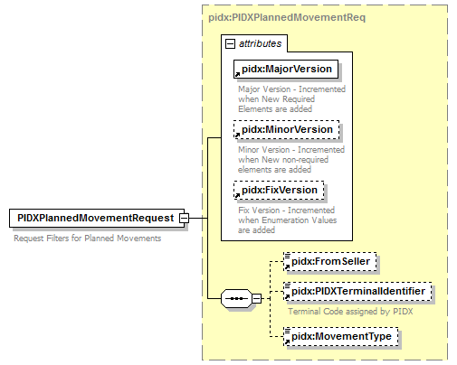
namespace | http://www.pidx.org/schema/ds/v5.02
type | pidx:PIDXPlannedMovementReq
properties | content complex
children | pidx:FromSeller pidx:PIDXTerminalIdentifier pidx:MovementType
attributes | Name Type Use Default Fixed annotation  MajorVersion required 05 documentation Major Version - Incremented when New Required Elements are added  MinorVersion optional 02 documentation Minor Version - Incremented when New non-required elements are added  FixVersion optional 01 documentation Fix Version - Incremented when Enumeration Values are added
annotation | documentation  Request Filters for Planned Movements
source | <element name="PIDXPlannedMovementRequest" type="pidx:PIDXPlannedMovementReq">  <annotation>  <documentation>Request Filters for Planned Movements</documentation>  </annotation>  </element>

element PIDXPlannedMovementResponse
diagram | 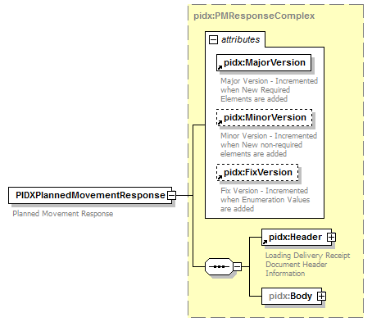
namespace | http://www.pidx.org/schema/ds/v5.02
type | pidx:PMResponseComplex
properties | content complex
children | pidx:Header pidx:Body
attributes | Name Type Use Default Fixed annotation  MajorVersion required 05 documentation Major Version - Incremented when New Required Elements are added  MinorVersion optional 02 documentation Minor Version - Incremented when New non-required elements are added  FixVersion optional 01 documentation Fix Version - Incremented when Enumeration Values are added
annotation | documentation  Planned Movement Response
source | <element name="PIDXPlannedMovementResponse" type="pidx:PMResponseComplex">  <annotation>  <documentation>Planned Movement Response</documentation>  </annotation>  </element>

XML Schema documentation generated by XMLSpy Schema Editor http://www.altova.com/xmlspy

