PIDX Enhanced Price Sheet BPG
Invoice Rate Validation Using Enhanced Price Sheets

Based on industry desire to be able to perform rate validation on more line items within an invoice, a method has been developed to allow for additional attributes within the line item portion of a PIDX Invoice. These additional attributes, along with existing part identification data, are combined to form a unique key which is used to find a specific price within an enhanced price sheet.
To perform rate validation the seller must distribute a price sheet that has been enhanced with additional attributes to provide uniqueness for each row in the price sheet. The buyer must store the price sheet data, including the additional attributes, in their back-end system. Both seller and buyer should follow the PIDX Price Sheet Syndication Business Process Guidelines.
The buyer must be able to use these additional attributes as provided in the PIDX Invoice document to look up the stored price sheet information.
Although the method described below does not limit the number of attributes to be included, evidence from a Proof of Concept and an initial pilot has shown that adding up to 3 attributes per line item seems to improve the rate validation substantially for those product/service lines which require complex pricing. Additional attributes do not seem to gain results proportionally with the effort of managing those additional attributes.
Below is the process flow:
Process Model - A seller first must add additional attributes in the form of a name-value pair to each line item within the price sheet if they do not already exists. The name-value pair should consist of a name of the attribute and the value of the attribute. The set of name-value pairs for a given item can be different from a set of another item within the same price sheet. The selected items for a given buyer must be populated in the price sheet and made available to the buyer either through an intermediary process or by directly providing the buyer with the price sheet items. The buyer must consume the price sheet and build the necessary information in their back-end system to be able to tie line item information received in PIDX Invoice documents with the additional attributes in the price sheet for proper rate validation.
The second step is for the seller to provide the additional price attributes within the PIDX Invoice documents when submitting invoices to the buyer. The buyer will have to interpret the invoices and perform the necessary rate validation against the previously stored information provided in the price sheet. Price attributes may be presented at the Invoice Header level or the Invoice Line Item level. If a particular price attribute is present at both the header level and the line item level, the line item attribute takes precedent.
The usage of this functionality can best be described through the following examples.
One-Level Identification with Price Sheet
The seller provides to the buyer an enhanced price sheet that contains enough data to make each row in the price sheet unique. The seller may use a single product/service identification element (part number) to identify the product or service, along with up to 3 price attributes which identify the correct price sheet row:
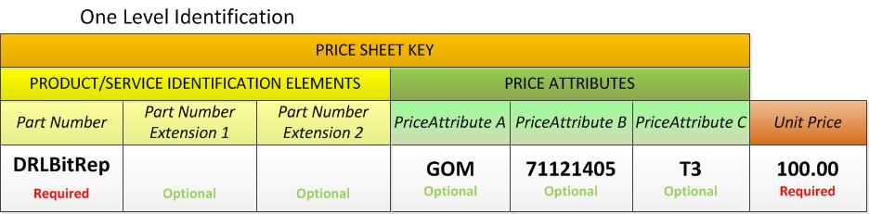
One-Level Identification with PIDX Horizontal Invoice
If the buyer uses a single product/service identification element (part number) to identify an item, the invoice should represent that item and its additional attributes using the PIDX Horizontal Invoice Method.
A seller publishing a given price sheet to a buyer should allow for up to 3 additional attributes not counting the identification element (part number). The name-value pair fields in the price sheet are Price Attribute A Name, Price Attribute A Value, Price Attribute B Name, Price Attribute B Value, Price Attribute C Name, and Price Attribute C Value. The names of Price Attribute pairs can be different across line items. For example, one line item may use temperature and pressure for price attribute names and another may use region and service type.
Line items within the price sheet may have different numbers (from 0 to 3) and combinations (of A, B, or C) of price attribute pairs populated.
Only the Price Attribute Values are used to build the key to the price sheet row. Names are optional and only provided for convenience.
Once the seller has published the price sheet and made it available to the buyer, the buyer imports the price sheet information and stores the additional line item attributes in some way. Whether the buyer stores both the name and the value part of the price attributes or just the value part depends on their implementation. However, it is imperative that the buyer retains the identification of the origin of the attributes (PriceAttribute A, PriceAttribute B, PriceAttribute C.). The seller may not provide the price attributes in the same order in the invoice but each price attribute will have a unique tag.
When the buyer has built their representation of the price sheet and informed the seller that the price sheet is available to be invoiced against, the seller will provide the same price attributes with every item noted in the invoice as it pertain to the agreed upon price sheet. Non-price sheet items may or may not have additional price attributes but are not expected to be rate validated.
A PIDX Horizontal Invoice can contain a mixture of line items with and without additional line item price attributes.
The additional price attributes on the PIDX invoice are not guaranteed to be in any particular order. Price attributes may be skipped. In other words, there may be a PriceAttribute B tag but no PriceAttribute A tag.
The price attributes are represented in the PIDX Horizontal Invoice as illustrated below:
<pidx:InvoiceLineItem>
<pidx:LineItemNumber>1</pidx:LineItemNumber>
<pidx:InvoiceQuantity>
<pidx:Quantity>1.0000</pidx:Quantity>
<pidx:UnitOfMeasureCode>EA</pidx:UnitOfMeasureCode>
</pidx:InvoiceQuantity>
<pidx:LineItemInformation>
<pidx:LineItemIdentifier identifierIndicator="AssignedBySeller">DRLBitRep</pidx:LineItemIdentifier>
<pidx:LineItemDescription>Drilling Bit Repair</pidx:LineItemDescription>
</pidx:LineItemInformation>

Order does not matter
<pidx:PriceAttributeA>
<pidx:PriceAttributeName>REGION</pidx:PriceAttributeName >
<pidx:PriceAttributeValue>GOM</pidx:PriceAttributeValue >
</pidx: PriceAttributeA >
Optional fields

<pidx:PriceAttributeB>
<pidx:PriceAttributeName>UNSPSC</pidx:PriceAttributeName >
<pidx:PriceAttributeValue>71121405</pidx:PriceAttributeValue >
Attributes occur @ the “lowest” level
</pidx: PriceAttributeB >

<pidx:PriceAttributeC>
<pidx:PriceAttributeName>TIER</pidx:PriceAttributeName >
<pidx:PriceAttributeValue>T3</pidx:PriceAttributeValue >
</pidx: PriceAttributeC>

<pidx:LineItemTotal>
<pidx:MonetaryAmount>100.00</pidx:MonetaryAmount>
<pidx:CurrencyCode>USD</pidx:CurrencyCode>
</pidx:LineItemTotal>
</pidx:InvoiceLineItem>
Multi-Level Identification with Enhanced Price Sheet
The seller may also use multiple product/service identification elements (part number and extensions) to identify the product or service, along with up to 3 price attributes which identify the correct price sheet row. The following examples show multi-level identification using Enhanced Price Sheet and the PIDX Hierarchical Invoice.

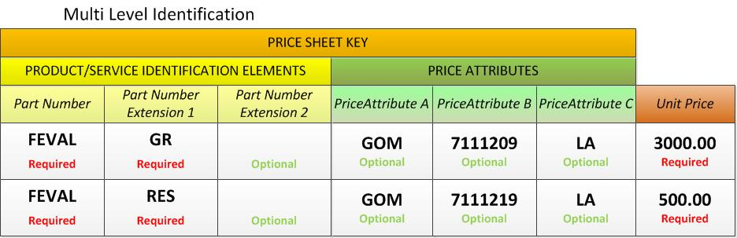
Multi-Level Identification with PIDX Hierarchical Invoice
If the buyer uses multiple product/service identification elements (part number and extensions) to identify an item, the invoice should represent that item and its additional attributes using the PIDX Hierarchical Invoice Method.
As in the previous example, a seller publishing a given price sheet to a buyer should allow for up to 3 additional attributes not counting the identification elements (part number and extensions). The name-value pair fields in the price sheet are PriceAttribute A Description, PriceAttribute A Value, PriceAttribute B Description, PriceAttribute B Value, PriceAttribute C Description, and PriceAttribute C Value. The names of name-value pairs can be different across line items. For example, one line item may use temperature and pressure for PriceAttribute names and another may use region and service type.
Line items within the price sheet may have different numbers (from 0 to 3) and combinations (of A, B, or C) of name-value pairs populated.
Only the PriceAttribute Values are used to build the key to the price sheet row. Descriptions are optional and only provided for convenience.
The price sheet line items above would be represented in the PIDX Hierarchical Invoice as illustrated below:
<pidx:InvoiceLineItem>
<pidx:LineItemNumber>1</pidx:LineItemNumber>

<pidx:InvoiceQuantity>
<pidx:Quantity>1.000</pidx:Quantity> <pidx:UnitOfMeasureCode>EA</pidx:UnitOfMeasureCode>
</pidx:InvoiceQuantity>

<pidx:LineItemInformation>
<pidx:LineItemIdentifier identifierIndicator="AssignedBySeller">FEVAL</pidx:LineItemIdentifier>
<pidx:LineItemDescription>Formation Evaluation</pidx:LineItemDescription>
</pidx:LineItemInformation>

<pidx:ReferenceInformation referenceInformationIndicator="TemplateNumber">
<pidx:Description>High</pidx:Description>
</pidx:ReferenceInformation>
</pidx:InvoiceLineItem>

XML (GR) – 1st Subline Item
<pidx:InvoiceLineItem>
<pidx:LineItemNumber>2</pidx:LineItemNumber>

<pidx:InvoiceQuantity>
<pidx:Quantity>100.000</pidx:Quantity> <pidx:UnitOfMeasureCode>FT</pidx:UnitOfMeasureCode>
</pidx:InvoiceQuantity>

<pidx:LineItemInformation>
<pidx:LineItemIdentifier identifierIndicator="AssignedBySeller">GR</pidx:LineItemIdentifier> <pidx:LineItemDescription>Gamma Ray</pidx:LineItemDescription>
</pidx:LineItemInformation>

<pidx:PriceAttributeA>
<pidx:PriceAttributeName>REGION</pidx:PriceAttributeName >
<pidx:PriceAttributeValue>GOM</pidx:PriceAttributeValue >
</pidx: PriceAttributeA >

<pidx:PriceAttributeB>
<pidx:PriceAttributeName>UNSPSC</pidx:PriceAttributeName >
<pidx:PriceAttributeValue>7111209</pidx:PriceAttributeValue >
</pidx: PriceAttributeB >

<pidx:PriceAttributeC>
<pidx:PriceAttributeName>TIER</pidx:PriceAttributeName >
<pidx:PriceAttributeValue>LA</pidx:PriceAttributeValue >
</pidx:PriceAttributeC>

<pidx:LineItemTotal>
<pidx:MonetaryAmount>3000.00</pidx:MonetaryAmount>
<pidx:CurrencyCode>USD</pidx:CurrencyCode>
</pidx:LineItemTotal>

<pidx:ReferenceInformation referenceInformationIndicator="TemplateNumber">
<pidx:ReferenceNumber>1</pidx:ReferenceNumber> <pidx:Description>Low</pidx:Description>
</pidx:ReferenceInformation>
</pidx:InvoiceLineItem>

XML (RES) – 2nd Subline Item
<pidx:InvoiceLineItem>
<pidx:LineItemNumber>3</pidx:LineItemNumber>

<pidx:InvoiceQuantity>
<pidx:Quantity>100.000</pidx:Quantity> <pidx:UnitOfMeasureCode>FT</pidx:UnitOfMeasureCode>
</pidx:InvoiceQuantity>

<pidx:LineItemInformation>
<pidx:LineItemIdentifier identifierIndicator="AssignedBySeller">RES</pidx:LineItemIdentifier>
<pidx:LineItemDescription>Resistivity</pidx:LineItemDescription>
</pidx:LineItemInformation>

<pidx:PriceAttributeA>
<pidx:PriceAttributeName>REGION</pidx:PriceAttributeName >
<pidx:PriceAttributeValue>GOM</pidx:PriceAttributeValue >
</pidx: PriceAttributeA >

<pidx:PriceAttributeB>
<pidx:PriceAttributeName>UNSPSC</pidx:PriceAttributeName >
<pidx:PriceAttributeValue>7111219</pidx:PriceAttributeValue >
</pidx: PriceAttributeB >

<pidx:PriceAttributeC>
<pidx:PriceAttributeName>TIER</pidx:PriceAttributeName >
<pidx:PriceAttributeValue>LA</pidx:PriceAttributeValue >
</pidx:PriceAttributeC>

<pidx:LineItemTotal>
<pidx:MonetaryAmount>500.00</pidx:MonetaryAmount>
<pidx:CurrencyCode>USD</pidx:CurrencyCode>
</pidx:LineItemTotal>

<pidx:ReferenceInformation referenceInformationIndicator="TemplateNumber">
<pidx:ReferenceNumber>1</pidx:ReferenceNumber>
<pidx:Description>Low</pidx:Description>
</pidx:ReferenceInformation>
</pidx:InvoiceLineItem>
Note that Line Item 2 and Line Item 3 reference the same parent (Line Item 1). It is not necessary to repeat the Part Number (Line Item 1), although it would be valid to do so.

Items in the Enhanced Price Sheet may use three product/service identification elements.
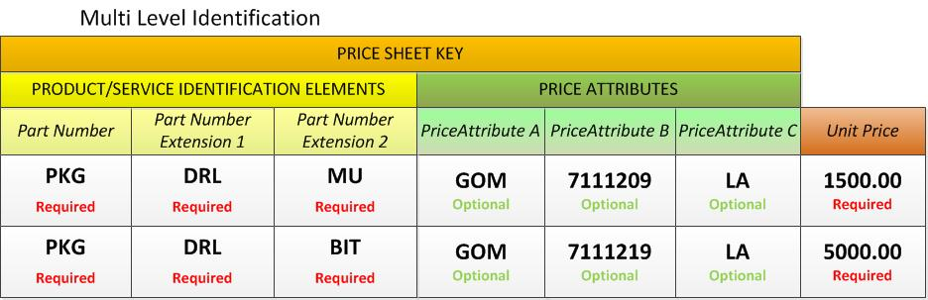
The price sheet line items above would be represented in the PIDX Hierarchical Invoice as illustrated below:

XML (PKG)
<pidx:InvoiceLineItem>
<pidx:LineItemNumber>1</pidx:LineItemNumber>

<pidx:InvoiceQuantity>
<pidx:Quantity>1.000</pidx:Quantity>
<pidx:UnitOfMeasureCode>EA</pidx:UnitOfMeasureCode>
</pidx:InvoiceQuantity>

<pidx:LineItemInformation>
<pidx:LineItemIdentifier identifierIndicator="AssignedBySeller">PKG</pidx:LineItemIdentifier>
<pidx:LineItemDescription>Package</pidx:LineItemDescription>
</pidx:LineItemInformation>

<pidx:ReferenceInformation referenceInformationIndicator="TemplateNumber">
<pidx:Description>High</pidx:Description>
</pidx:ReferenceInformation>
</pidx:InvoiceLineItem>

XML (DRL) – Sub line Item
<pidx:InvoiceLineItem>
<pidx:LineItemNumber>2</pidx:LineItemNumber>

<pidx:InvoiceQuantity>
<pidx:Quantity>1.000</pidx:Quantity> <pidx:UnitOfMeasureCode>EA</pidx:UnitOfMeasureCode>
</pidx:InvoiceQuantity>

<pidx:LineItemInformation>
<pidx:LineItemIdentifier identifierIndicator="AssignedBySeller">DRL</pidx:LineItemIdentifier>
<pidx:LineItemDescription>Drilling</pidx:LineItemDescription>
</pidx:LineItemInformation>

<pidx:ReferenceInformation referenceInformationIndicator="TemplateNumber">
<pidx:ReferenceNumber>1</pidx:ReferenceNumber> <pidx:Description>Low</pidx:Description>
</pidx:ReferenceInformation>
</pidx:InvoiceLineItem>

XML (MU) – 1st Sub-Sub line Item
<pidx:InvoiceLineItem>
<pidx:LineItemNumber>3</pidx:LineItemNumber>

<pidx:InvoiceQuantity>
<pidx:Quantity>100.000</pidx:Quantity> <pidx:UnitOfMeasureCode>FT</pidx:UnitOfMeasureCode>
</pidx:InvoiceQuantity>

<pidx:LineItemInformation>
<pidx:LineItemIdentifier identifierIndicator="AssignedBySeller">MU</pidx:LineItemIdentifier>
<pidx:LineItemDescription>Mud</pidx:LineItemDescription>
</pidx:LineItemInformation>

<pidx:PriceAttributeA>
<pidx:PriceAttributeName>REGION</pidx:PriceAttributeName >
<pidx:PriceAttributeValue>GOM</pidx:PriceAttributeValue >
</pidx: PriceAttributeA >

<pidx:PriceAttributeB>
<pidx:PriceAttributeName>UNSPSC</pidx:PriceAttributeName >
<pidx:PriceAttributeValue>7111209</pidx:PriceAttributeValue >
</pidx: PriceAttributeB >

<pidx:PriceAttributeC>
<pidx:PriceAttributeName>TIER</pidx:PriceAttributeName >
<pidx:PriceAttributeValue>LA</pidx:PriceAttributeValue >
</pidx:PriceAttributeC>

<pidx:LineItemTotal>
<pidx:MonetaryAmount>1500.00</pidx:MonetaryAmount>
<pidx:CurrencyCode>USD</pidx:CurrencyCode>
</pidx:LineItemTotal>

<pidx:ReferenceInformation referenceInformationIndicator="TemplateNumber">
<pidx:ReferenceNumber>2</pidx:ReferenceNumber> <pidx:Description>Low</pidx:Description>
</pidx:ReferenceInformation>
</pidx:InvoiceLineItem>

XML (Bit) – 2nd Sub-Sub line Item
<pidx:InvoiceLineItem>
<pidx:LineItemNumber>4</pidx:LineItemNumber>

<pidx:InvoiceQuantity>
<pidx:Quantity>100.000</pidx:Quantity> <pidx:UnitOfMeasureCode>FT</pidx:UnitOfMeasureCode>
</pidx:InvoiceQuantity>

<pidx:LineItemInformation>
<pidx:LineItemIdentifier identifierIndicator="AssignedBySeller">BIT</pidx:LineItemIdentifier> <pidx:LineItemDescription>Drilling Bit</pidx:LineItemDescription>
</pidx:LineItemInformation>

<pidx:PriceAttributeA>
<pidx:PriceAttributeName>REGION</pidx:PriceAttributeName >
<pidx:PriceAttributeValue>GOM</pidx:PriceAttributeValue >
</pidx: PriceAttributeA >

<pidx:PriceAttributeB>
<pidx:PriceAttributeName>UNSPSC</pidx:PriceAttributeName >
<pidx:PriceAttributeValue>7111219</pidx:PriceAttributeValue >
</pidx: PriceAttributeB >

<pidx:PriceAttributeC>
<pidx:PriceAttributeName>TIER</pidx:PriceAttributeName >
<pidx:PriceAttributeValue>LA</pidx:PriceAttributeValue >
</pidx:PriceAttributeC>

<pidx:LineItemTotal>
<pidx:MonetaryAmount>5000.00</pidx:MonetaryAmount>
<pidx:CurrencyCode>USD</pidx:CurrencyCode>
</pidx:LineItemTotal>

<pidx:ReferenceInformation referenceInformationIndicator="TemplateNumber">
<pidx:ReferenceNumber>2</pidx:ReferenceNumber> <pidx:Description>Low</pidx:Description>
</pidx:ReferenceInformation>
</pidx:InvoiceLineItem>

Note that Line Item 3 and Line Item 4 reference the same parent (Line Item 2). It is not necessary to repeat the Part Number (Line Item 1) and Part Number Extension (Line Item 2), although it would be valid to do so.

Header Level Usage of Price Attributes
The price attribute tags may be used in the invoice header, within the InvoiceProperties section of the document, subject to the following rules:

- A price attribute that appears in the InvoiceProperties section applies to every line item in the document. For example, if all line items have the same Region identifier, the invoice may store the region in <pidx:PriceAttributeA> in the invoice header.
- Price attributes may appear in the invoice header (InvoiceProperties) and the individual line items (InvoiceDetail). For example, the line items in the above example may have <pidx:PriceAttributeB> and <pidx:PriceAttributeC> tags at the line item level while <pidx:PriceAttributeA> remains at the header level.
- If the same price attribute tag appears at both the header level and the line item level, the line item price attribute tag takes precedent for that line item only.

XML (Header Usage)

<pidx:InvoiceProperties>
<pidx:InvoiceNumber>12345</pidx:InvoiceNumber>
<pidx:InvoiceDate>2011-05-26</pidx:InvoiceDate>
…
<pidx:PriceAttributeA>
<pidx:PriceAttributeName>REGION</pidx:PriceAttributeName >
<pidx:PriceAttributeValue>GOM</pidx:PriceAttributeValue >
</pidx: PriceAttributeA >

<pidx:PriceAttributeB>
<pidx:PriceAttributeName>UNSPSC</pidx:PriceAttributeName >
<pidx:PriceAttributeValue>7111219</pidx:PriceAttributeValue >
</pidx: PriceAttributeB >

<pidx:PriceAttributeC>
<pidx:PriceAttributeName>TIER</pidx:PriceAttributeName >
<pidx:PriceAttributeValue>LA</pidx:PriceAttributeValue >
</pidx:PriceAttributeC>

</pidx:InvoiceProperties>

Price Attributes A, B, and C would be applied to every line item on the invoice.

Sample Price Validation Process (Horizontal or Hierarchical Invoice)
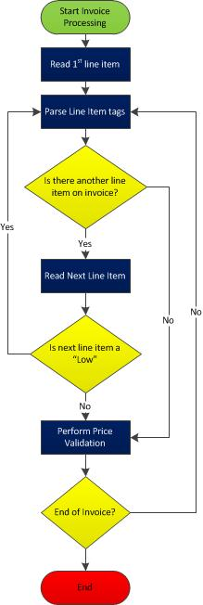
Use Case: Seller Provides Invoice Information

Business process name | Seller provides PIDX Invoice information
Identifier | PIDX XML Invoice using PriceAttribute tags
Actors | Buyer, Seller  Intermediary may be involved
Definitions | Trading Partner: The Buyer or Seller  Intermediary: Organization between Trading Partners that may handle routing and/or act on behalf of Trading Partner at different stages in the business process workflow  Message: Payload along with TRP protocol envelope  Payload: Invoice line item price sheet attributes as agreed by trading partners  Routing Hub: Intermediary that routes messages but does not participate in business process workflow.  Network: Intermediary that acts on behalf of buyer or seller and is a participant in the business process workflow.
Description | The seller is providing the PIDX Invoice document with additional line item attributes which are populated based upon information in the price sheet for a particular buyer. Each line item within the price sheet, and therefore invoice, may have a different set of line item attributes.  The line item attributes are provided either in the PIDX Hierarchical Invoice format, or in the PIDX Horizontal Invoice format.
Pre-condition | Additional line item attributes have been exchanged and agreed upon between trading partners through the price sheet.
Post-conditions | Rate validation is successful for any line items in invoice where corresponding line item exists in price sheet
Main Scenario | The seller generates PIDX Invoice documents based upon timesheets, field tickets etc. and associate the internal part numbers with the additional attributes provided to the seller previously through the price sheet process.
Alternate Scenario | The seller generates PIDX Invoice documents based upon timesheets; field tickets etc. but cannot associate internal part numbers with additional attributes as they may be 3rd party items or non-price sheet items. In this case no PriceAttribute tags will be present for the line item.
Recommended Best Practices | The seller should provide a PriceAttributeName and PriceAttributeValue with each populated attribute (A, B, and/or C) tag. The PriceAttributeValue fields should be limited to 24 characters in length. Hierarchical invoices may contain PriceAttribute tags, but only in the lowest level “child”. Seller should present price attributes at EITHER header level or line item level, but in any case the line item attribute takes precedent over the header level attribute where A, B, or C appear in both.
Reference Documentation

Use Case: Buyer Consumes Invoice Information

Business process name | Buyer consumes PIDX Invoice document information
Identifier | PIDX XML Invoice using Price sheetAttribute tag
Actors | Buyer, Seller  Intermediary may be involved
Definitions | Trading Partner: The Buyer or Seller  Intermediary: Organization between Trading Partners that may handle routing and/or act on behalf of Trading Partner at different stages in the business process workflow  Message: Payload along with TRP protocol envelope  Payload: Invoice line item price sheet attributes as agreed by trading partners  Routing Hub: Intermediary that routes messages but does not participate in business process workflow.  Network: Intermediary that acts on behalf of buyer or seller and is a participant in the business process workflow.
Description | The buyer is receiving a PIDX Invoice document and interprets the additional line item attributes and matches the line item up against the price sheet information provided previously. If matching occur, rate validation is possible.  The additional line item attributes have been provided in the <pidx:PriceAttributeValue> tags of the populated Price Attributes (A, B, and/or C)
Pre-condition | Additional line item attributes have been exchanged and agreed upon between trading partners through the price sheet.
Post-conditions | Line item is either accepted or rejected based on rate validation and this process can be automated by the buyer.
Main Scenario | The buyer parses the PIDX Invoice document and matches the additional line item attributes in connection with the part number up against the stored price sheet information. If part number and additional line item attributes is a match, rate validation may occur.
Alternate Scenario | The buyer parses the PIDX Invoice document and matches the additional line item attributes in connection with the part number up against the stored price sheet information. If part number and additional line item attributes is not a match, line item cannot be rate validated.
Alternate Scenario | The buyer parses the PIDX Invoice document and no additional line item attributes have been given for a particular item, no match against price sheet for particular part number can be made and no rate validation can occur.
Recommended Best Practices | The buyer should accommodate out-of-order tags or skipped tags. PriceAttributeC may appear before PriceAttributeA. PriceAttributeB may be populated, but PriceAttributeA skipped. Buyer should accommodate PriceAttributeA, PriceAttributeB, and PriceAttributeC at EITHER header level or line item level, but in any case the line item attribute takes precedent over the header level attribute where the same tag appears in both.
Reference Documentation

Glossary of Terms

Name | Description
<pidx:PriceAttributeA> | Optional PIDX tag containing first price attribute name and value pair; complex type; contains <pidx:PriceAttributeName> and <pidx:PriceAttributeValue>
<pidx:PriceAttributeB> | Optional PIDX tag containing second price attribute name and value pair; complex type; contains <pidx:PriceAttributeName> and <pidx:PriceAttributeValue>
<pidx:PriceAttributeC> | Optional PIDX tag containing third price attribute name and value pair; complex type; contains <pidx:PriceAttributeName> and <pidx:PriceAttributeValue>
<pidx:PriceAttributeName> | Optional PIDX tag contained within the structure of <pidx:PriceAttributeA>, <pidx:PriceAttributeB>, and <pidx:PriceAttributeC>. It contains freeform alphanumeric text describing the data stored in <pidx:PriceAttributeValue>
<pidx:PriceAttributeValue> | Optional PIDX tag contained within the structure of <pidx:PriceAttributeA>, <pidx:PriceAttributeB>, and <pidx:PriceAttributeC>. It contains freeform alphanumeric text. Combined with part number information, it is used to locate the correct row of data in a price sheet to validate the invoice line item price.
Hierarchical Invoice | PIDX invoice structure using parent line items (“High”) and child line items (“Low”) to represent product/service identification elements (part number and extensions. Price attribute elements for complex-priced line items may be included in the lowest level.
Horizontal Invoice | PIDX invoice structure using a line item to represent a single product/service identification element and price attribute elements for complex-priced line items.
Seller | Supplier; Generator of the Enhanced Price Sheet and the PIDX Invoice
Buyer | Operator; Receiver of the Enhanced Price Sheet and the PIDX Invoice

