Schema LoadingDeliveryReceipt.xsd

schema location: | \\fsprod01\users\bryan.mcpadden\MyDocs\PIDX5\5.02.01\5.02.01 8-31-2016\XSD Definitions and Diagrams\LoadingDeliveryReceipt.xsd
attribute form default: | unqualified
element form default: | qualified
targetNamespace: | http://www.pidx.org/schema/ds/v5.02

Elements
LoadingDeliveryReceipt

element LoadingDeliveryReceipt
diagram | 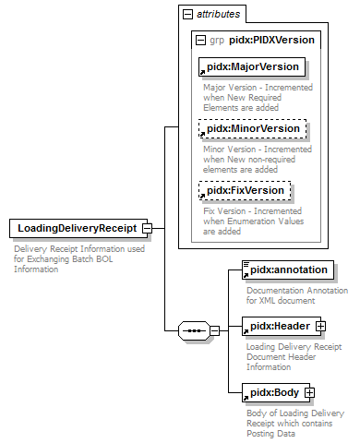
namespace | http://www.pidx.org/schema/ds/v5.02
properties | content complex
children | pidx:annotation pidx:Header pidx:Body
attributes | Name Type Use Default Fixed annotation  MajorVersion required 05 documentation Major Version - Incremented when New Required Elements are added  MinorVersion optional 02 documentation Minor Version - Incremented when New non-required elements are added  FixVersion optional 01 documentation Fix Version - Incremented when Enumeration Values are added
annotation | documentation  Delivery Receipt Information used for Exchanging Batch BOL Information
source | <element name="LoadingDeliveryReceipt">  <annotation>  <documentation>Delivery Receipt Information used for Exchanging Batch BOL Information</documentation>  </annotation>  <complexType>  <sequence>  <element ref="pidx:annotation"/>  <element ref="pidx:Header"/>  <element ref="pidx:Body"/>  </sequence>  <attributeGroup ref="pidx:PIDXVersion"/>  </complexType>  </element>

XML Schema documentation generated by XMLSpy Schema Editor http://www.altova.com/xmlspy

